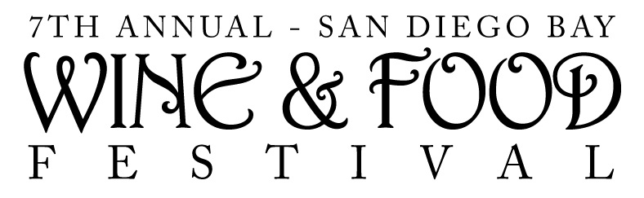
Contact:

Evan Klein
858-578-9463
klein@fastforwardevents.com

FOR IMMEDIATE RELEASE

AMTRAK CALIFORNIA® JOINS 7th ANNUAL SAN DIEGO BAY WINE & FOOD FESTIVAL AS THE OFFICIAL TRANSPORTATION PARTNER

Wine & Food Lovers Save with Special Travel Discount on Amtrak California Pacific Surfliner® When Traveling to Southern California’s Largest Wine & Food Festival this November 17-21

SAN DIEGO (July 15, 2010) – The 7th Annual San Diego Bay Wine & Food Festival, the largest wine and food festival in Southern California, is pleased to announce Amtrak California as its official transportation partner for the 2010 event, taking place November 17-21. With an increasing number of enthusiasts traveling to the Festival from along the California coast, it is a perfect match to partner with Amtrak California and provide wine and food travelers a safe, comfortable and affordable journey, said Michelle Metter, the Festival’s co-producer.

“For the second year in a row, Amtrak California Pacific Surfliner and the San Diego Bay Wine & Food Festival have teamed up to provide wine and food lovers in California the opportunity to experience this one-of-a-kind Festival with an easy means of transportation,” added Metter. “We invite all out-of-towners to ride Pacific Surfliner down to San Diego and take part in the epicurean experience of a lifetime.”

The Pacific Surfliner travels along the California coast from San Luis Obispo to San Diego passing through several cities on the way. San Diego Bay Wine & Food Festival attendees who wish to take advantage of Amtrak California’s promotion will receive a 10 percent discount off the lowest available ticket price to San Diego. For reservations, fares and schedules visit AmtrakCalifornia.com and enter discount code V809 for 10 percent off. This code cannot be booked via phone and can be redeemed from October 15 – November 21. The discount is valid for travel from November 16 – 21.

The weeklong San Diego Bay Wine & Food Festival features over 170 wineries, breweries and spirits companies, 70 of San Diego's finest restaurants and chefs, gourmet food companies, celebrity chefs, culinary personalities, legendary winemakers, cooking and wine tasting classes, the WineRave, a Reserve & New Release Tasting, the star-studded Grand Event and much more.
Make a weekend out of the Festival and book a Wine Weekend Getaway Package with a stay in one of San Diego’s top hotels, Festival event tickets and savings of up to $425. Participating hotels include:
· Embassy Suites
· Hard Rock Hotel San Diego
· Hilton San Diego Bayfront
· Horton Grand
· Hotel Indigo
· Manchester Grand Hyatt San Diego
· Omni San Diego
· San Diego Marriott Hotel & Marina
For more information or to purchase tickets for the San Diego Bay Wine & Food Festival, please visit www.worldofwineevents.com. A complete schedule and line up of all events for the 7th Annual San Diego Bay Wine & Food Festival can be found by visiting the website or by calling 619-342-7337.

SAN DIEGO BAY WINE & FOOD FESTIVAL

The 7th Annual San Diego Bay Wine & Food Festival is an international showcase of the world's premier wine and spirits producers, chefs and culinary personalities, and gourmet foods. Held November 17-21, 2010, the event benefits the American Institute of Wine & Food culinary arts scholarship program. Over 170 wineries, 70 of San Diego’s top fine dining restaurants and 30 gourmet food companies and exhibitors will participate in the 2010 Festival. For more information visit www.worldofwineevents.com. Produced by World of Wine Events and Fast Forward Event Productions. For more information call 858-578-9463.

###

