All-Inclusive Lifestyle Available at Cherokee Valley

Cherokee Valley can play host to you and your family for a weekend or for a lifetime. The long-range mountain views and golf-front real estate make Cherokee Valley your one-stop destination for exceptional outdoor living. This property’s vivid backdrop of Blue Ridge Mountain views complements its expertly designed championship golf course, complete with clubhouse and restaurant, pro-shop and exercise facility. While at Cherokee Valley fill your days with the 18-hole championship golf course, horseback riding lessons or travel to nearby city attractions.

The 18-hole championship golf course is a masterpiece to play with dramatic elevation changes, poising the Cherokee Valley golf course as a must play destination for any golf enthusiast! Also, the newly constructed, state-of-the-art Wellness Center, including a spectacular swimming pool and two competition clay tennis courts, provide residents with a stress-relieving fitness center and hours of active competition with friends and family.

Guests can enjoy the ultimate in luxury by renting one of Cherokee Valley’s Southern-style cottage homes. Each cottage is equipped with four separate bed-and-bath suites, so you can be sure that you’ll always have plenty of privacy and ample room for everyone. Spacious living areas provide the ideal backdrop for relaxing and entertaining, while classic southern porches offer panoramic views of the golf course and the majestic Blue Ridge Mountains. These gorgeous cottage homes for rent are sure to make the time spent at Cherokee Valley memorable.

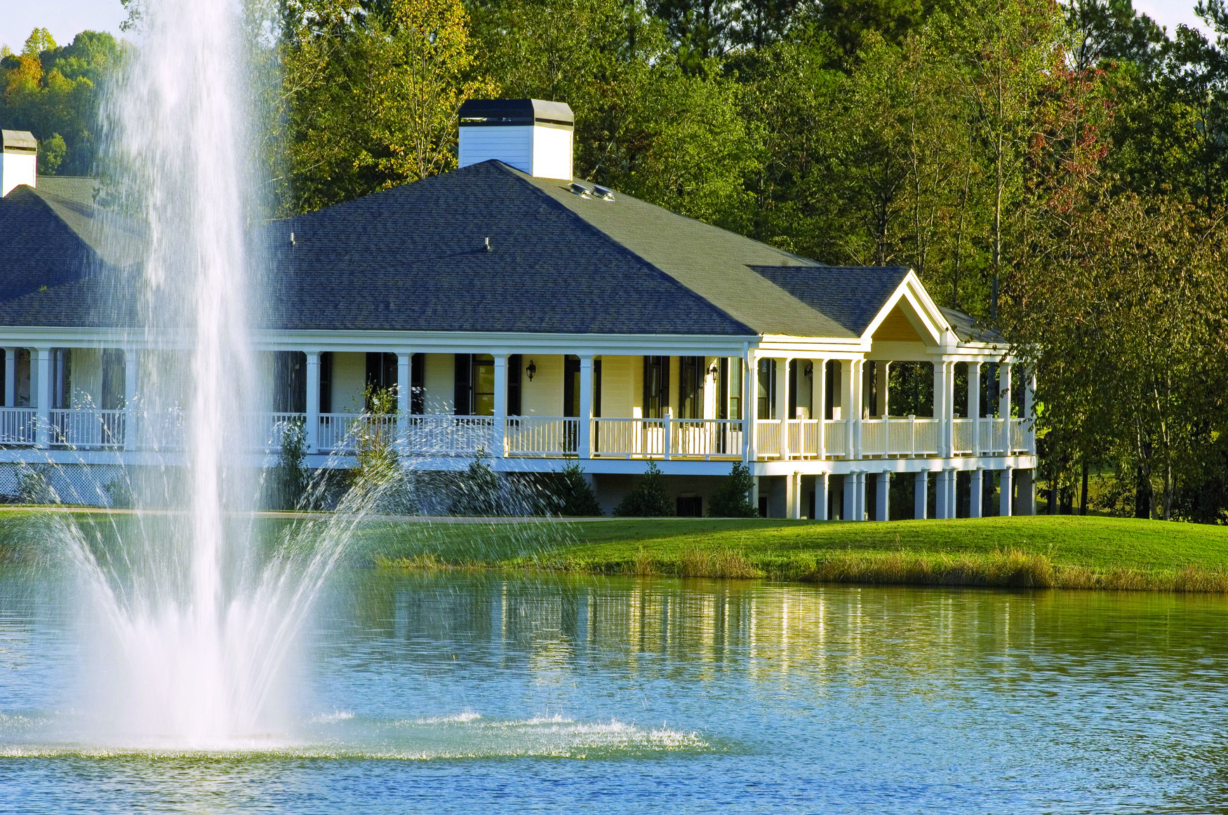
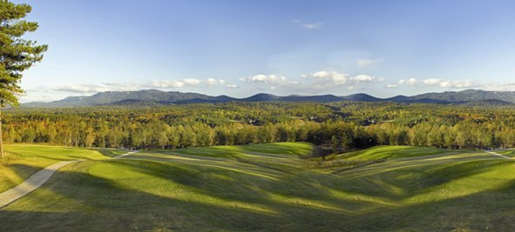
Real Estate for Sale

CHEROKEE VALLEY
“PRE” RE-GRAND OPENING LAND SALE

In celebration of our “BRAND-NEW” Wellness Center, Cherokee Valley is having a “PRE” Re-Grand Opening Sale on our breathtaking golf course homesites!
Come and see what Cherokee Valley has to offer…spectacular views, incredible pricing, recreational activities, golf, driving range, tennis courts, swimming pool, state-of-the-art fitness center!

We offer “Stay and Play” packages for couples, which include a weekend at our on-site, resort-style accommodations and access to all recreational activities and amenities (Real Estate tour required).

Please visit http://www.cherokeevalleysc.com/offer_0.html for further details on our “Stay and Play” packages or call for special pricing and further details!

COME AND SEE WHY CHEROKEE VALLEY,
IS THE PERFECT PLACE TO SPEND A WEEKEND OR A LIFETIME!

Cherokee Valley Golf Club
450 Cherokee Valley Way
Travelers Rest, SC 29690
(866) 334-3253
www.CherokeeValleySC.com

