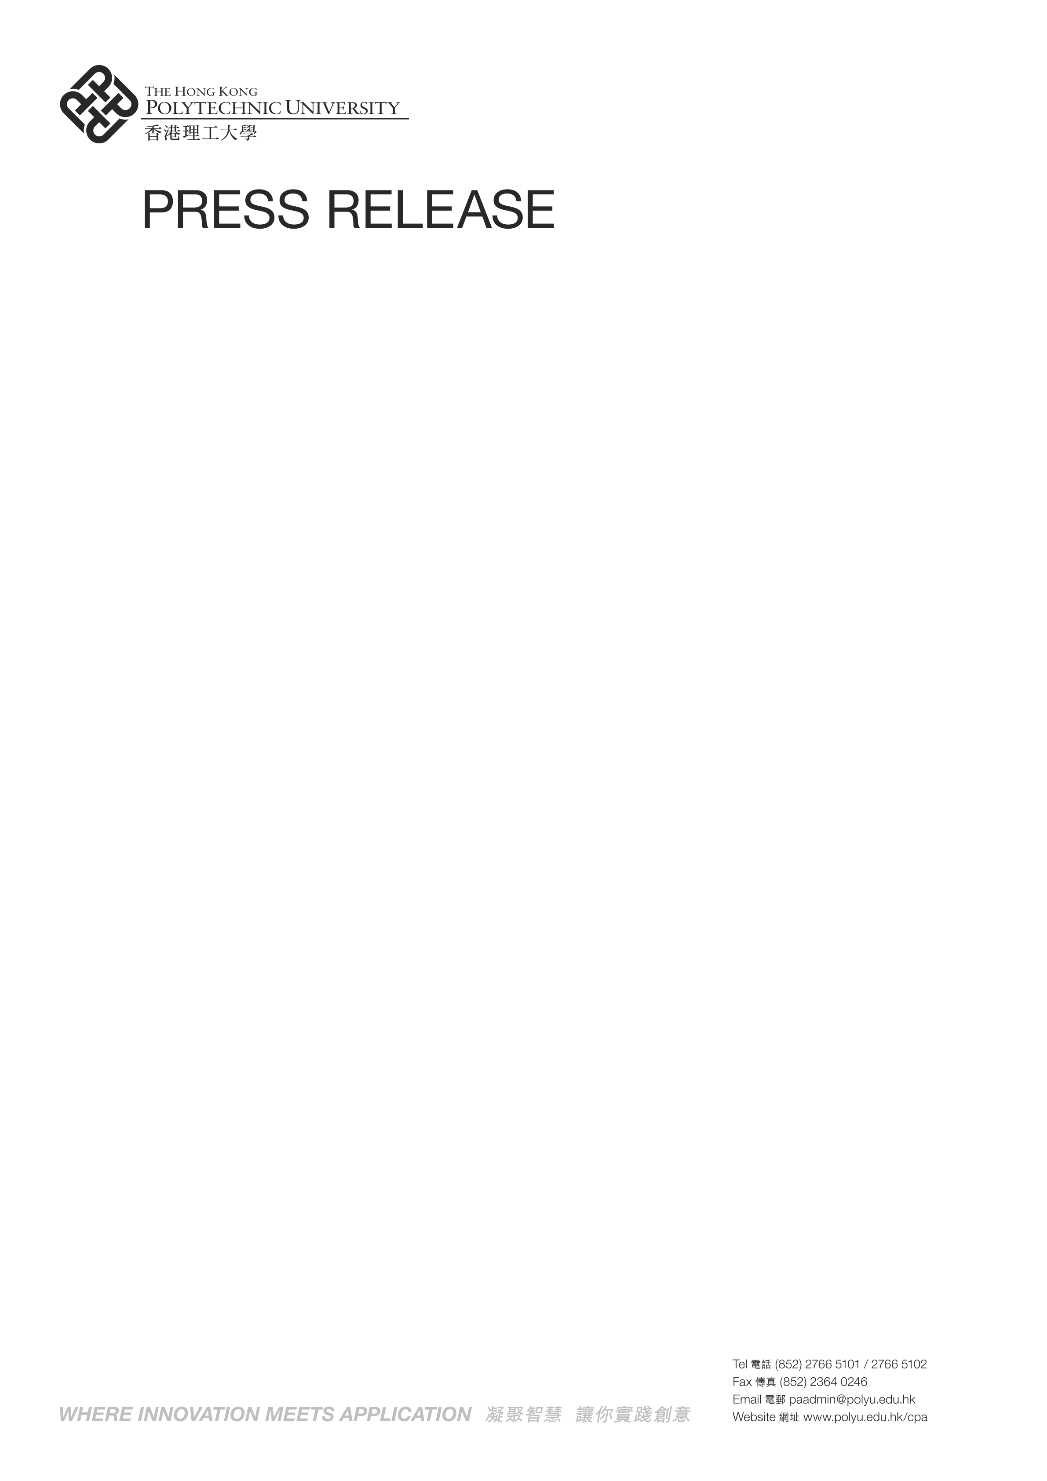

7 September 2010

PolyU gears up for further advancement in Space Research

The Hong Kong Polytechnic University (PolyU) today (7 September) showcased its capabilities in the area of space research. With its track record and strong links to space authorities at the national level and abroad, PolyU researchers are now actively engaged in several projects ranging from the making of sophisticated space tools and moon maps to monitoring the health of astronauts under micro-gravity condition.

Speaking at a press conference, Professor Philip Chan, Deputy President and Provost of the University, said PolyU sought to establish one or two special Research Institutes to support the further advancement of space research. The University would also explore the possibility of turning its space technology for civilian use in the future.

PolyU would welcome in three senior delegations from national space authorities in the next two months, starting with a visit from the Centre for Space Science and Applied Research under the China Academy of Science within the week. It would seal a deal with China Academy of Space Technology (CAST) on the establishment of a Joint Laboratory in the middle of the month, and greet another delegation from the Astronauts Training Centre in October this year.

Professor Philip Chan also introduced four key researchers who are leading teams to work on different aspects of space research. They are:

Professor Chetwyn Chan of the Department of Rehabilitation Sciences. His team is studying the impact of microgravity on the health of astronauts with a view to preventing bone and muscle loss. They are also involved in studying the use of Transcultaneous Electrical Simulation (TENS) for the training and selection of astronauts, and in the joint testing of an oral-intake herbal medicine with Ginseng, Huang Oi, and Dang Gui as the main ingredient for keeping Chinese astronauts in good shape.

Professor Chen Yongqi of the Department of Land Surveying and Geo-Informatics. He has been appointed a Member of the Scientific Application Committee for China’s Chang’E mission since 2007. With the use of advanced technologies, his team has made substantial contribution to the determination of the shape and size of the Moon and lunar mapping after Chinese orbitor Chang’E I completed its historic mission.

Professor Tao Xiao-ming of the Institute of Textiles and Clothing. Her department was invited by the China National Space Administration to design new sets of work clothes for its ground staff at the Control Centre in Jiuquan. Special fabrics with anti-static property were used to meet the stringent requirement of the Centre. This project was sponsored by Cha Textiles Ltd and the work clothes have been in use since 2004.

/2…

Professor Yung Kai-leung of the Department of Industrial and Systems Engineering. Professor Yung will be working closely with mainland space experts from CAST on the development of a “Camera Pointing System” for lunar exploration. He is also responsible for developing the “Soil Preparation System” for the Sino-Russian Space Mission “Phobos Grunt” to be launched in 2011.

Over the years, the University has built up a strong credential for active participation in space research. In 1995, the Space Holinser Forceps jointly developed by PolyU researchers and independent inventor Dr Ng Tsz-chuen was deployed by Russian Astronauts in the then MIR Space Station. The University was further appointed by the European Space Agency to develop the Mars Rock Corer for its 2003 Mars Express Mission. (Please refer to the Appendix for a chronology of major happenings.)

Earlier this year, PolyU President Professor Timothy Tong led a senior delegation to Beijing in June and explore collaborations with CAST. During the visit, PolyU also signed an agreement with CAST to formalize research collaboration between two parties relating to China’s lunar exploration programme.

*****

Press Contact : Professor Alex Wai
Vice President (Research Development)
Telephone : (852) 2766 6231
Email : enwai@inet.polyu.edu.hk

Press Contact : Mr Wilfred Lai
Division Head (Media and Community Relations)
Telephone : (852) 2766 5218
Email : pawilfred@inet.polyu.edu.hk

