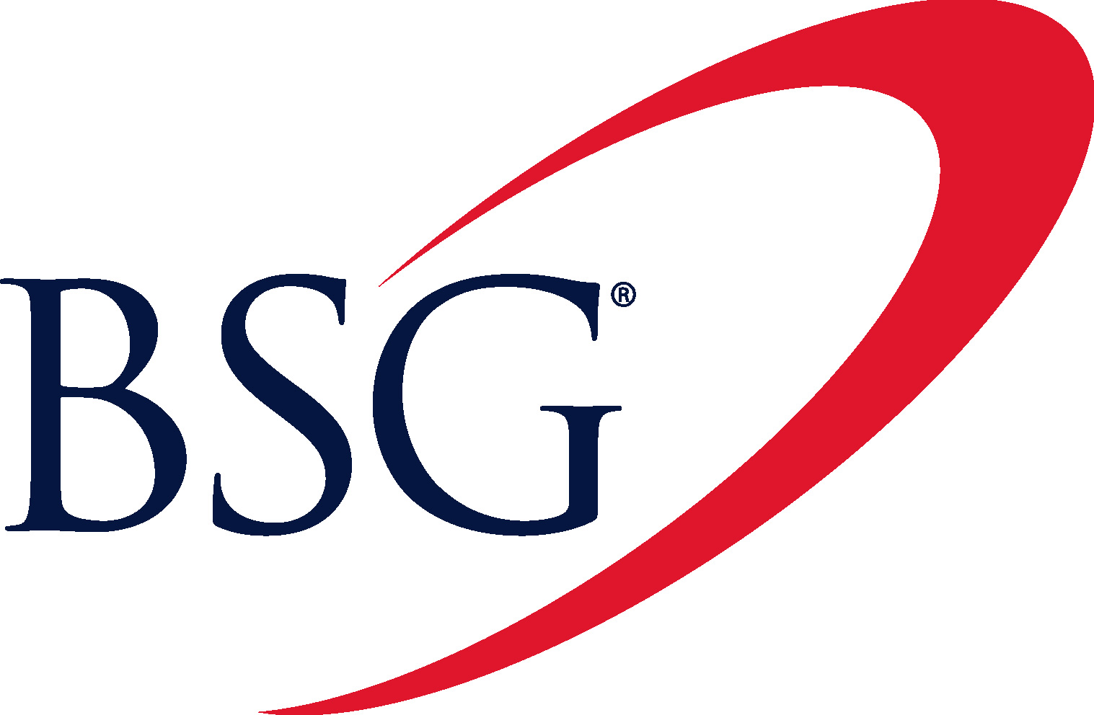 For Immediate Release
Standard & Poor’s Raises BSG's Term Loan Rating to BB

SAN ANTONIO, TX, USA (September 13, 2010) – Billing Services Group Limited (AIM: BILL) today announced that Standard & Poor's Ratings Services has raised its issue-level rating on the senior secured term loan at the Company’s subsidiary, Billing Services Group North America, Inc., to BB from B+. In addition, Standard & Poor’s affirmed its corporate credit rating of B+ on the parent entity, Billing Services Group Limited.

“We are continually working to deliver maximum value to our stakeholders through a variety of efforts, including our ongoing debt reduction program,” said Greg Carter, CEO of BSG. “This ratings upgrade is an indication that our hard work and financial strategy are paying off.”

Inquiries:
Billing Services Group Limited +1 210 949 7000
Greg Carter
Norm Phipps

Evolution Securities Limited +44 (0) 20 7071 4300
Stuart Andrews

Media Relations
Leslie Komet Ausburn +1 210 479 7255
+1 210 326 8992
About BSG
Billing Services Group Limited is headquartered in San Antonio, Texas, USA and traded on the London Stock Exchange (AIM: BILL). For over 20 years, BSG has been a leading provider of clearing, settlement, payment and financial risk management solutions for the telecommunications industry, merchants and online stores. For more information on BSG, visit www.bsgclearing.com.
###

