MEDIA CONTACT: Lee & Associates, Inc. Sarah Levin 323-938-3300 or leeassociatespr@aol.com

“NO MORE NAKED SALADS” NATIONAL RECIPE SWEEPSTAKES LAUNCHES
www.mrs.cubbisons.com
Top Prize Is Year’s Worth Of Free Groceries Worth $5,200; 20 Runners-Up Prizes of $100

(Los Angeles, CA) -- Mrs. Cubbison’s invites home cooks across the country to share their creative ideas in its “No More Naked Salads” Recipe Sweepstakes. The Grand Prize winner will win a year’s supply of free groceries - worth $5,200! Plus, 20 second place winners will receive a $100 grocery gift card and all winning recipe ideas will be featured on the company’s website. For complete details and contest rules log onto http://www.mrscubbisons.com. The contest runs through December 31st. Open to U.S. residents only.

HOW TO DRESS A NAKED SALAD
No salad deserves to be naked! After all, a dish that can deliver so much taste, and nutrition in one meal should always be served with style! With all the healthy convenience items available in supermarkets, it’s easy to liven up a lonely bowl of lettuce. Here are some easy ideas from Mrs. Cubbison’s Test Kitchens:
Chicken Nugget Caesar Salad -- Toss chopped romaine lettuce with bottled Caesar dressing; top with boneless chicken nuggets. Sprinkle with Parmesan cheese and Caesar Salad Restaurant Style Croutons. A kid-pleasing meal in minutes!
Hamburger Salad – Toss iceberg or green leaf lettuce with diced tomatoes and pickle slices. Top with grilled, cut up beef, turkey or vegetarian burgers. Drizzle with Light or Fat Free Thousand Island dressing and top with Fat Free Seasoned Restaurant Style croutons.
Baja Fish Taco Style Salad -- Place baby salad greens in a bowl and spoon bottled black bean salsa over the top. Sprinkle grilled fish fillet pieces over the salsa and top with shredded cheddar cheese, a dollop of sour cream and Seasoned Restaurant Style Croutons.
Pepperoni Pizza Salad—Arrange a bag of mixed salad greens in a large salad bowl. Top with thinly sliced red onion, tomato wedges, sliced pepperoni, and shredded Italian blend cheese. Add sliced, fresh mushrooms if desired. Pour a ½ cup of bottled Italian dressing over all ingredients and serve with Cheese & Garlic Restaurant Style Croutons.
Steak and Potato Salad -- Start with leftover grilled steak and oven roasted red potatoes. Cut the steak and potatoes into bite sized chunks. Toss meat and potatoes with sour cream, chives and cracked black pepper in a bowl; cover and chill. Serve over fresh salad greens and top with Garlic & Butter French Bread Croutons.
California Chicken & Fruit Salad – Use bagged salad greens and freezer section breaded chicken strips that have been heated and chopped. Add fresh strawberry slices, halved, fresh grapes, and peeled navel orange sections. Sprinkle shredded Monterey Jack cheese and Fat Free Seasoned Restaurant Style Croutons and serve with light vinaigrette. A perfect light lunch!
Vidalia Onion & Spinach Salad --Toss a bag of baby spinach with thinly sliced sweet onions and chopped, hard-boiled eggs. Serve with vinaigrette and Garlic and Butter French Bread Croutons. Sauté fresh garlic slices in butter and spoon onto the salad if desired.
How do you like to dress up your greens? Enter your ideas in Mrs. Cubbison’s “No More Naked Salads Sweepstakes” for a chance to win a year’s worth of free groceries. Visit http://www.mrscubbisons.com for complete details.

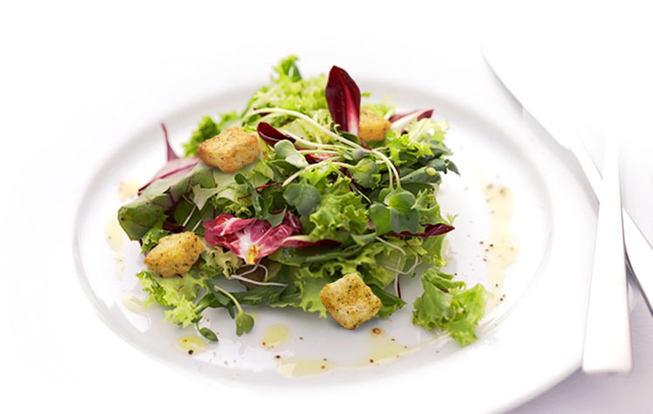

Introducing Restaurant Style Croutons In New Stay-Fresh Resealable Bags.
Mrs. Cubbison’s has optimized its top-selling seasoned restaurant style croutons for greater convenience, taste and crunch. The brand’s new resealable, moisture-proof stand-up bags assure fresh-from-the-oven flavor and texture. Using the freshest breads, each crouton is toasted to crisp perfection with seasonings and herbs to complement popular salads. Flavors include Classic Seasoned, Cheese & Garlic, Caesar Salad, Garlic & Butter and Fat-Free Seasoned. Larger, restaurant style croutons like Mrs. Cubbison’s are preferred by consumers in extensive national taste surveys.
For More information, go to http://www.mrscubbisons.com

