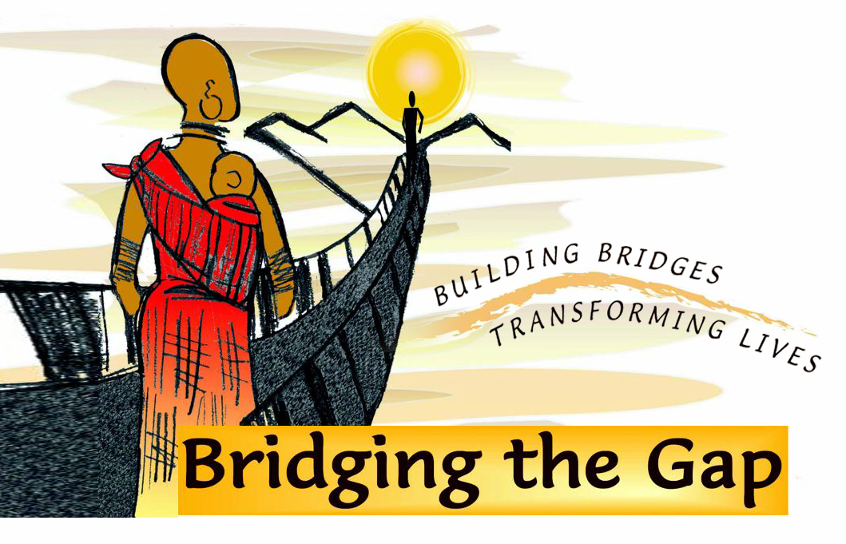
Fact Sheet
October 4, 2010

- On a visit to Kenya in the mid-1990s, remote communities asked Mr. Parker if he could use his building skills to construct bridges that would make daily lives safer.
  - His friend and fellow development worker, Jay Hindson, introduced Harmon to footbridge building.
  - Jay returned to England as Harmon continued to construct bridges for poor communities.

- For Harmon, the bridges offer hope and inspiration that provide daily safe access to:
  - Life-saving healthcare
  - Basic education
  - Food and basic staples
  - Family in other villages

- Bridging the Gap is also about Saving Lives
  - Bridges overcome the dangers of impassable rivers that threaten lives.
  - Every life is important.
  - Bridging the Gap is not about numbers – it’s about helping isolated communities.
  - Bridges have been built for remote communities ranging from a few hundred to 5000 people.

- Bridging the Gap has built more than 45 pedestrian bridges in Kenya since 1996 improving the safety and quality of life for thousands of marginalized communities.

- Harmon built his first bridge in West Pokot, Kenya over the Moruny River at the request of a community.

- The smallest bridge is the 60 foot (20 meters) span over the Talek River.

- The bridges vary in cost due to variation in length, location and other factors.

- Largest bridge is the 375 foot span (112 meters) over the Galana River, the second longest rover in Kenya.

- Bridging the Gap helps communities help themselves in the IPO bridge building process.

  - We empower and improve the quality of life for marginalized communities in Sub-Sahara Africa:

    - Community Initiative
      - First step. For a successful footbridge
    - Community Participation
      - Imperative for true and lasting empowerment
        - Villagers provide labor
    - Community Ownership
      - Rewards the hard work for everyone involved
        - They also learn to maintain the bridge.

- The Need is Great; the Need is Now
  - Demand for our bridges far outweighs our current financial ability.
  - Funding for bridges comes from individual donors and the villagers themselves, who primarily supply the labor for bridge construction.

- Bridging the Gap Inc. is a U.S. federally recognized 501©3 non-profit organization. All U.S. donations are tax deductible. Visit: www.bridgingthegapafrica.com.

- Vote NOW and OFTEN for Harmon Parker as the CNN Hero of the Year at: www.cnn.com/SPECIALS/cnn.heroes/archive10/harmon.parker.html.

