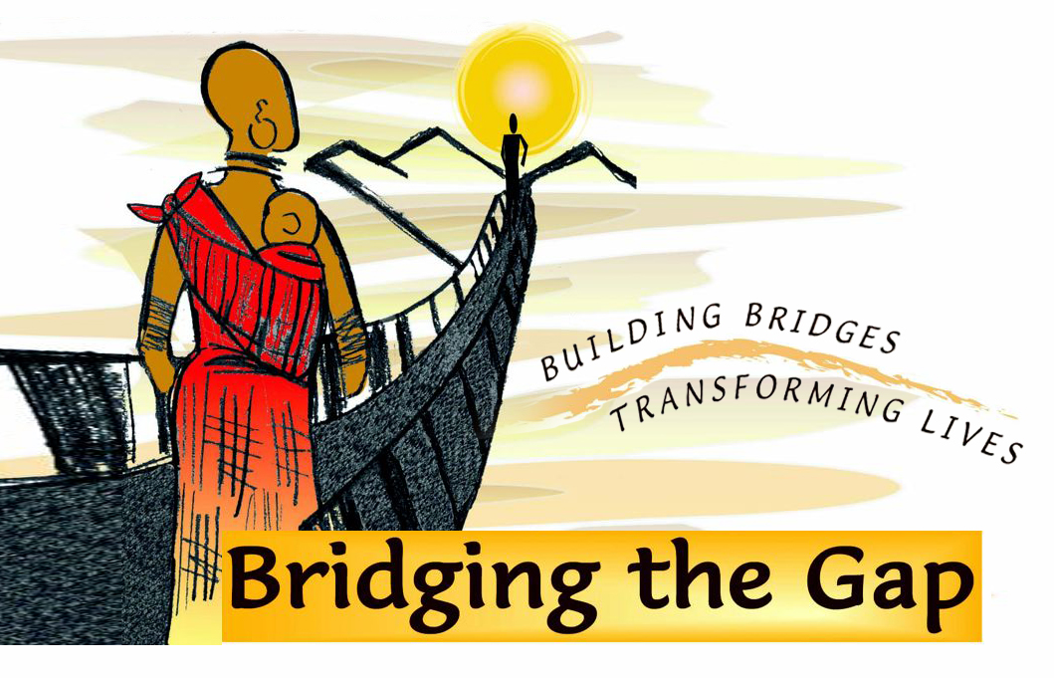

Biography of Harmon Parker

Harmon Parker is a bricklayer who became a master mason early in his life. An everyday, average workingman, his life took a remarkable turn on the African continent.
As a Christian developmental worker in Africa over the last twenty years, Harmon Parker has gained an understanding of the culture and needs of marginalized communities in Kenya that has led him to a unique and valuable role in offering them hope so that lives will be saved through his bridge building efforts. His most notable contribution came when he saw the dangerous river crossings they make on a daily basis to attend schools, markets, health clinics and to visit family in other villages. He built his first bridge in 1996. As the demand for more bridges grew, he created “Bridging the Gap” in 2003 to construct footbridges that keep these people, especially children, women and the elderly, out of these treacherous waters. Over the past thirteen years, he has built more than 45 footbridges in Kenya.
Harmon was first introduced to Africa at the request of missionaries in 1985 as a skilled mason to help build a home for missionaries in a remote part of the Democratic Republic of the Congo. He was then invited to Kitale, Kenya in 1990 to participate in planting a build a school, moving there with his wife and three-year-old son. The project took more than a year to build using soil-block technology. The school has been an incredible successful and still operates today.
During a visit to Kenya in the mid-1990s Harmon’s friend and fellow development worker Jay Hindson introduced him to building footbridges. His building skills led a remote community to ask him to build a footbridge so they could bypass the hazardous river crossings. Being a builder by trade and “bush engineers” through experience, Harmon constructed his first successful footbridge in 1997, and word of his work began to spread.
Harmon also believes in helping communities help themselves by empowering them and improving the quality of life for marginalized Sub-Sahara Africa. Communities get involved through Harmon’s “IPO” methodology, which starts with the communities taking the Initiative, then Participating in the construction and finally celebrating Ownership of the bridge.
Over the past thirteen years, he has built more than 45 footbridges in Kenya. Parker’s Bridging the Gap organization looks to share technology and resources with other bridge building organizations, such as Bridges to Prosperity, on whose Board he sits, to promote and bring more footbridges to countless rural communities worldwide. Parker believes that every life is important and that rural marginalized communities should not be denied the opportunity to safe river crossings.
Parker was raised in Lexington, Kentucky, and married his wife Teri in 1984. Their 23 year-old son, Josh, who was born in Lexington, and recently graduated from Azusa Pacific University with a degree in Sociology. Josh has returned to Africa and is currently working with a relief organization in southern Sudan. Teri, a native of San Jose, CA, is Bridging the Gap’s Kenya Office Manager and is an incredible hostess for the many visitors who visit the Parker home. The Parkers have lived in Kenya for the past 19 years. Parker enjoys playing guitar, golfing, and spending time with his family and friends.
In September 2010, CNN named Harmon one of the top ten CNN Heroes, making him eligible to be named CNN Hero of the Year and a cash prize that will allow Harmon to save more Kenyans from the perilous rivers.
Contact: Rob Doughty
(305) 495-3311
rob@robdoughtycommunciations.com

