
N E W S R E L E A S E

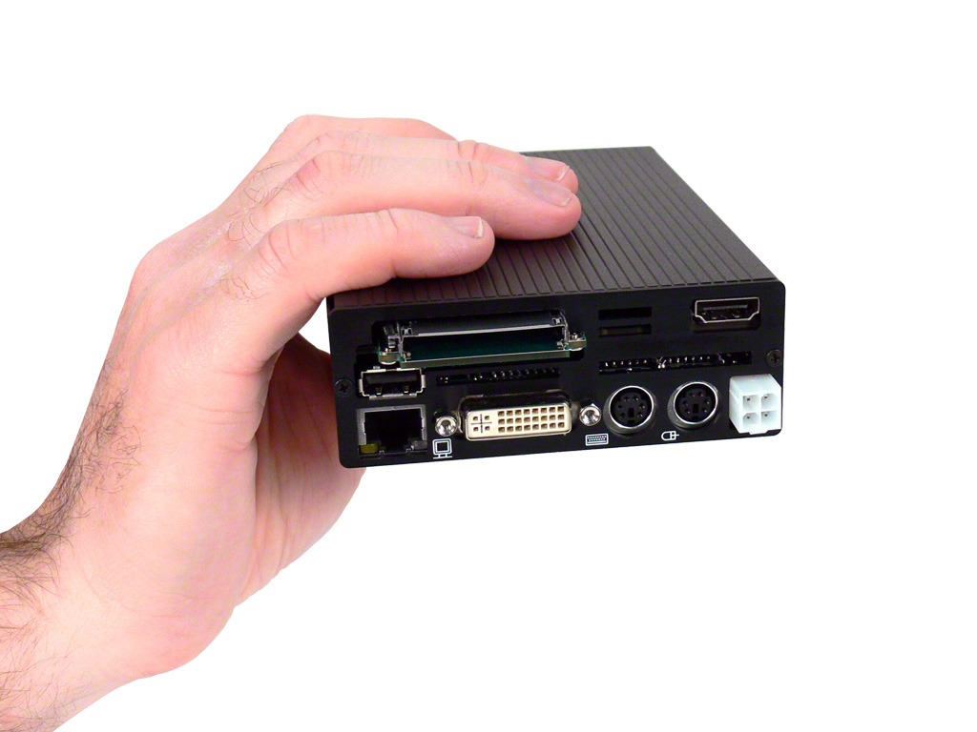
FOR IMMEDIATE RELEASE
Contact: Andrew Pakula, 905-264-9000 ext #243
marketing@stealth.com

For high quality digital images
of this product, click here.

Stealth.Com Introduces a New Ultra Compact Mini PC
Ideal for Mobile and Embedded Applications

Toronto / San Jose ~ November 2010 – Stealth.Com Inc. (Stealth Computer), a leader in the industrial computer and peripherals market has released a new ultra small PC designed specifically for in-vehicle/mobile/embedded applications. Stealth’s model LPC-100M is a rugged small form PC that operates from 10-26 VDC power input making it ideal for DC powered applications typically found in vehicles and remote applications.

According to Stealth CEO, Ed Boutilier; “One of the unique attributes the LPC-100M mobile computer possesses is a user selectable smart power control interface. Start-up and shut-down times are user definable allowing for safe application launching along with a controlled shutdown period. This is absolutely critical in preventing data corruption when power sources are interrupted in mobile and field environments.”

Housed in a rugged aluminum enclosure this powerful & versatile machine measures out at only 4.0" x 6.1" x 1.45” (102mm x 155mm x 37mm) or about the size of a paperback novel. The machine weighs in at a mere 1.2lbs or 0.54kg.

Stealth.Com Introduces a New Ultra Compact Mini PC Ideal for Mobile and Embedded Applications
Page # 2

Stealth’s ultra small mobile PC utilizes the Intel® Core™ 2 Duo mobile processor technology and outperforms other computers many times its size. The LPC-100M is available with a standard Intel Dual Core Celeron T3100 (1.9GHz) or optional Intel Core 2 Duo processor P8400 (2.26Ghz). The machine employs the Intel Mobile GM45 Express Chipset featuring Intel’s graphic media accelerator with advanced 3D graphics performance.

The LPC-100M mini PC features a multitude of I/O connectivity built directly into its impressively small design such as; Gigabit LAN, 4-USB, 2-Serial, 1-DVI-I, 1-DVI-D Video, Audio In/Out, 2-PS/2 ports and 1-external express card slot. The rear locking DC power connector ensures power is securely in place. The LPC-100M supports up to 8GB of DDR3 memory and has a built-in 2.5” mobile hard drive with up to 500GB’s of storage space for archived data. For applications that require extra high shock, vibration and wide temperature ranges an optional SSD (Solid State Hard Drive) is available. Systems are compatible with Microsoft Windows 7/XP, Linux etc and can be custom configured to meet the exact needs of the OEM or end user. The LPC-100M is currently shipping with base pricing starting at $1095.00 USD.

Stealth’s LittlePC products serve a demanding market where powerful solutions are being deployed in space-challenged applications around the world. Embedded Control, Digital Signs, Kiosks, Mobile Navigation, Thin-Clients, POS & Human/Machine Interface are just a few of the applications that are ideal for Stealth’s industry trusted products.
About Stealth
Founded in 1990 Stealth.Com, is a leading manufacturer of specialized Computers and Peripherals. The company is ISO 9001 registered and continually develops innovative products designed to meet the exact needs of their clients. For almost two decades Stealth has provided thousands of proven reliable product solutions that have assisted clients with a myriad of applications. Our impressive customer base includes a wide range of customers from single man operations to Fortune 500 companies, Military installations and Governments worldwide. www.stealth.com

#########
For more information, press only:
Andrew Pakula, Stealth Computer, PH: 905-264-9000 ext #243
E-mail: marketing@stealth.com
For high quality digital images of Stealth’s products (300 DPI): www.stealth.com/photos
Stealth’s main website and corporate information is available at: www.stealth.com

