MAURICE GILBERT GURIN
Innovative Thinker and Leader
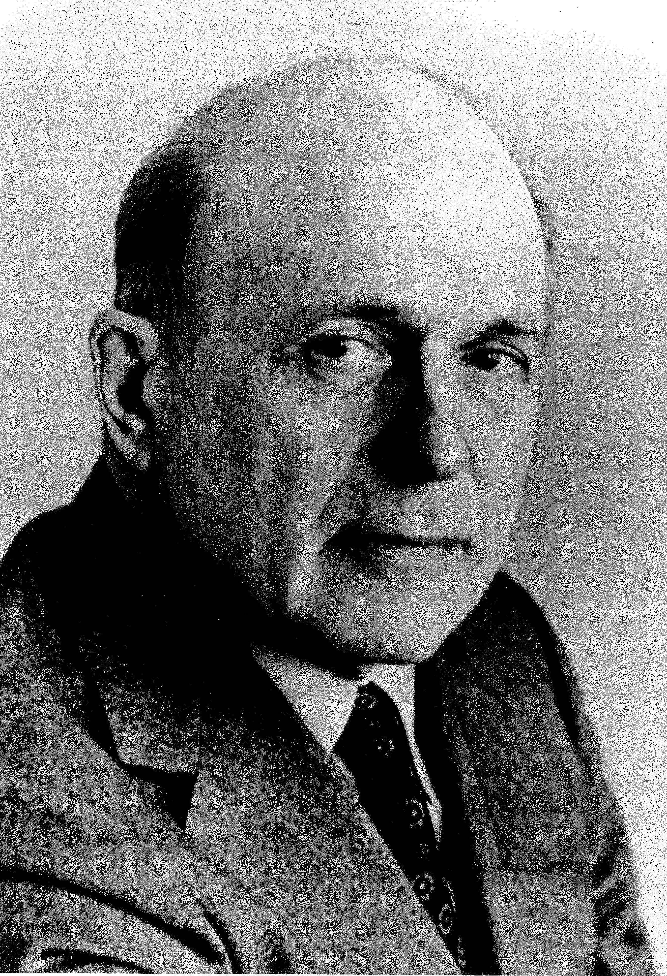
The purpose of The Gurin Forum is twofold: to honor Maurice Gurin, a foremost leader and thinker who impacted the evolution of philanthropy, and to bring attention to timely issues facing the sector. The periodic forums are designed to stimulate dialogue, debate, research, and education.

Funding for the Gurin Forum is made possible through an endowment created primarily through the generosity of Mr. Gurin. Mr. Gurin was a past chair of the American Association of Fundraising Counsel (now the Giving Institute: Leading Consultants to Non-Profits) and one of the original incorporators of the American Association of Fundraising Counsel Trust for Philanthropy, now known as Giving USA FoundationTM.

Maurice Gilbert Gurin (1911-1990), was nearly 50 years old in 1959 when he made the career change from public relations to fundraising. Gurin incorporated new and innovative fundraising methods with more traditional techniques and in only 12 years rose from free-lancer fundraising to president of a fundraising firm with offices in New York, Philadelphia, and Los Angeles. He continued over the next 30 years to seek creative new answers to old questions, using imaginative new approaches to fundraising focused on individual client needs and making the fundraising plan fit the client rather than the client fit the fundraising plan.

– reprinted with permission from the Maurice Gurin Papers, Ruth Lilly Special Collections and Archives.

