
News Release
FOR IMMEDIATE RELEASE

Contact:
A. Bruce Crawley
Millennium 3 Management
Tel: 215-922-7184
Email: abcrawley@millennium3management.com

PK Financial Group, LLC Acquires West Insurance Group, One of the Nation’s Largest African- American-Owned Insurance Brokerages
Philadelphia, Pa, November 18, 2010 - PK Financial Group, LLC (http://www.pkfinancialgrp.com/), a Pennsylvania-based insurance and benefits company, based in Broomall, Pennsylvania, today announced that it has acquired the assets of West Insurance Group, one of the largest African-American-owned risk management, brokerage and financial services firms in the United States.
According to Samuel J. Patterson, CEO, and a principal owner of PK Financial, the West firm had been established in 1991, maintained offices in Boston, Chicago and Philadelphia, and had managed a portfolio with gross premiums written estimated at $120 million.
Established in 2009, PK Financial Group, also African-American-owned and licensed in 38 states across the country, maintains offices in Annapolis, MD and New Orleans, LA, in addition to Broomall.
Patterson said the West Insurance acquisition will enable PK Financial to significantly expand the company’s services to large, privately held and publicly traded corporations, to large not-for-profit firms and to faith-based institutions.
“With its deep reservoir of top-level industry talent and experience,” said Patterson, “PK Financial has established, in a relatively brief period of time, a strong, professional reputation in the industry. With the acquisition of West, we are, both, growing our portfolio substantially, and sending a clear message that we’re now positioned to compete with any insurance and benefits consultants in the nation.”
PK Financial's corporate and institutional client list includes Union Packaging, Veridyne and The Philadelphia Tribune, among others.
Offering a broad range of institutional and personal insurance and financial services, PK Financial provides homeowner’s, disability, medical, life and auto insurance through its long-standing relationships with a cross-section of the nation’s most significant underwriters.

-More-

PK Financial Acquires West Insurance Group/ Page 2 of 2

A significant majority of PK Financial’s equity is owned by Patterson and by his business partner, Cleosie Kirkland, who serves as the company’s president and chief operating officer. Prior to joining PK Financial, Kirkland had served as president of AV International, Inc., one of America’s largest minority-owned insurance brokerages.
Patterson and Kirkland first met when both were MBA students at the University of Pennsylvania’s Wharton School.

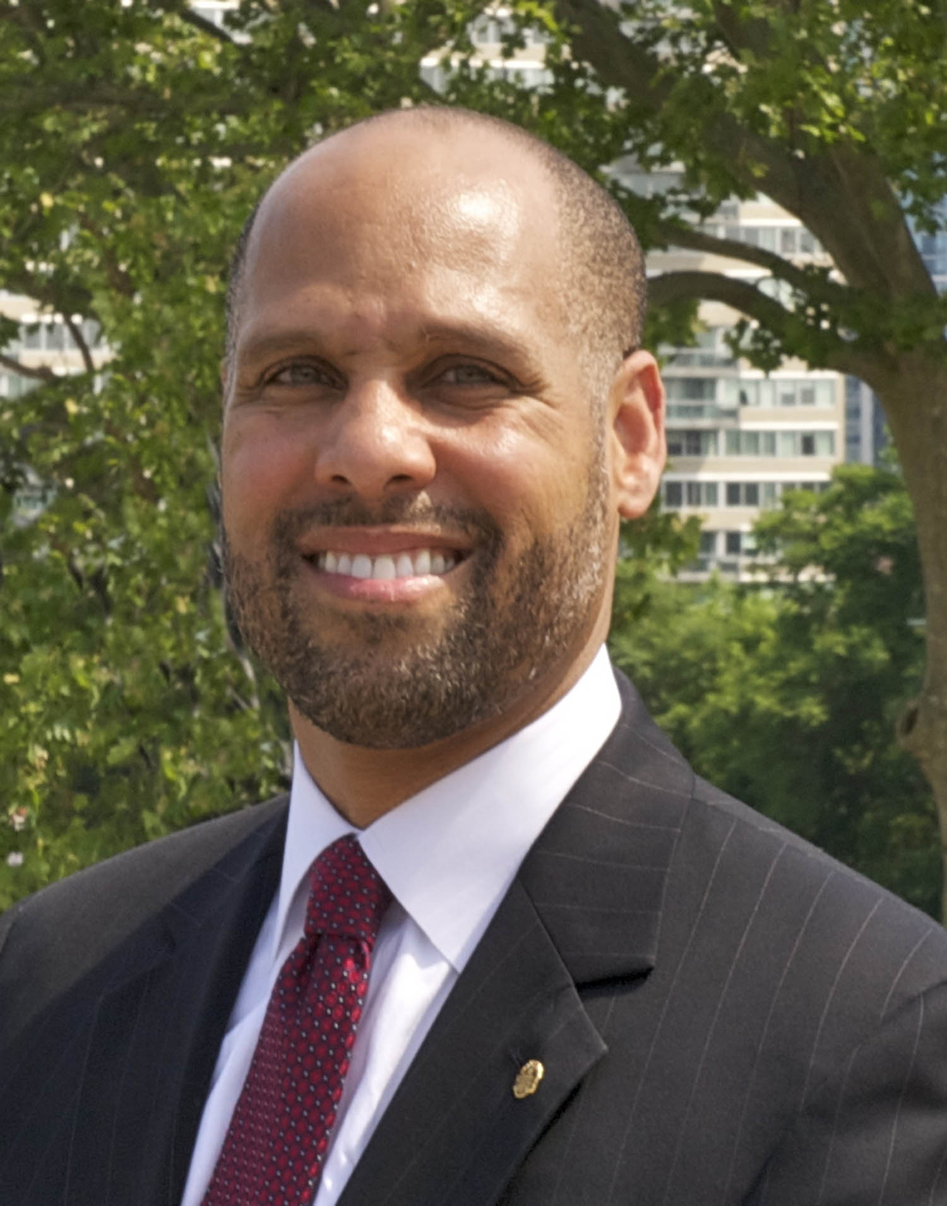
Samuel Patterson
CEO and a principal owner of PK Financial Group, LLC

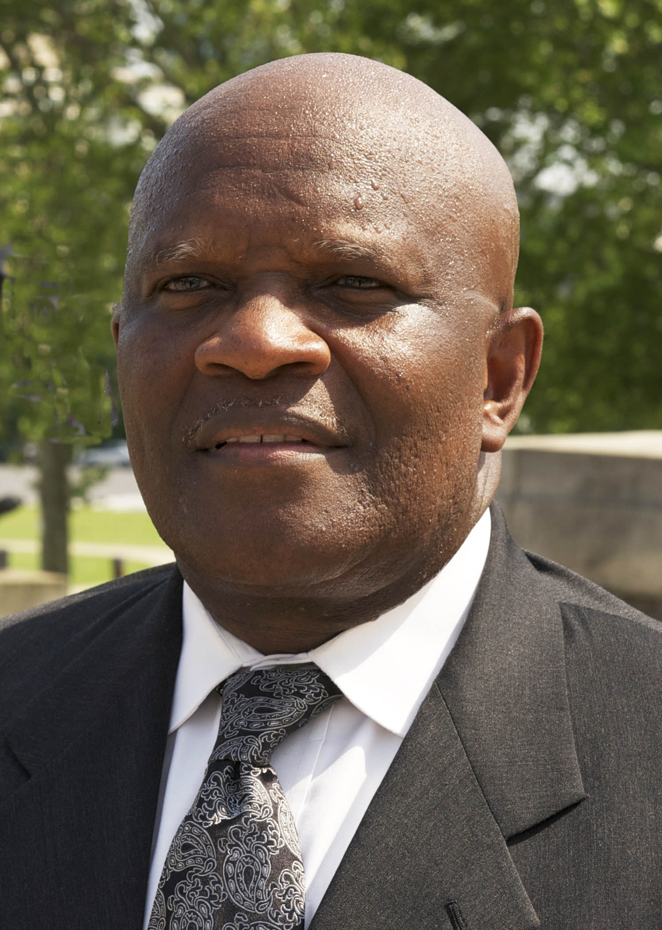
Cleosie Kirkland
President and Chief Operating Officer, PK Financial Group, LLC

###

