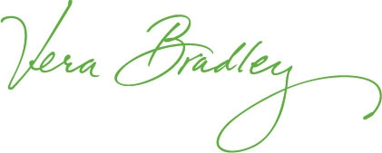

MEDIA RELEASE CONTACT:
Melissa Schenkel
mschenkel@verabradley.com
(260) 207-5176
m (260) 437-7797

VERA BRADLEY SPRING COLORS TO ARRIVE IN STORES AND ONLINE

Fort Wayne, Ind. (January 10, 2011) – Bold, bright colors bring in the New Year with Vera Bradley’s New Spring 2011 Season! Vera Bradley (Nasdaq: VRA), internationally known handbag, luggage, travel, eyewear and paper & gift designer, will introduce four new colors and 12 new styles in stores and online on Thursday, January 13.

New Colors:
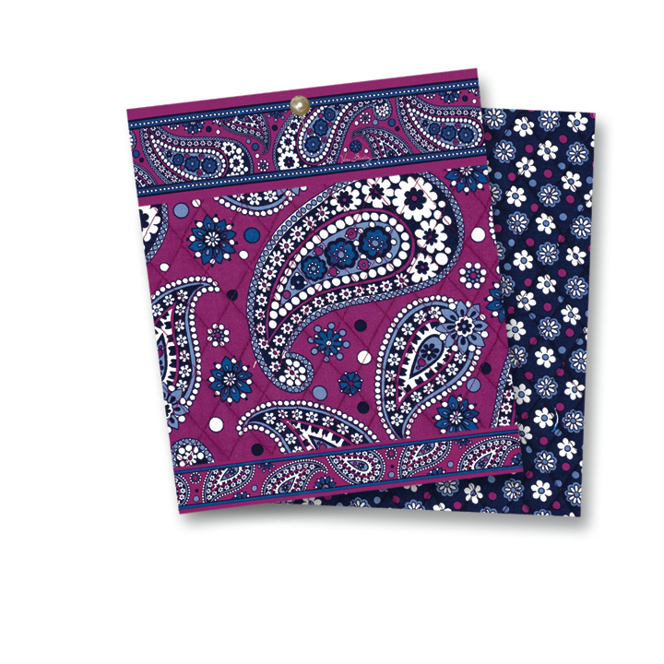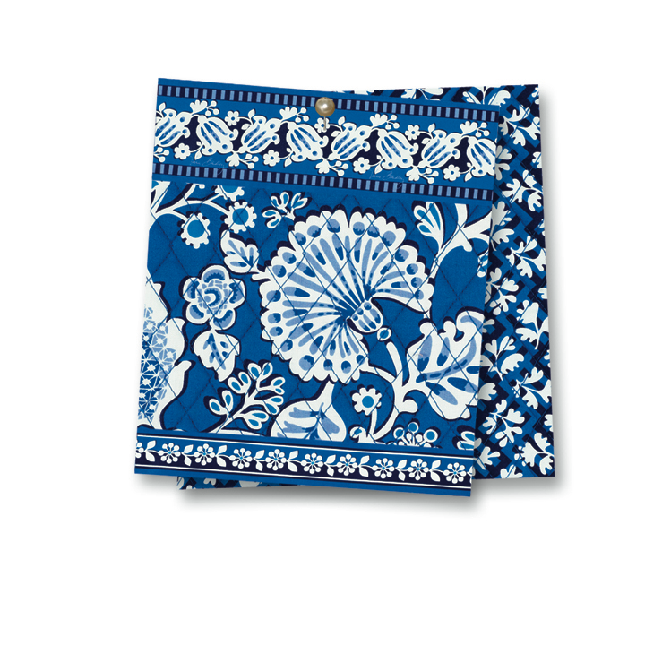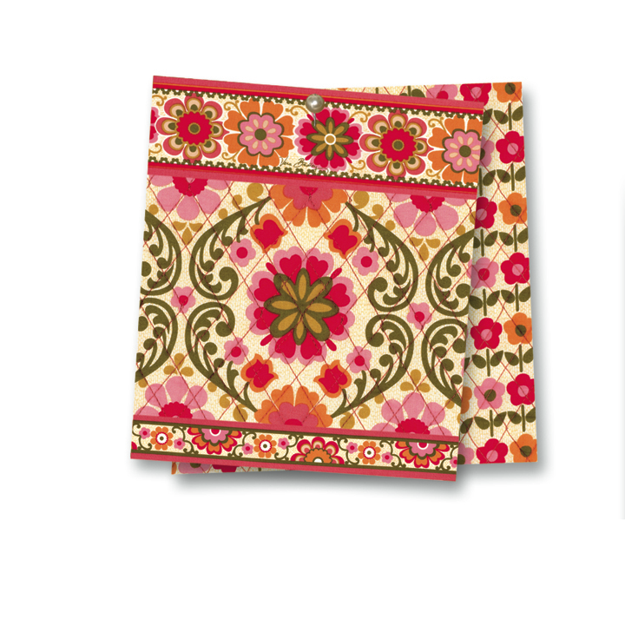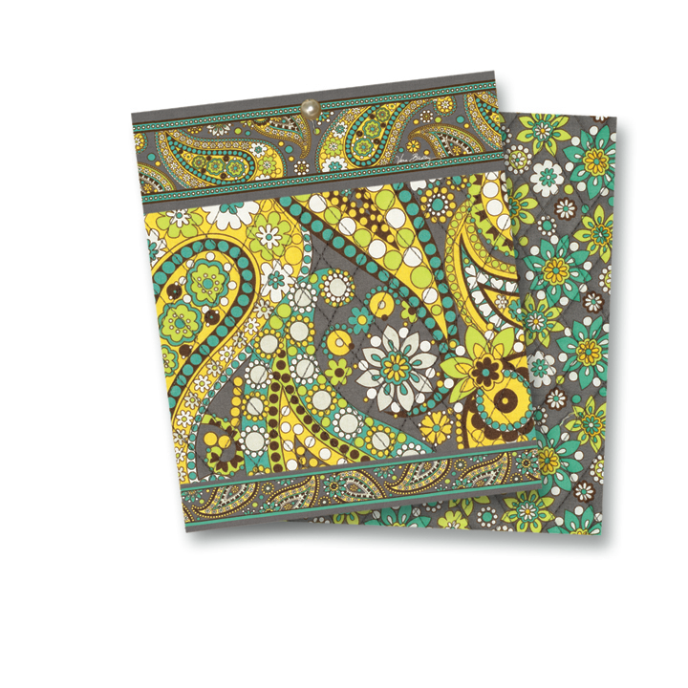
Boysenberry Blue Lagoon Folkloric Lemon Parfait

New styles include handbags, an E-Reader Sleeve, a Laptop Sleeve and many accessories.

Store visitors could become a Vera Bradley Star!
As part of the new Spring 2011 release, on Saturday, January 13 from Noon – 4 p.m. select Vera Bradley Stores across the nation will be asking visitors to film a 30-second Vera Bradley commercial that will be uploaded to YouTube, and a few lucky participants may be chosen to appear in an upcoming Vera Bradley catalog, video or advertising photo shoot! Learn more here: http://www.verabradley.com/assets/becolorful/index.html

About Vera Bradley: Friends Barbara Bradley Baekgaard and Patricia R. Miller founded Vera Bradley in 1982. Today, Vera Bradley is sold through 3,300 specialty stores as well as 39 Vera Bradley Stores nationwide. Vera Bradley accessories, handbags, travel and paper & gift items have recently been spotted on: Desperate Housewives, Brothers and Sisters, Entourage, Modern Family and in more than 20 feature-length films. Visit http://www.verabradley.com for a store near you or to learn more.

