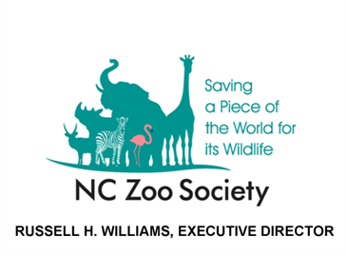
Contact:
Kerry Sparks
Director of Operations and Communication
NC Zoo Society
336.879.7285
ksparks@nczoo.com
www.nczoo.com

FOR IMMEDIATE RELEASE:
January 22, 2011

NC ZOO SOCIETY SEEN AS A “CLOSE FRIEND”
ASHEBORO, N.C. – NC Zoo Society members see their organization as a “close friend” or “an acquaintance I admire” with eighty-five percent of the NC Zoo Society members reporting a “very favorable” opinion of their member experience, compared to a zoo and aquarium benchmark of 72 percent. Those are among the findings of a recent research project of the Association of Zoos and Aquariums (AZA).
Members of the NC Zoo Society visit much less often than their big-city counterparts, but stay members longer and like their Society more. More than 24,000 individual interviews with supporters of 93 zoos and aquariums nationwide and in Canada pointed out that NC Zoo Society members report visiting 2.9 times annually compared to the 7.2 times reported by other zoo members. “This probably reflects the greater distance members of the state Zoo Society travel, compared to members of big-city zoos,” NC Zoo Society Executive Director Russ Williams speculates.
Interviewees were also asked which comparison best captures how they think about their member organization. The NC Zoo Society received 40 percent “friend” responses (compared to a benchmark 32 percent) and 58 percent “admired acquaintance” responses.
One benefit members specifically enjoy is the valuable reciprocal program the NC Zoo Society has established. In addition to unlimited admission to the NC Zoo for one year, members receive plus free or half-priced admission to over 150 AZA accredited zoos and aquariums across the country - including free admission to all three North Carolina aquariums and Sylvan Heights Waterfowl Park in Scotland Neck. The NC Zoo Society continues to add institutions to this list and in 2011 the reciprocal program added six new institutions from across the country and one in Mexico.
Members agree, NC Zoo Society membership offers more than a one-time visit to the Zoo.
The NC Zoo Society is an independent association of members committed to fostering enduring personal connections between people and nature. It supports the North Carolina Zoo and its projects that educate and inspire people about our natural environment. The Society, through the Zoo, conserves wildlife and wild places throughout the world, promotes scientific research and advocacy, encourages relationships with nature through outdoor recreation, and generates respect for animals and their welfare.
###

