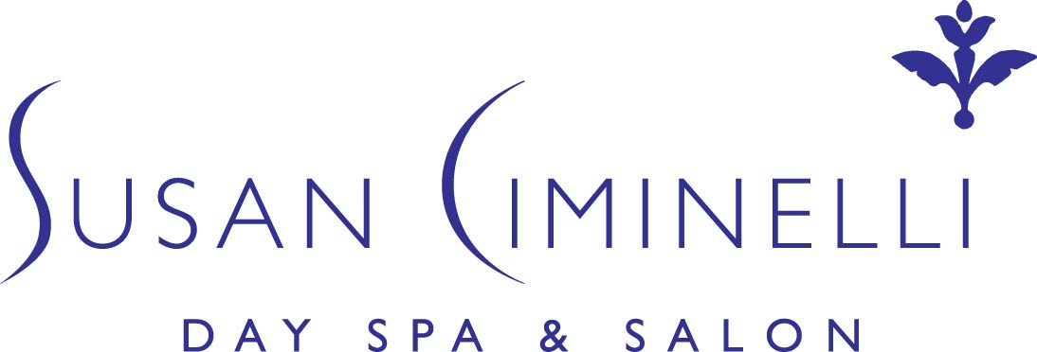

Celebrity Sightings

Susan has established a loyal customer base in New York, Los Angeles and London. Her treatments and products have become favorites among celebrities and socialites, including but not limited to:

Joanna Kerns Jennifer Lopez
Constance Marie Lopez Susan Lucci
Marla Maples Debbie Mazar
Paul McCartney Martine McCutcheon
Heather Mills Kate Moss
Karen Mulder Nancy Myers
Becki Newton Al Pacino
Kandice Pelletier Regis Philbin
Miuccia Prada Phylicia Rashad
Ariel Reid Lisa Rinna
Paulina Rubio Stephanie Seymour
Shakira Maria Shriver
Jamie Lynn Sigler Jessica Simpson
Kate Spade Mary Steenburgen
Martha Stewart Dita Von Teese
Christy Turlington Aisha Tyler
Tracey Ullman Amber Valetta
Steve Van Zandt Adrienne Vittadini
Deborah Voigt Sigourney Weaver
Steve Wynn Ashanti
Catherine Bach Anne Bass
Ellen Barkin Kristen Bell
Amanda Bynes Candice Bergen
David Boreanaz Naomi Campbell
Sean Combs Cindy Crawford
John Cusak Sophie Dahl
Robert DeNiro Janice Dickinson
Linda Evangelista Joey Fatone
Frederic Fekkai America Ferrera
Tina Fey Nina Griscom
Pia Getty Melanie Griffith
Lizzie Grubman Marvin Hamlisch
Patti Hansen Marcia Gay Harden
Deborah Harry Mariska Hargitay
Teri Hatcher Salma Hayek
Tommy Hilfiger Dustin Hoffman
Jennifer Holiday Vanessa Hudgens
Felicity Huffman Janet Jackson
Don Johnson Wynonna Judd

