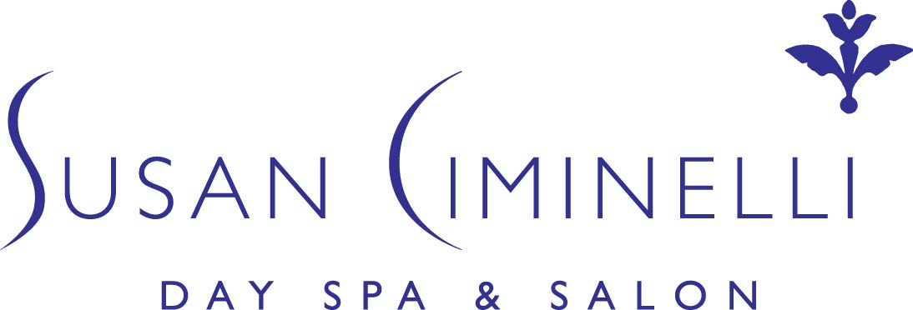

Fact Sheet

Overview: Bicoastal Day Spas in New York City and Montecito, CA, featuring the ultimate in body treatments, services, specialized skin and makeup products, teas and supplements.

Proprietor: Susan Ciminelli, author of “The Ciminelli Solution: A 7-Day Plan for Radiant Skin” and renowned holistic skin care expert.

Address: Susan Ciminelli Day Spa & Salon
120 East 56th Street, 2nd Floor
New York, NY 10022

The Private Sanctuary in Montecito Private Sanctuary in Greenwich
1280 Coast Village Circle 116 Mason Street
Suite C Greenwich, Ct 06830
Montecito, CA 93108

Four Seasons Biltmore
1260 Channel Drive
Santa Barbara, CA 93108

Telephone: 1-888-332-9772
212-750-4441 (NY)
805-695-8448 (Montecito, CA)

Fax: 212-750-4492 (NY)

Website: www.SusanCiminelli.com

Services: An array of services including facials, photofacials, body scrubs, body wraps, massages, manicures/pedicures, full service hair salon, nutritional consultations, packages, customized treatments and gift certificates.

Products: An extensive line of cleansers, moisturizers, creams, masks, serums, make-up, teas, candles, essential oils, seawaters and other supplements.

Price Range: Services: $25 - $450
Products: $12 - $300

Hours: New York Locale
M-F 9:00 am - 7:00 pm
Sat. 9:00 am – 6:30 pm
Sun. 12:00 pm – 6:00 pm
Montecito, CA & Greenwich, CT Locale : By appointment only

Media Contact: Dorothy Lysek
212- 750-4441
dlysek@susanciminelli.com

