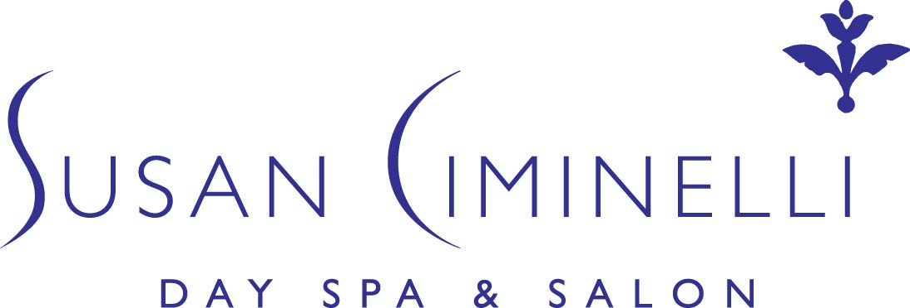

Testimonials:

“I work in harsh, cold environments. The Calming Cream I bought from the Susan Ciminelli line for my face was so fantastic. I started to use it on my hands and the cracks healed within days and my face never felt so good. There has never been a product more powerful than this. I think I’ve tried them all.” -C.C.

“I am a bit of a beauty junkie so for me to stay with a line as many years as I have with your products is saying quite a lot about the amazing results I get!! I also am a frequent client at the spa. Your facials are the best...your hands are truly gifted. Thanks so much!” –April

“In our medical office we have access to doctors only, high potency skin care products, yet I find Susan Ciminelli's skin care line to be most effective and compatible with the health of my skin. I especially love the Restorative Red Marine Algae Cream.” -K.R.

“I live in the Washington, DC, greater metro area, and just ordered some of your products from your spa at Bergdorf's. This morning I tried your Algae Deep Cleanser, Marine Lotion, and Super Hydrating Cream. I am still in disbelief about how quickly the products worked and how radiant my skin looks (I keep walking back to the mirror to look at myself). I am turning 60 on August 1st and hope to come to your spa at Bergdorf's for a special treat.” -Sincerely, N.B.

“I enjoyed watching you on the Martha Stewart Show today. What amazing skin you have! I got on your site and found it amazing. I am going to order your book! My skin and stress levels are crazy! My daughter's wedding is coming up in April and I am hoping to use your book to help me look younger and relaxed! Thank you for sharing your information with all of us!” -V.E.

“My husband, who is a physician, and myself are so impressed about how my skin looks after using your products. I have always had nice skin and I've had to work at it. I am 66 years old and hardly have a wrinkle, but with your products my skin just glowed. I do not have your book but I would like it very much. I loved talking to you yesterday and today; it has been a pleasure. Thank you.” -C.W.

“I last visited you at BG a few years back. I noticed my testimonial is still featured on your website, and I have never topped my facial experience with you (especially the version with the seaweed wrap and reflexology happening at the same time). I live in Wrightsville Beach, NC now and look forward to reconnecting with you and your products. Your book is great too!” - Amy, NC

“It feels like I am at a spa when I'm using your products. The scents and the way the products feel is truly invigorating and rejuvenating. My skin feels so much softer and more hydrated -thank you!” –TL

“I felt like Sleeping Beauty this am. Very rested and feeling great as a result of the wonderful facial, massage and products. Thank you ever so much.” - Debra Shriver, CCO Hearst Corp.

“I am a new customer and have been using several of your products for a couple of weeks now - boy, what an amazing difference in my skin! I didn't know what clean, hydrated skin was until now. I have ordered your book and am anxious to receive it. Thank you for reading this and thank you for making a difference in my 65 year old skin.” R.A.V., CA

“My favorite is the Susan Ciminelli Signature Facial with the plum peel and the foot massage at the same time! Heaven beyond!!!!!” - Lisa Rinna.

“This is my favorite spa. When you enter, it is serene and you are greeted quickly with a smile. The specialist greeted me kindly and professionally. She led me into the treatment room and gave me privacy. The treatment was great and soothing. The specialist explained what she wanted to do and why. She asked what kind of products I used and suggested others, but didn't put my choices down. This treatment was relaxing and effective. My skin was glowing and didn't break out. Friends stopped me and remarked on how good I looked. “ –D.L. NY

“I have tried every expensive product on the market both in America and in France. The only product that makes my skin feel dewy, soft and look radiant is Susan Ciminelli. Especially when I use it the way it it is supposed to be used with the essential oils, seawater, marine lotion followed by her creams. I only get compliments on my skin whenever I am using Susan Ciminelli.” -Jessica

“I have suffered with acne all my teenage and early adult life. When I discovered "The Ciminelli Solution, a 7 day Plan for Radiant Skin" and started using the acne kit that I bought online, my skin cleared up and I am a new person. My deep scars are still there but my skin is radiant, it has a glow, and it is pimple free. Thank you Susan, you are a genius.” C.B. NY

“Dear Susan - Never again will I allow myself to run out of your products. Every day my skin gets dryer and dryer while substituting with other product lines that just do not compare. I have tried them all. Not any longer. Your products, Susan, are the only ones that continue to deliver what they claim to. The Red Marine Algae Cream is just what my skin needs in this time of high stress. It calms me down and melts into my skin and vanishes lines immediately. A true Miracle Cream... Thank you, Susan, for remaining passionate about what you do. Your clients benefit.” –D.B. FL

