ENCINITAS, CA—April 20, 2011---NEW EMBEDDED TECHNOLOGY is pleased to announce the A-Brain mobile compact computer baseboard compatible with COM Express compact size standard computer modules. New Embedded Technology designed this unit specifically for such rugged mobile computer applications such as Androids, Robots, UAV and wearable computers where extended temperature, shock and vibration were a critical factor of the environment. It is also excellent for fixed outdoor settings requiring a small size and in an environment that is not friendly to regular computers such as security monitoring, RFID control, green energy data acquisition, outdoor Kiosk, and harsh external research data collection. The A-Brain features a baseboard only 95mm square and includes on the top I/O side two low profile RJ45 Gigabit LAN connectors, Mini-PCIe I/O board socket with hard screw/nut mounting and standard Type II CF IDE Flash for diskless booting. Also available are two SATA ports with one standard and one locking connector. Included on multiple locking connectors are eight USB 2.0 ports, Four RS-232 ports, VGA, 8 digitally buffered GPIO, and RESET/POWER/External LEDs multi-use connection. The fourth serial port can also become a RS-422/485 interface as a factory option.

The A-Brain is unique due to the capability of utilizing any embedded COM Express CPU module that meets the PCMIG standard for its processing while providing additional I/O expansion particular to the mobile and military market. The unit is ideal when used with a passive cooling plate with Compact size 95mm by 95mm SBC modules. Whether the application requires a high-end dual core processor, a low power Intel Atom processor or an Arm processor, New Embedded Technology can provide a system solution to match a specific requirement. Power can be provided to the A-Brain through a small locking 12-pin power connector with a cable adapter available, able to be connected to any ATX power supply. New Embedded Technology can also provide internal DC-DC mounted ATX power supplies, the size of a quarter coin, with models available to be powered by 12V regulated, 24-28V and 12V battery power sources and up to 120W of ATX output.

Key features of the A-Brain board include:

- COM Express standard baseboard
- Small size only 95mm by 95mm (3.74" by 3.74")
- 1X or USB MINI-PCIe I/O expansion
- Two low profile rear-mounted RJ45 10/100/1000 Ethernet LAN ports
- Eight USB 2.0 ports and Four RS-232 COM ports(factory RS-422/485 option)
- Two SATA ports and a Type II Compact Flash IDE socket support
- VGA, RESET, and Power connections with ATX power support
- Rugged mil spec locking I/O connectors(vibration)
- Extended temperature operation standard (-40C to 85C)

The A-Brain is the platform of choice for high performance mobile applications requiring both COTS and long life. This product life cycle is designed to last longer than most COM Express standard modules with a minimum
5-year life span. By combining the benefits of both the COM Express and Laptop MINI-PCIe standards, a more cost effective time to market is achieved no matter what the quantity. Large quantity OEMs can use the wide range of COTS I/O of USB, RS-232 and MINI-PCIe as well as a large array of COM Express CPU modules for simple and easy prototyping and evaluation purposes. For embedded developers designing systems which may require smaller quantities, the A-Brain is still the perfect solution. For your next outdoor or mobile computer think Android Brain or A-Brain.

For additional information, readers can view a data sheet for the A-Brain by visiting http://www.newembedded.com/A-Brain.htm

About NEW EMBEDDED TECHNOLOGY
New Embedded Technology is a futuristic oriented technology company in the embedded computing market. Our particular focus is rugged, power saving and space restricted computers capable of both networking and I/O data acquisition and control. Our standard products are designed to operate at wider extended temperature ranges and higher levels of shock and vibration as a standard COTS product. In addition to standard COTS products, New Embedded Technology has excellent customer-partnered custom Hardware and Software design Engineering Services. New Embedded Technology is made up of an advanced staff of individuals with a combined experience of over a hundred years working in the embedded computing industry.

Price: Prices range from $249 to $569 depending on features and options
Please inquire for OEM and volume pricing

Availability: Now

Delivery: Stock to two weeks ARO

For Further Information, Contact:

Stephen Newbegin
New Embedded Technology
204 N El Camino Real, Suite E-440
Encinitas, CA 92024
Tel: 760-845-1699
Email: contact@newembedded.com
URL: http://www.newembedded.com/

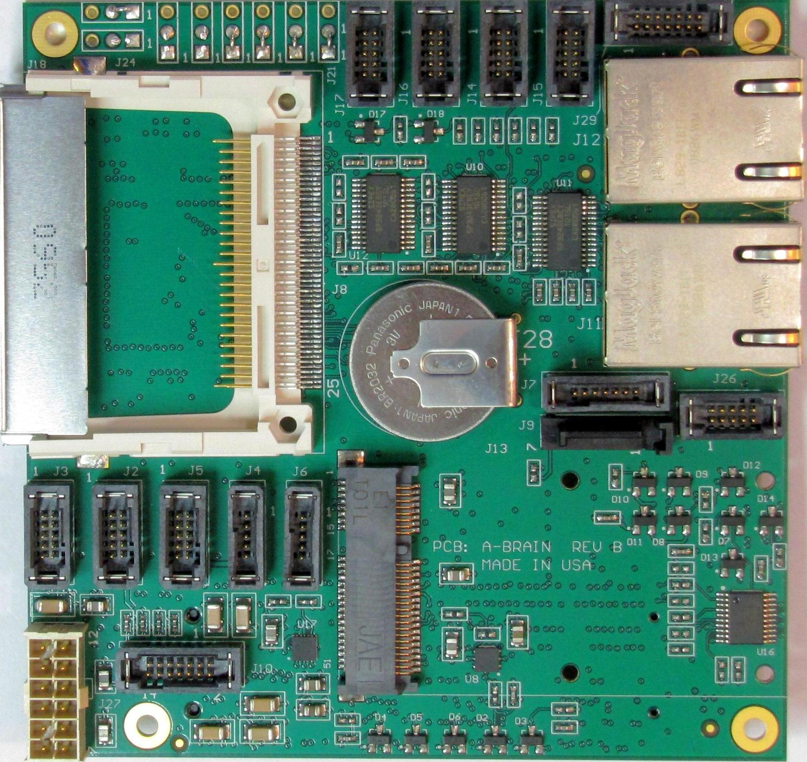

A-Brain Compact COM EXPRESS baseboard for
rugged computer mobile and outdoor I/O applications


New
EMBEDDED TECHNOLOGY

