Catapult the Cow
By: Gary Conner

Talk about being in the right place at the right time!
In 1983 I joined a precision sheet metal company just as the high tech heyday was beginning. Our customers soon began asking the company I worked for to deliver product using a program they called “JIT” (Just in Time)
We didn’t know anything about JIT, but that didn’t stop us from trying.
We read books; went to seminars, and even took a trip to Japan to visit twenty different companies who were trying to emulate what Toyota was doing.
After years of struggling we finally got it right. Our company was even profiled in FMA magazines.
It was difficult because we were a job shop. There were plenty of books about how large OEM (original equipment manufacturers) like Honda, Harley Davidson, John Deere and other might adopt these techniques, but little was written about how to apply these tools in a make to order environment.
In 2001 I wrote about our journey in the book “Lean Manufacturing for the Small Shop”. That text later won the Shingo Prize, something I am very proud of.
Since 1996 I have had the privilege of consulting to over 150 companies; the majority being job shops. I’ve facilitated over 500 kaizen (continuous improvement) events, and worked with tens of thousands of unforgettable people.
I have often thought that a book of stories (case studies) from some of these events would serve to enthuse and encourage people who may be just starting their journey toward a goal of “world class” performance.
Therefore, I have written a new book (my fifth). It is titled “Catapult the Cow”. Here are a few excerpts.
In Monty Python’s movie Search for the Holy Grail the inhabitants of a castle catapult a cow toward an invading military force. Most people are unaware that this is based on an actual event. In 1334, Margartea Maultasch (of Tyrol) had her army invade the small kingdom in Carinthia.
Illustration 1.1 Margartea Maultasch Source: www.wikipedia.com
Because of the terrain, a traditional attack of the castle was out of the question. The invaders decided to starve out the inhabitants.
The situation inside the castle was desperate, they were soon down to their last two bags of grain, and one skinny cow. The commander of the castle took unexpected action. He butchered the cow, filled it with the grain, and catapulted both over the wall. The enemy interpreted this as a clear message that starving them out was useless; obviously they had food to waste. They invaders picked up and moved on.
Illustration 1.2 Hochosterwitz Source: www.wikipedia.com
What does this have to do with business in America? We have recently seen millions of US jobs lost. There are other countries who would like to starve us out.
We have had thirty years to learn from Toyota. Some stubbornly refuse to acknowledge that there could be a better way; taking the stance “Our process was good enough for Dad and Granddad; it’s good enough for me!”
We may have to catapult the cow; try something difficult and unexpected in order to get the result we want.
Not to suggest throwing anyone’s company over the wall; but transforming to the lean approach.
Instead of trying to completely transform your company in one motion. We suggest utilizing the concept of a model line to transform a percentage of the business. Select one value stream or product family. Drill to the “bedrock” by firmly and completely applying the appropriate lean tools. Quantify the benefits, justify and fund future events. In doing so, you will overcome resistance and be able to more quickly spread best practices and lessons learned to additional other value streams.
You will need encouragement from time to time. Transforming a company is hard work. My new book was written with the idea that we all need encouragement to stay on the path.
Forty stories are included; case studies and examples of individuals and companies doing the hard thing; the unexpected thing.
It will take 100% participation and effort from everyone on your team. I hope these stories will help.

Case Study #1

Kurt’s Outline
An Oregon based machine shop called requesting help with 5-S training (a technique of workspace organization). I took a tour of their plant, we identified a target area; a tool room shared by thirty five machinists.
The tool room manager was a rather diminutive gentleman of advancing years. His beard, hat and clothing indicated that he was of Pennsylvania Dutch heritage.
The plan was to train about a dozen people the first day, and then split off with a smaller team of five kaizen (a term meaning continuous improvement) team members to carry out the project. We planned to gather all those affected by the kaizen on Friday afternoon; providing them a report explaining the findings of the team, recommendations, costs and benefits analysis.
As I awaited the final member of the team (the tool room supervisor), the group was getting anxious. I asked “Should we wait for Kurt?”
They responded: “Oh, Kurt won’t be on the kaizen event.”
My surprise must have been apparent to the group.
The team leader provided an explanation. “Kurt is two years away from retirement. He said that we could do anything we want to in the tool room, but he just wants to be left out of this event.”
I did not find it encouraging; to realize on day one of the event that the ‘Owner’ of the process was obviously so resistant.
The tool room occupied an area roughly 900 square feet. There were seven tool cabinets each with ten or twelve drawers; full of mill and lathe tooling. There may have been a sense of order Kurt’s mind, but no one else could put a finger on it. If a machinist needed to retrieve a tool and Kurt happened to be unavailable, it was anyone’s guess where the required tool might be stored.
When machinists were finished with one job, they would make their way to the tool room, retrieving paperwork, tooling and equipment for their next job. They would drop off tooling from the previous job on any open surface. Every table, desk, cart, shelf and drawer was covered in litter, broken tools, new tools, tools needing repair, sample parts, fixtures, clamps and while I never found out why; a chain saw blade.
We certainly had our work cut out for us especially considering Kurt’s lack of participation.
Tuesday was spent on the first of the five “S’s”; Sort. We sorted out everything deemed as unnecessary to the day to day operation of the tool room. Using the ‘red-tag’ process we identified and dispositioned hundreds of items (including the chain saw blade).
By mid week we had identified the items that were required, brainstormed a filing system for the storage, replenishment and retrieval of tooling. We Straightened the area so that anyone could find anything within thirty seconds.

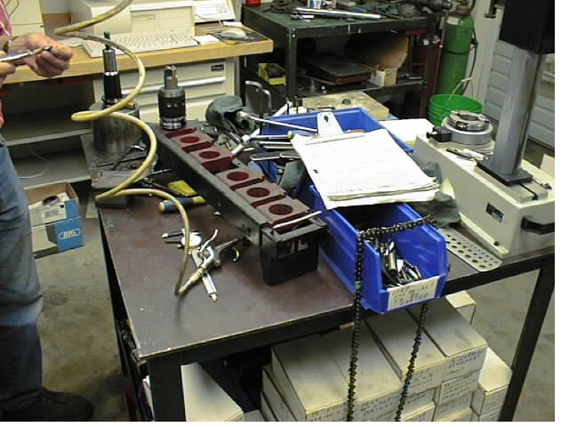
Illustration 2.1 Before Condition in Machine Shop Tool Room
We cleaned or Shined all surfaces and equipment. We built visual indicators to identify tooling location and storage areas for consumable items like sandpaper and cutting fluids. This satisfied the Standardization requirement of the 5-S program. Now anyone could find a tool, not just Kurt.
The kaizen team developed an audit program to insure that the last S in the 5-S program: Sustainment would be possible and expected.
Despite the tool room manager’s lack of participation, we were successful in accomplishing our team objectives by Noon on Friday.
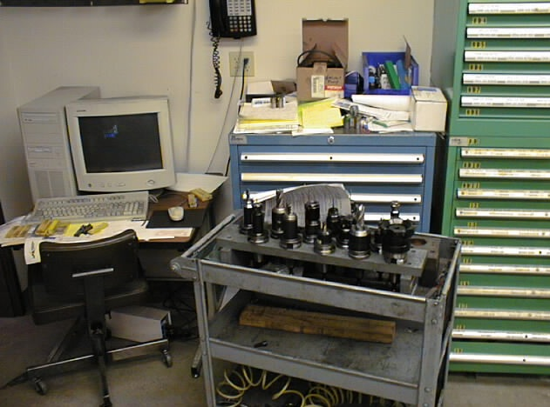
Illustration 2.2 Before Condition in Machine Shop Tool Room

The only thing left to do was to develop and deliver the end of week kaizen presentation.
As the team was gathering up our kaizen tools, Kurt approached me. I had not seen or heard much from Kurt all week, so it was a bit surprising to see him standing there holding out his hand.
He asked “Can I borrow your blue tape?”

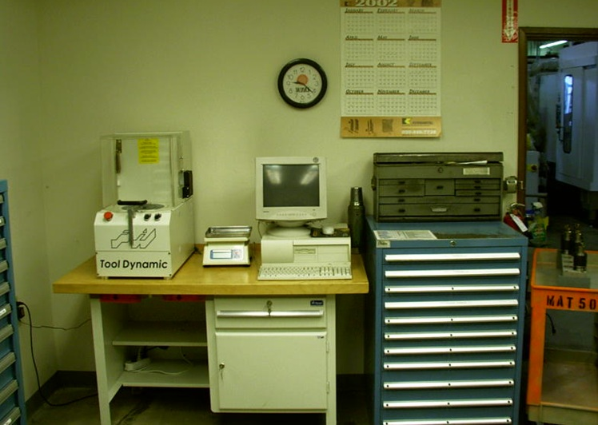
Illustration 2.3 After Condition in Machine Shop Tool Room
I pulled the roll of blue masking tape back out of the kaizen tool box.
I handed the tape over to Kurt with a self satisfied smile; thinking to myself, “Maybe Kurt is finally getting it!”
The kaizen team celebrated with a pizza while we generated the presentation that we would deliver to the entire shop after lunch.
The shop intercom summoned everyone to the tool room precisely at 1:00 PM. The kaizen team gave one last nervous look to each other and we picked up easel, flip charts and other presentation materials; heading downstairs to the tool room.
As we approached the completely transformed tool room, now with standing room only for 35 machinists, I couldn’t help but notice that everyone’s gaze seemed completely transfixed on the concrete floor before them.
As we parted the crowd to set up our flip charts, the subject of their attention became apparent. In our absence, Kurt had used the blue masking tape to draw the outline of a body on the concrete floor.
It looked like an outline of Kurt’s body.
Illustration 2.4 Chalk outline (similar to Kurt’s tape outline)
I thought to myself “Oh, no! What is Kurt up to? This is going to ruin everything.”
“No!” I silently shook it off, “I am not going to let this distract from the great work that this kaizen team has just accomplished. Just don’t look directly at it!” The team followed my lead, and we just ignored the blue image on the floor.
The presentation took about fifteen minutes. I then asked if anyone had anything to add, questions, or comments.
Wouldn’t you know it? Kurt was standing in the back of the room with his arm in the air.
I took a deep breath, smiled my most convincing smile and invited Kurt’s comment. He stepped to the front of the room right in front of our flip chart. He silently stared at the before and after photos of his tool room. He then turned back to the audience of machinists and said: “I was not happy about this event in my area. But…now I see the results” pointing to the photographs “This is going to make everyone’s job easier, including mine.”
He paused, “And if anyone ever comes in here and makes my tool-room look like this again!” He pointed to a before picture…then…you will look like this!” Swinging his arm toward the tape outline sprawled on the floor.
Everyone broke into a nervous laugh. I breathed a sigh of relief.
In the end I think Kurt did get it. He realized that the kaizen process made his working life better. That’s exactly what kaizen, and 5-S or any world class technique should do; it should make people’s lives better.
When I showed up, Kurt’s manager had informed me that Kurt was two years away from retirement, and couldn’t wait to leave.
I was back four years later, and Kurt was still there; happy and healthy. Kurt had sustained the transformed tool room’s 5-S conditions better than anyone I had worked with to that point in my career.
Obviously, everyone involved had to participate if sustainment was going to have a chance.
This company; and Kurt continue to serve as an example for all of us.

Case Study #2

“Have a nice day”

My first visit to DEP was to perform an assessment, and offer suggestions to their management team about adopting Lean manufacturing within their ‘lost wax investment casting’ business.
If you have never been inside a lost wax casting plant, you would be amazed at the blend of high technology and what I can only describe as brute force manufacturing.
They start with small pellets of wax which they melt and force into a mold. This molded wax will later be melted away to provide a ‘cavity’ in which molten metal will be poured; to become an artificial knee, replacement hip or jet engine component. A number wax pieces are precisely positioned together onto a larger mold.
They then dip the entire mold; now about the size of a wheel off your passenger car into a vat of liquid ceramic; next a robot manipulates the entire mold under a waterfall of sand. This builds up a crust that is dried for a number of hours. The process of dipping and applying sand is repeated up to ten times.
In one room of their plant products are carefully X-rayed. On the other side of the wall, teams of three men; looking more like space men walk around in shimmering silver suits designed to protect them from the heat of 2500 degree gas fired ovens. They retrieve molds and transfer them into a shallow pit of sand; quickly pouring a crucible of molten cobalt into the mold.
My first experience and visit to this casting plant was an exciting one, and a bit scary as glowing bits of molten material rained down around us during our tour of the casting department.
It was equally surprising to sit in the General Managers office and listen to the very ‘prescriptive’ nature of their lean manufacturing vision. I believe his exact words were: “It seems like everything we’ve read about lean manufacturing has to do with moving equipment around into physical ‘cells’. We are not going to do that.”
He seemed to look at me as if waiting for some kind of reaction. Then he continued. “We are not going to put a 2,500 degree pre-heating oven next to a wax press, and we are not going to drop a half-million dollar X-ray machine into a dirty investing department where sand is being blown around by hurricane force drying fans.” He squinting a little, seeming to survey my facial expression for the slightest hint of disagreement. He leaned forward in his chair, and as if preparing to dismiss me, he summarized.
“So…” pause “…we’d like to take a shot lean manufacturing but we are not Toyota. If your solution involves moving equipment; then it has been very nice to meet you!”
I was willing to give it a try, even with the mandate that no equipment would be moved.
Their current state was providing a 41 day lead time. At one hundred molds per day that equated to 4100 molds in process, with a sales value of over $1,000 per mold, they had $4,100,000 tied up in ‘work-in-process’ inventory.
At the end of the event we had reduced lead time from 41 days to just over 12. Their ‘in-plant’ process time could now be measured in hours rather than in weeks (parts still had to be shipped to the mid-west for heat treating; a seven day process).
I went on to work with other clients and felt good about the improvements. About six months later I received a phone call from the General Manager.
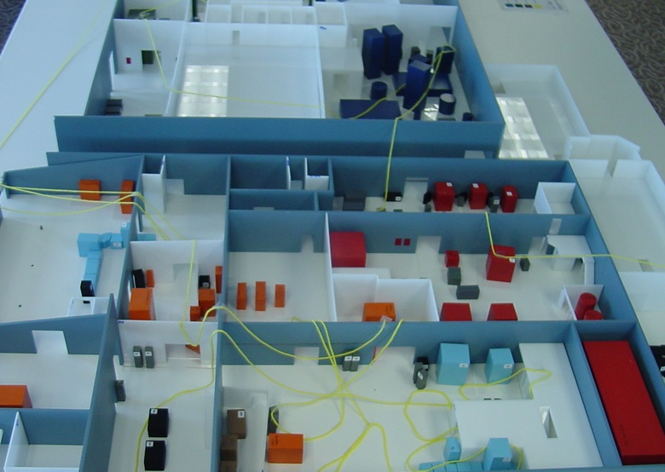
Illustration 3.1 Before condition plant layout (spaghetti diagram)
After exchanged pleasantries, he stammered a little “You know…remember when…You know how we got rid of all that inventory?” He was searching for the right words “Well…all that space that used to be filled up with inventory…it’s all empty space now.” He paused “We can’t keep moving this material so far between processes.”
Finally he got to the point “We need to move the furniture.” I tried not to smile, even though I knew he couldn’t see me. He and his team had finally determined that moving the equipment was possible (and necessary) given their improved ‘lean’ processes. Again I was invited to assist them in achieving their next level of improvement toward their goal of world class status.
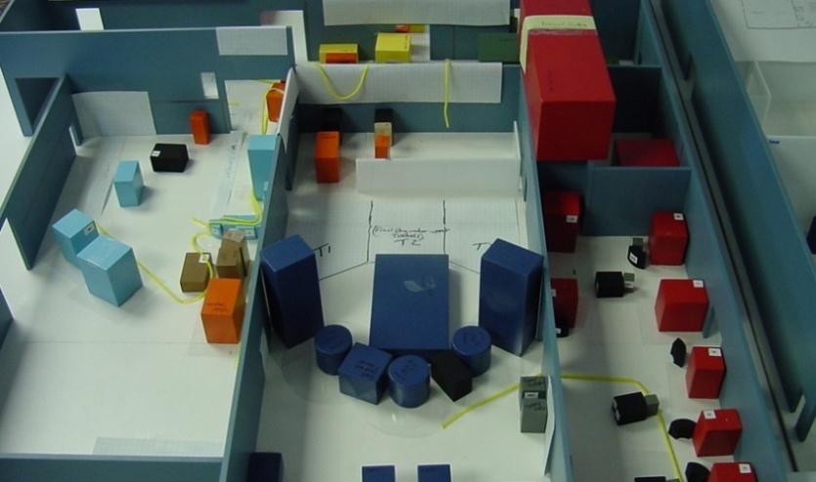
Illustration 3.2 After condition plant layout (spaghetti diagram)
We developed a visual representation (spaghetti diagram) of the product flow for each value stream by overlaying yarn on a three dimensional scale model of their plant. The result was a continuous length of yarn 112 feet long. Each inch of yarn represented 12 feet; a total travel distance of 16,000 feet per mold. After the project, the new layout resulted in a yarn length of only 6 feet; less than 900 feet of travel distance!
The last time I visited the General Manager he walked me over to a framed letter on the wall of his office. He waited while I read it. It was from their largest customer. In so many words, it read; “If you keep doing what you are doing, we have no choice but to buy from you!” Can you imagine a buyer writing such a letter to their supplier?
There was a condition though, “If you keep doing what you are doing…” What they have been doing is cutting lead time by nearly 75%, being able to improve costs because they have eliminated nearly $3 million dollars of inventory, they have improved quality because if they have reason to suspect that a quality problem has made its’ way into their value stream, there are only 1,200 potential suspect molds in process instead of the previous number of 4,100.
All these factors make it very difficult for the customer to go anywhere else to get the same level of performance in Quality, Cost and Delivery.

Case Study #3

Solutions are the Children of Desperation

This story comes from a job shop near Las Vegas. The client and I selected a product family to use as a model line; it equated to about 40% of their business.
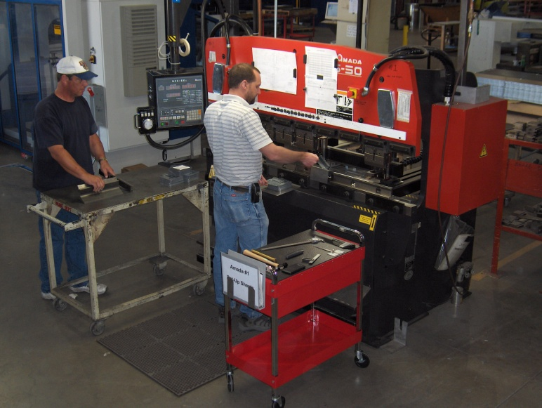
Illustration 41.1 Press brake
They had eleven press brakes similar to the one pictured here. Value Stream Map analysis indicated that the model line would require six such machines to sustain the current sales demand. During our kaizen report, the management team bluntly said we could have only four.
The disbelief must have been apparent on my face. I repeated the team’s recommendation, “At the current takt time, and with the idea of minimizing overtime, the data shows that we actually need 6.2 machines. We think we can improve scheduling and set-ups in order to maintain on time delivery with just six machines.”
Without batting an eye, and without even looking up, the President played with his blackberry and repeated his earlier comment “You can have four.”
The team schlepped back to the kaizen war room; spirits dragging.
But how on earth were we going to get six machine’s worth of work out of four?
The team was looking to me for an answer. I didn’t have one. We sat in silence for a minute.
Then one of the kaizen team offered a comment simply vocalizing our hopeless situation. “The only way to the work of six machines with four is to completely eliminate set-up!”
“Hold on now…” I said “How many parts; and how many set-ups are we talking about?” We had the value stream map hanging on the wall of the kaizen room along with the part prints.
“About 80 part types, and four different material thicknesses.” Came the answer.
“So, if we are limited to only four machines; and if each machine could do 25% (twenty of the eighty part types), is it possible to design a set-up for each machine that would allow an operator to do any of the twenty part types on demand without a set-up?”
“That would be a stupid looking set-up” someone responded. “You would have to mix tooling. Straight punches and dies, gooseneck tooling, reversed and standard all in the same set-up.”
The team looked at each other in silence for a moment. “So you are saying that it might be possible?” I queried.
“It may require buying a few duplicated tools…but…yeah, it might work.”
“How do we test it?” I asked
“Well, we have to sort the parts into four piles.” The team was now on its feet, with renewed energy. They pulled the prints off the wall and within fifteen minutes had categorized the prints, determining that similar bend features could be done together on certain machines and with certain tool configurations.
We set up a test and within one day the operators had developed four distinct (albeit “stupid” looking) set-ups. They had found a way to process all the part types with virtually no set-up.
Having this kind of breakthrough would not have been possible if management had not challenged the team to the very edge of impossibility.
They saw a 33% capacity improvement, a 33% reduction in required floor space, a $200,000 cost avoidance (the cost of two new machines) and a $60,000 ongoing labor cost reduction (annually).
The results were possible because; the team never gave up; we were willing to listen to every idea and comment. Even those expressed out of a sense of frustration.
My new book includes 37 more stories like these.
Contact us or visit our website to find out how you can obtain a copy of our new book.
www.LEAN1MFG.com

Note: Company names (and individual team member names) have been changed to respect privacy

Contact: Gary Conner
Lean Enterprise Training LLC
3530 North Coast Hwy
Newport, OR 97365
503-580-1156
Web address: www.lean1mfg.com
Email address: lean1mfg@aol.com

