

Check out these and other products in the ***AES Ponics Catalog*** – Coming Summer 2011.

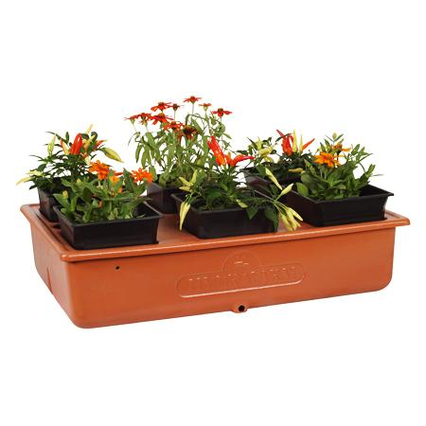

From Aquatic Eco-Systems, [Emily’s Garden](http://www.aquaticeco.com/subcategories/3339/Emily's%20Garden) is a perfect option for beginners and experienced gardeners alike. Grow flowers, herbs, and vegetables together in Emily's Garden! This 16" x 24" garden is very easy to use. The individual planters allow rotation of plants or addition of new plants. Each planter (filled with Geolite growing medium) rests in a pump-aerated nutrient solution. Get great results by pouring in a little nutrient and water every week – that’s it!

Emily's Garden is an economical option that will fit just about anywhere: on a bench, a shelf or table. It's a satisfying way to discover the ease and fun of hydroponic gardening in a mere 2 1/2 square feet. Weighs 20 lbs. The system includes a pump, pH test kit, formed cover, six planters, Geolite growing medium, seed starter cubes and all-purpose nutrient, 16 oz.

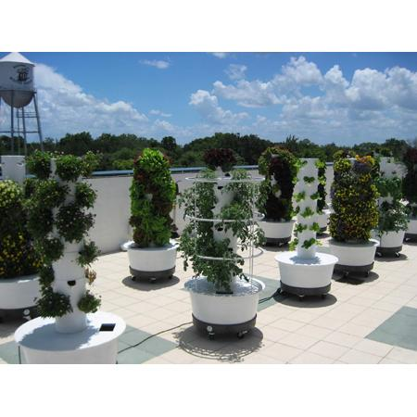

Aquatic Eco-Systems is pleased to offer the [Tower Garden®](http://www.aquaticeco.com/subcategories/4105/Aeroponics%20System,%20Tower%20Garden%C2%AE). Available now, The Tower Garden® will allow anyone to grow their own food year-round without weeding, tilling, kneeling or getting dirty. The Tower Garden® is a closed system aeroponics tower that will grow almost any vegetable, fruit or flower. This system allows you to grow 20 plants on a single tower (up to 36 with add-on kits) in half the time it would take to grow them in the ground. Made from USDA-approved, UV-stabilized, food-grade plastic. 2.5' x 2.5' footprint. Made in the USA.

AES offers additional options to add on to the Tower Garden®: AERO2 which includes everything you need to start growing, including gourmet lettuce seeds, seed starter enviro-dome, 20 rock fiber starter plugs, 20 net pots, pump, drain tube, plant fertilizers, pH Test Kit, pH Up, pH Down and 100-mL measuring cup. AEROADD will add 8 additional planting spaces. Use up to two. AEROWHLS is a wheeled pot that allows easy mobility. AEROCAGE is a cage that supports tomatoes and other large vegetable crops. AEROSEED kit includes seed starter enviro-dome, 20 rock fiber starter plugs and 20 net pots. The AEROTONIC Tower Tonic pack includes 2 gallons of mineral solution for superior plant growth. Makes 200 gallons of nutrient solution.

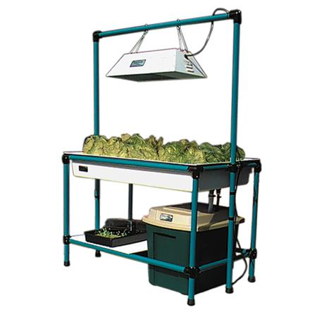

Aquatic Eco-Systems is thrilled to include the [Sweetwater® NatureGrowth System](http://www.aquaticeco.com/subcategories/2192/Sweetwater%C2%AE%20NatureGrowth%20System) in this line of hydroponics products. The NatureGrowth System is a compact educational system that is easy to operate. Designed with the highest quality materials, this system can grow virtually any type of plant including lettuce, herbs, tomatoes and flowers. It is an ebb and flow system, using gravity and a pump to periodically flood and drain the growing media. It measures 4' x 2' and can fit into most classrooms.

The stand is heavy-duty aluminum and includes a light stand that adjusts easily as plants grow. Add-on kits with larger light systems are available. Rockwool® starter cubes, Hydroton growing media, net pots and 16 oz of nutrient solution are included. The system is complete, easy to assemble and instructions are included. Weighs 130 lbs. One-year warranty. Made in USA.

**About Aquatic Eco-Systems:**

Aquatic Eco-Systems Inc. (AES) of Apopka, FL, is the largest source of aquatic products and systems worldwide. Since it was founded in 1978, AES has offered unmatched selection, service and solutions to the aquatic community. With over 13,000 products, AES serves a variety of aquatic interests and industries, from aquaculture and lake management to aquariums and water gardens. AES staffs over 20 technicians and biologists to provide service, expert advice, troubleshooting and custom design solutions to hobbyists and professionals alike. For more information, visit [AquaticEco.com](http://www.AquaticEco.com) or call 407-886-3939.

PR Contact - Bruce Vizueta: Office: 407-886-3939 Ext. 164 / Cell: 407-461-8933.