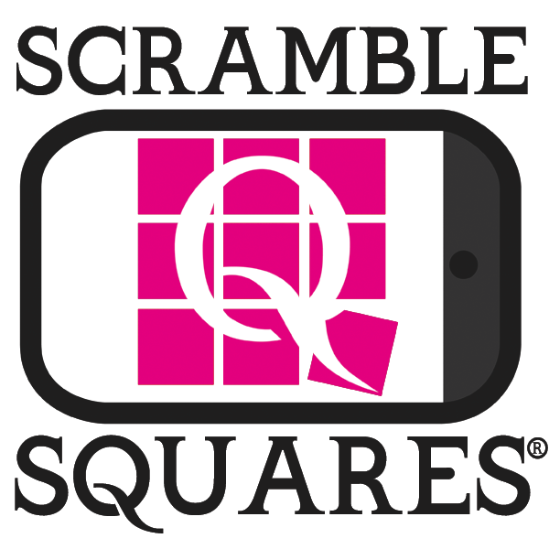
Contact: Scott Cone
Tel. 281-360-6811
Mobile: 832-969-1959
Email: Scott@247venturesinc.com

Scramble Squares® Puzzle App game for iPad, iPhone and iPod Touch announces 99-cent price for all app puzzles.

May 10, 2011 (REDONDO BEACH, CA & HOUSTON, TX) -- Scramble Squares®, the recently launched visual puzzle app for the iPad, iPhone and iPod Touch, announces it is reducing it’s price on all app puzzles to just 99-cents.

Scramble Squares® is a FREE iTunes download that contains one FREE free
5-MINUTE CHALLENGE® game puzzle and the ability to make in-app purchases of additional puzzles from a library of over 75 puzzles.

Scramble Squares® are visual puzzles comprised of nine square pieces, each containing images that must be properly arranged to form the solution. Scramble Squares® puzzles look easy to solve but in reality, only one in every 5,000 people can unscramble a Scramble Squares® puzzle in under 5 minutes.

The Scramble Squares® app and puzzle library is built to take advantage of the features of Apple’s iOS 4 operating system. The puzzles appeal to all ages and featuring over 75 original creations in a variety of themes including nature, sports, history, culture, geography, science, technology, gourmet, occupations, fantasy, hobbies and activities. New puzzles are added on a regular basis to expand your Scramble Squares® puzzle fun.

The iPad, iPhone and iPod Touch Scramble Squares® application includes a FREE 5-MINUTE CHALLENGE® puzzle. Players who solve the 5-MINUTE CHALLENGE® puzzle in under five minutes receive an additional free brainteaser puzzle, a 99-cent value.

Demo Video
http://www.youtube.com/watch?v=OLSpUXCURGg

The iPad, iPhone and iPod Touch application allows in app purchases of additional puzzles in a variety of themes with new puzzles are added on a regular basis; connectivity to the Apple Game Center so players can see where they rank with other players; communication through Facebook and Twitter for social gamers; and location-based iOS geolocation features to find nearby retailers that sell physical Scramble Squares® puzzles. All Scramble Squares® puzzles are stored in an in-app bookcase, similar to Apple’s iBook organization.

To download the FREE Scramble Squares® app, including the 5-MINUTE CHALLENGE® giving you the chance to win another FREE Scramble Squares® puzzle, visit http://itunes.apple.com/us/app/scramble-squares/id407954395?mt=8 .

For more information about the Scramble Squares® app for iPad, iPhone and iPod Touch: www.scramblesquares.com. Like us on Facebook for updates on the product and meet other 5-MINUTE CHALLENGE® masterminds Facebook.com/ScrambleSquares, follow us on twitter@ScrambleSquares, and visit our YouTube Page (YouTube.com/ScrambleSquares) to see a demo of the app in action and even some surprise messages from a very famous holiday celebrity.

###
About b. dazzle, inc.
Founded in 1993, b. dazzle, inc. is a progressive market-driven company which manufactures and distributes wholesale in the gift, souvenir, toy and educational products industries a wide range of beautiful, wholesome, entertaining and informative made-in-America gifts of high quality and low cost for all ages of adults and children that can be selected by topic to appeal to the personal interests of the recipient and can be enjoyed as cross-generational family activities. For more information, visit http://www.b-dazzle.com/ or www.scramblesquares.com

247 Ventures, Inc.
Founded in 2009 by three former marketing and media executives, 247 Ventures, Inc. develops applications and provides cloud-based hosting and rich media connectivity and serving for mobile devices as well as social networks and other internet connected devices. Based in Houston, Texas, 247 Ventures works with enterprise customers as well as develops their own portfolio of direct-to-consumer apps. For more information on 247 Ventures, Inc. email us at info@247venturesinc.com or call us at 281-360-6811.

