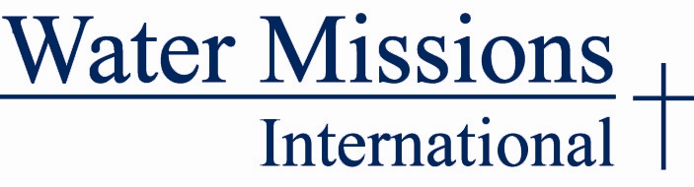

FOR IMMEDIATE RELEASE
May 19, 2011
Lynn Bheam – (843) 769-7395
lbeahm@watermissions.org
Jennifer Cherock – (843) 216-0442
jcherock@trio-solutions.com

WATER MISSIONS INTERNATIONAL IN THE RUNNING TO WIN $500,000 TO BUILD GLOBAL WATER CENTER
Facebook users can make a huge impact on the global water crisis

Charleston, SC – Water Missions International, a South Carolina-based nonprofit that provides sustainable, safe water solutions to developing countries and disaster victims worldwide, is competing for the opportunity to win $500,000 through the Chase Community Giving program. Facebook users can help tackle the global water crisis by simply voting for Water Missions International’s “Big Idea” through the Chase Community Giving program. Water Missions International would use the funds to construct a global water center, increasing their capacity to end the global water crisis forever.

“Nearly one billion people worldwide lack access to safe water and approximately 1.4 million children die each year from water-borne illnesses,” explains chief executive officer and co-founder, George Greene III. “For more than a decade, Water Missions International has been committed to providing relief to those without safe water and bringing an end to the global water crisis. Even though we have been able to provide safe water to more than 2 million people around the world, we realize we have so much more to do.”

Water Missions International is competing with 100 charities across the country in the Chase program. Each organization has submitted a “Big Idea” describing how they would use the $500,000 to further its cause. In addition to Water Missions International, there are six other nonprofits based in Charleston, SC who are in the running, including the South Carolina Aquarium, Pet Helpers, Charleston Animal Society, Crisis Ministries, Coastal Conservation League and the Historic Charleston Foundation. Visit www.votecharleston.org to learn more about these organizations. With the help of volunteers, fans and supporters, Water Missions International has the opportunity to receive the necessary resources to implement big changes around the world and save lives by bringing safe water to millions of people.

“Our water is safe for drinking, cooking, washing and bathing now,” explains Solomon Imalingat, a villager from Uganda. “Before the installation of the Water Missions’ water system, we had to fetch water from a borehole 1.5 kilometers away, but the water was not safe. It was dirty, filled with worms, and cases of typhoid among students were common in the school. I thank God for connecting us to Water Missions; now we don’t have any water problems. The water is near, safe and clean.”

“We believe that everyone has the right to safe water and that no one should experience the suffering that so many people endure every day due to a lack of such a basic human need,” says chairman of the board and co-founder Molly Greene. “In order to build necessary resources and increase our capacity to end the global water crisis forever, we need help,” she adds. “A vote for Water Missions International’s Global Water Center will help us build a place where people and organizations from around the world would come to learn best practices in the areas of water, sanitation and hygiene; and train on how, together, we can bring about positive change for our world.”

Through the utilization of social media networks, the Chase Community Giving program has already directed more than $10 million dollars toward charities nationwide, putting the power to bring positive change across the nation into the hands of some of those who need it most.

How You Can Help
You can help Water Missions International win up to $500,000 by simply clicking “Like” on the Chase Community Giving program’s Facebook page, www.facebook.com/chasecommunitygiving/, and casting your vote for Water Missions International. If you have questions about the organization or would like to get involved, please call (843) 769-7395 or e-mail Lynn Beahm at lbeahm@watermissions.org.

About Water Missions International
Water Missions International is an engineering relief and development Christian nonprofit. Its engineers, staff and volunteers design and provide sustainable, safe water solutions to disaster victims worldwide and people in 49 developing countries. Since 2001, Water Missions has responded to the world's largest natural disasters and each day tackles the world’s single biggest cause of illness - lack of safe water and adequate sanitation (U.N. Report, 2005) by providing safe water to more than 2 million people. Charleston, South Carolina-based Water Missions International has received Charity Navigator's top rating five years in a row. To learn, more visit watermissions.org.

