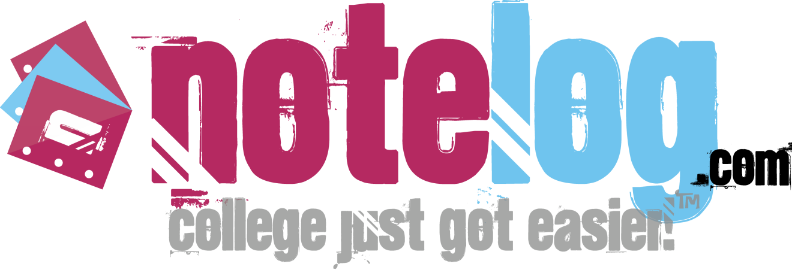

NoteLog, LLC (NoteLog) is the premier online social learning network used for sharing academic knowledge on college campuses worldwide. Often cited by media as the “Facebook® of academics,” NoteLog combines social networking tools with academics innovating the way knowledge is distributed among students, scholars, and other academia around the world.

NoteLog also provides a one stop shop for textbooks, helping users save money through its real-time price comparison application, LooksForBooks™. NoteLog was founded in 2007 accepted into The Jim Moran Institute for Global Entrepreneurship and the Florida State University College of Business SBI and is co-based in Tallahassee, Florida and San Francisco, California.

Notelog L.L.C.
PO Box 210273
San Francisco, CA 94121
Office: 415.484.6683

Founders:

Mike Fingado: mike@notelog.com
A serial-entrepreneur and former student-athlete at the Florida State University holds degrees in both Sport Management (M.S.) and Economics (B.S.). Most recently co-founded “Athletepreneur” –featuring, advising, and inspiring athletes pursuing entrepreneurial endeavors.

Cedric Nabe: nabecedric@notelog.com
Former FSU All-American student-athlete and 2008 FCPA “Student of the Year.” Currently a professional runner for Puma. In August 2009, Nabe won the 100-meter Swiss Championship title, and became an Olympic hopeful for 2012. In addition to entrepreneur endeavors also worked as an Enterprise Risk Services Consultant in Miami for Deloitte & Touché LLP, where he has been featured in BusinessWeek.

