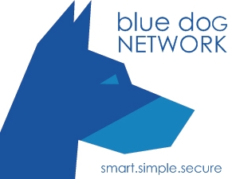

blue dog NETWORK
Cloud Based Back-up, Disaster Recovery and
Business Continuance Solutions

Table of Contents
Cloud Backup & Business Continuance White Paper 4
Abstract 4
Introduction 4
Contemporary data management 5
Conventional Backup 5
Problems 5
Cost 5
Human Error 5
Need for manual intervention 5
Unreliable 5
blue dog NETWORK Backup, Business Continuance and Disaster Recovery 5
Benefits 7
Key Features 7
Web Based User Interface 7
Efficient Backups 7
Supported Operating Systems 7
Microsoft 7
Linux 7
Mac OS X 8
Firewall/Proxy Friendly 8
Automation 8
Security 8
Secure SSL connection 8
SOAP and Message Signing 8
Secure encryption 8
Physical Security 8
Application plugins 9
Outlook (Express), favorites 9
System state 9
MS Exchange 9
MS SQL 9
MySQL Backup 9
Open file back-up 9
Seed load-technology 10
Recovery 10
Global 10
The Cloud 10
Choices: 10
Fix It: 10
Replace It: 10
Stay with blue dog NETWORK: 10
Requirements 11

Cloud Backup & Business Continuance White Paper

Abstract

This White Paper speaks to the Small and Medium Enterprises (SMEs) and Small Office Home Office (SOHO) data storage, back-up and recovery needs.

Traditional tape-based back-ups do not meet the growing demands of effective data back-up and storage, as they are error prone and not cost effective.

blue dog NETWORK cloud back-up solutions eliminate hassles and provide secure and reliable back-up for Windows, Mac and Linux clients / servers and your entire system state*.

We also offer near-instant hosted business continuance access to a live running state of your server in blue dog NETWORK award-winning cloud.

Read this whitepaper to find out more about:

- Conventional back-up and its drawbacks
- Advantages of online back-up vis-à-vis conventional back-up
- Benefits and cost effectiveness of online data back-up
- Benefits of blue dog NETWORK Back UpAgent& Business Continuance Options

*System State is not available for Server OS prior to Server 2003r2

Introduction
The blue dog NETWORK cloud back-up client solution is a reliable back-up and restore process. Safeguarding your critical data in case of system crash, or hardware failure, by automatically backing it up to the blue dog NETWORK private cloud.

The intuitive web-based interface, provides quick access to your system back-ups from anywhere you can access the web.

All data is encrypted on transmission and storage, ensuring security.

The other key features of our back-up solution include data compression during file transfer that ensures efficient back-ups, incremental back-ups that economize bandwidth usage.

Data stored on our servers is never deleted, unless you choose to remove it. Growing with you as your needs for data storage expands or contracts.

Contemporary data management
Your data’s security is of utmost importance as it is the lifeline of your organization and critical for business continuity.

While data volume has seen a sharp increase, methods of back-up remain largely archaic making them vulnerable to internal and external threats, attacks or simply mismanagement of your company’s data.

Conventional Backup
The conventional back-up method involves copying files from one hard disk to another disk (network attached storage) or a removal media – like tapes, CDs and DVDs. This is usually done with software to help automate the process but is long, extremely time consuming for large data sets, and 70% of all tape restores fail.

Problems
There are many problems that one faces while using a conventional back-up system, as listed below:

Cost
Conventional methods need large amounts of capital investment and expertise to use and maintain the electronic devices like tape, CD/DVD, network attached storage or disk arrays libraries.

Human Error
32% of data loss is due to human error (e.g. forgetting to switch tapes) or natural disaster.

Need for manual intervention
Changing tapes and switching magazines after every back-up does not constitute automation and reliability. Every step of the way data is at risk of loss, theft, and accidental over write, or simply being ignored. Do you have another copy offsite?

Unreliable
There is no provision to recover the data accidentally deleted due to a sudden server crash, drive failure, or malicious virus.

blue dog NETWORK Back-up, Business Continuance and Disaster Recovery
- Quick, cost effective back-ups and restores
- Minimal human intervention as the entire back-up process can be completely automated, monitored and tested regularly.
- Ability to restore backed up data to any machine, using the web interface.
- Bandwidth Optimization
- Encryption
- Compression

blue dog NETWORK Protects Your Data
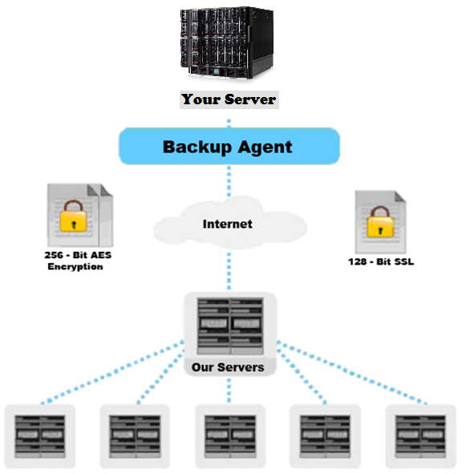

Benefits
- Support for Windows, Mac and Linux Clients AND Servers
- Available for an affordable monthly fee
- Is 100% hardware agnostic
- Eliminates tapes, and tape vaulting, disk 2 disk, network attached storage etc.
- All in one solution
- Virtually Effortless Configuration
- Features WAN-friendly operation
- Insurance Errors and Omissions
- Replicates and recovers between any configuration of physical and/or virtual systems
- Recover whole systems, mail stores, entire databases or single documents
- Provides nightly server back-up and snapshots based on the schedule you set
- Enables affordable business continuance and disaster recovery options
- Delivers the industry-leading system state replication engine for Windows
- Supports VSS snapshots

Key Features

Web Based User Interface
The globally accessible web user interface makes it easy for you to manage your back-ups from anywhere. Email notification of full job report, access log reports for.

Efficient Backups
Effective utilization of Internet bandwidth as the data files are compressed during transmission. Further, only the modified portions of your file(s) are backed up, resulting in faster time to completion.

Supported Operating Systems
The blue dog NETWORK back-up agent is compatible with:

Microsoft
blue dog NETWORK back-up client is certified by Microsoft for Windows Vista and Windows XP and supports all Microsoft Windows platforms which support the .NET (dot net) application framework, such as workstation versions Windows 2000 Professional, Windows XP and Windows Vista and server versions Windows Server 2000/2003/2008 and (Small Business Server).

Linux
blue dog NETWORK back-up agent has Client Software available for most popular Linux versions, such as Red Hat, SuSE and Debian (and Debian based systems such as Ubuntu), all with Java 1.5 or higher.

Mac OS X
blue dog NETWORK back-up agent client software also supports Mac OS X Workstation and Mac OS X Server platforms; Mac OS X 10.4.10 and higher (Tiger) and Mac OS X 10.5.0 and higher (Leopard).

Firewall/Proxy Friendly
The back-up agent uses secure communication channels for the entire back-up process of communicating with our servers. This allows for easy configuration if any to get everything up and running.

Automation
After the initial back-up agent installation, the entire process is automated, until you need to make a change.

Security
blue dog NETWORK back- up agent uses the following security techniques to ensure that the back-up data is 100% private and not accessible to anyone but the end-user.

Secure SSL connection
All communication between the PC, laptop or server and the blue dog NETWORK back-up server takes place through a secure SSL (Secure Socket Layer) channel.

SOAP and Message Signing
All communication with the blue dog NETWORK back-up server is conducted through a secured SOAP/XML interface. Each request is signed by a unique signature per user. This offers an extra security layer on top of SSL, which not only protects the transfer of the data, but also secures the total integrity between client and server processes.

Secure encryption
All the back-up data is compressed first and encrypted using AES (Advanced Encryption Standard) 128 or 256 bit encryption technology. Once encrypted, the back-up data is transferred to the blue dog NETWORK back-up server. The encryption key is only known by the end-user, so no one but the end-user can open the back-up data on the blue dog NETWORK back-up server.

Physical Security
The blue dog NETWORK servers and storage are hosted in 16 Class A compliant data centers across the United States, which provide the environment necessary to keep the servers running 24x7. These facilities offer HVAC temperature control systems, diesel generator back-up power, dual power grids, state-of the-art smoke detection and fire suppression systems. As well as round-the-clock secured access with video camera surveillance, security breach alarms, and live security.

Application plugins

Outlook (Express), favorites
blue dog NETWORK back-up agent client software makes it very easy to back-up Microsoft Outlook, Outlook Express and Favorites. By simply selecting the corresponding icon, the client software detects the underlying files in the folder structure.

System state
blue dog NETWORK back-up agent client software backs up Windows System State, containing e.g. Windows Registry, Active Directory and System and Boot Files.

MS Exchange
The blue dog NETWORK back-up agent client software can back up a Microsoft Exchange Server database. A MS Exchange Server is continuously operational. Therefore blue dog NETWORK back-up agent makes a “hot back-up”, of the Exchange database without interrupting business operations; even during the back-up window. Next to the full MS Exchange Server back-up, the client software also includes a plugin for the MS Exchange Server back-up on folder level. This plug-in is designed to facilitate an easy back-up and fast restore of individual mailboxes, contacts, calendars etc.
blue dog NETWORK back-up agent is available for MS Exchange Server 2000, 2003 and 2007.

MS SQL
The blue dog NETWORK back-up agent client software can back up a Microsoft SQL database. A MS SQL Server database server is continuously operational. Therefore blue dog NETWORK back-up agent makes a “hot back-up” of the MS SQL Server database without interrupting business operations, even during the back-up window.
blue dog NETWORK back-up agent is available for both MS SQL Server 2000 and 2005.

MySQL Backup
The blue dog NETWORK back-up agent client software can back up a MySQL database. A MySQL database server is continuously operational. Therefore, blue dog NETWORK back-up agent can back-up the MySQL database without interrupting business operations, even during the back-up window.
blue dog NETWORK Backup Agent is available for MySQL version 5.0 and higher.

Open file back-up
blue dog NETWORK back-up agent is capable of backing up open files. Leveraging Microsoft's latest Volume Shadow-Copy Service (VSS) framework, applications do not have to be shut down during the back-up process. So e.g. Word/Excel documents and even Outlook files are backed up, even when they are in use.

Seed load-technology
blue dog NETWORK back-up agent supports an easy “seed-load” technology, which allows the initial back-up of a large volume of data to a local hard drive, which can be shipped to the blue dog NETWORK back-up server. This eliminates the first back-up over the internet of hours/days/weeks. Of course, subsequent back-ups will be made incrementally over the internet. This method saves time and bandwidth.

Additionally, in case of a disaster, the back-up data can also be restored using a local hard drive. This allows you to be back-in-business ultra-fast. All back-up data on a local hard drive is fully secured and encrypted.

Recovery

Global
Your data can be restored from anywhere with a supported web accessible web browser. Files can be downloaded directly through the browser for quick viewing, or restored to its original location.

The Cloud
Optionally if disaster strikes, we can spin up your server(s) with all its data in the cloud within 24 hours*. Connecting you to what matters most via secure virtual private tunnels using 128-BIT SSL Encryption.

Choices:
With blue dog NETWORK’s backup solution you will be presented with three options in the event of disaster.

Fix It:
Once the server is operational Update Sync will kick off (depending on data size, customer may prefer to complete the Seed Load and then re-sync).

Replace It:
You may continue to run on blue dog NETWORK’s VPS while your new server is being procured and implemented.
Stay with blue dog NETWORK:
Your organization has the ability to simply continue using blue dog NETWORK’s additional hosting services at a reduced rate.

Requirements
Internet Connectivity on Server
Administrator Login and Password for Server
Windows 2003 Server or higher, 32 & 64 bit support
Business Continuance and Disaster Recovery:
So how do we do it? Again blue dog NETWORK clients have access to their own customized business continuance and disaster recovery options.
Depending on your companies requirements you may opt for any of the following:

- blue dog NETWORK will overnight data to your site via external disk with the back-up data set(s) for restoration. Reinstall the blue dog NETWORK backup agent and complete the Seed Load then return the disk to blue dog NETWORK*.
*Fee for not returning disk will be applied.
- blue dog NETWORK will spin up your server in our cloud while you decide what to do with your existing server.

- For high availability, blue dog NETWORK can provide a mirrored image of your server in our cloud, ready for INSTANT* accesses without any downtime*.
*Customer supplied IPSec compatible device for VPN access.*Monitoring service required.

Call blue dog NETWORK today @ 910.256.9697 or
visit us on the web @ backup.bluedognetwork.com

