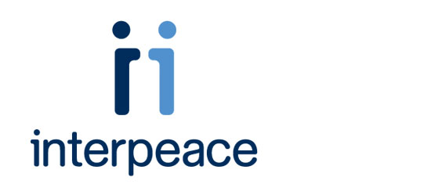

Constitution-making and reform: Options for the process
About the authors


Michele Brandt

Michele Brandt is a constitutional lawyer. She launched and directs Interpeace’s Constitution-making for Peace program, which develops tools and resources to improve constitution-making practice and provides technical assistance to both international organizations and national actors. As part of this role Michele has organized several international workshops on key constitution-making issues.

Michele has spent over twelve years directly assisting constitution processes in the field.
She was the full-time constitutional advisor to the United Nations Assistance Mission in
Afghanistan and the Afghan Constitutional Commission. In Timor-Leste, Michele served with the United Nations Transitional Administration as a judicial affairs officer and was a member of the Transitional Judicial Service Commission as well as the Cabinet Legislative Committee and later directed the Asia Foundation’s Constitutional Development program. In Cambodia, Michele cofounded the Cambodian Women’s Crisis Center and directed an eleven-office legal aid association.

Michele has published numerous articles on human rights, capacity development, gender, peacebuilding, and the rule of law, including a study of the United Nations’ constitutional assistance efforts.

Michele received her JD from the University of Minnesota Law School.

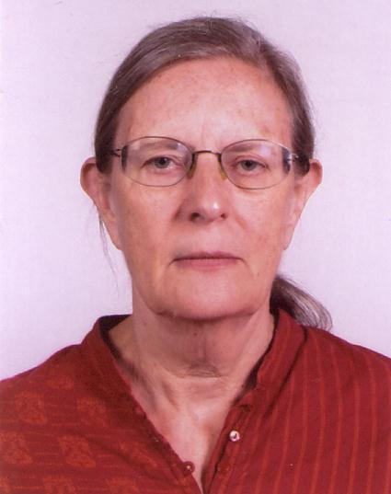
Jill Cottrell

Jill Cottrell retired in 2006 after teaching law for 40 years at universities in Nigeria, the United Kingdom, and Hong Kong. She has been a consultant on constitution-making for Timor-Leste, Maldives, Iraq, and Somalia.

From 2006 to 2008, Jill was a consultant with the Constitution Advisory Support Unit (CASU),
UNDP, Kathmandu, Nepal.

Jill has also been involved with International IDEA on a project for women members of the Constituent Assembly.

Jill studied at the University of London and Yale Law School.

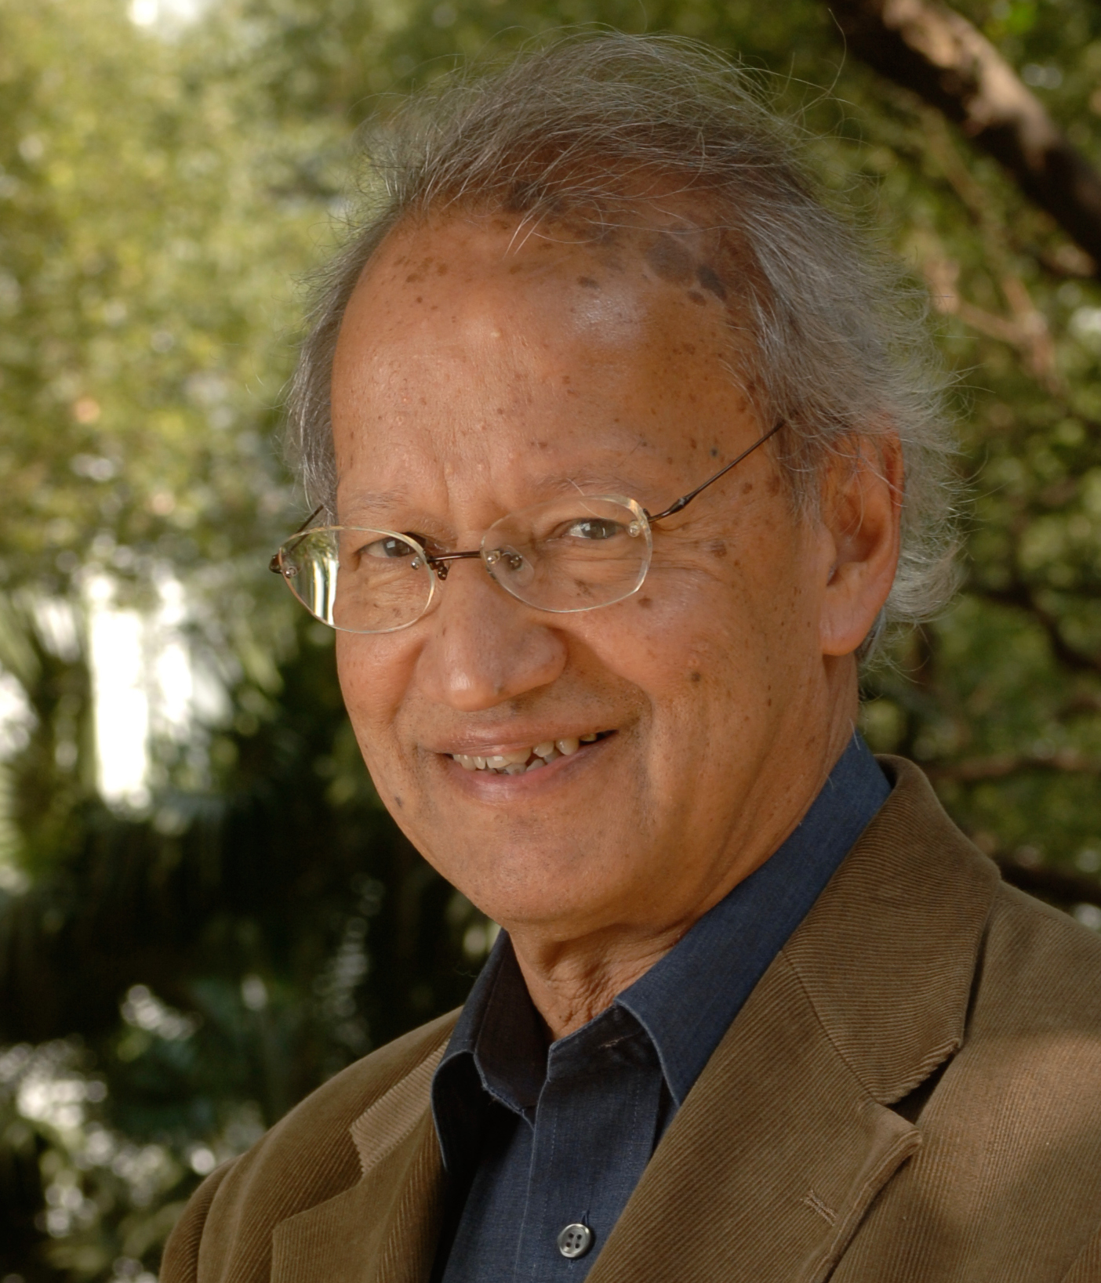
Yash Ghai

Yash has held positions at a number of universities including the Universities of Dar es Salaam, Warwick, Uppsala and Hong Kong. He has had visiting appointments at Harvard, Yale, the Universities of the South Pacific, Wisconsin, Toronto, Melbourne, and the National University of Singapore. He retired from university teaching in 2006.
Yash has published extensively on constitution-making, public law, sociology of law, ethnic
relations, comparative law, and law and development.

Yash has over 35 years of experience advising countries on constitutional matters, including the making or reviews of constitutions. He was the chair of the Constitution of Kenya Review Commission and of the Kenya National Constitutional Conference (2000–2004). More recently, he headed the Constitution Advisory Unit of UNDP, Nepal (2006–2008), which advised on the constitution-making process in Nepal. Yash has also been working as a consultant for UNDP on the constitution for Somalia, of which the draft is currently (2011) the subject of public consultation.

Yash Ghai studied at Oxford and Harvard.


Anthony Regan

Anthony Regan is a constitutional lawyer who has worked since 1997 for the Australian
National University (Canberra) as a fellow in the State, Society, and Governance in Melanesia
Program, College of Asia and the Pacific.

Anthony studies the law and politics of constitutions, and the design of the state as part of postconflict political settlements and peacebuilding efforts.

Anthony has undertaken advisory work in a number of countries, particularly Papua New
Guinea, where he has lived and worked full-time for 15 years (including more than two years
in Bougainville from 2002 to 2004, assisting in the development of a post conflict subnational constitution) and Uganda (where he worked for over three years from 1991 to 1994 assisting the Uganda Constitutional Commission and the Uganda Constituent Assembly in developing a new constitution).

Anthony has also been involved in advising on constitution-making and conflict-resolution work in Timor-Leste, the Solomon Islands, India (especially Nagaland), Sri Lanka, and Fiji. He has assisted in developing Interpeace’s Constitution-making for Peace program.

Anthony has written extensively on peacebuilding and constitution-making. His most recent
book is Light Intervention: Lessons from Bougainville, published by the United States Institute of Peace late in 2010.

For more information or to interview the authors please contact:

Lisa Ross-Magenty Blaettler
Head of Communication
Interpeace Headquarters
Ross-magenty@interpeace.org
+41 22 917 8338

Erin Helfert
Assistant
Interpeace USA
Helfert@interpeace.org
+1 713 825 3639

