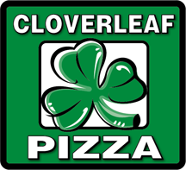
FOR IMMEDIATE RELEASE
Shawn Randazzo
Cloverleaf Pizza
40750 Garfield Rd.
Clinton Township, MI 48038
Ph: 586.489.4211
Email: Pr@CloverleafOnline.com
Website: www.CloverleafOnline.com
To: All Media

Detroit Style Turning Heads Around the World
Cloverleaf Pizza Placed 1st in Their Region and Made Pizza
History in the Process at the World Pizza Games in Las Vegas
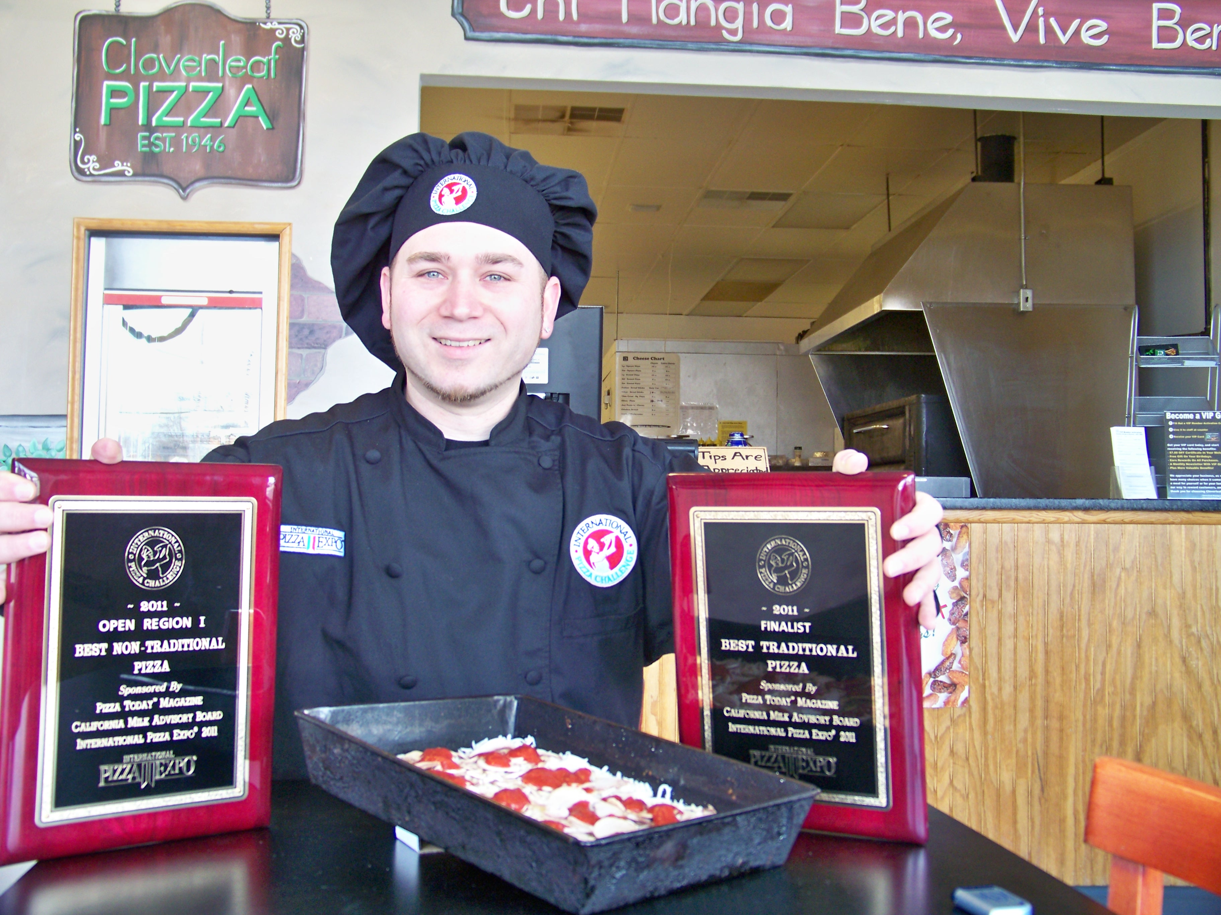
(Shawn Randazzo with awards from 2011 International Pizza Challenge)

(Clinton Township, MI. March 9, 2011) – History was made last week at the International Pizza Challenge in Las Vegas when pizza maker Shawn Randazzo, co-owner of Cloverleaf Pizza Carryout and Delivery, was the first to ever advance to the finals in both the Traditional and Non-Traditional categories. The competition took place at the 27th Annual Pizza Expo, where more than 1,000 exhibitors and 10,000 attendees roamed the show floors. The best pizza makers in the world brought their ingredients and best recipes in hopes to become the world’s next Pizza Maker of the Year.

Cloverleaf Pizza earned top honors in the Non-Traditional category winning 1st place in the Mid-West with their Greek Odyssey pizza recipe topped with lamb, cherry tomatoes, a variety of imported olives, and several other ingredients. Cloverleaf Pizza also did something that’s never been done before in the pizza industry, they advanced to the finals in both categories at the International Pizza Challenge, making history and becoming the first company to ever achieve such a feat. Competitors were on top of their game with the best from Italy, London, Australia, and even Canadian Pizza Magazines Chef of the Year all ready to compete in the world’s largest pizza competition. There were over 60 pizza makers in each category. “It was great to meet people from all over, and to have the best from around the world comment on our pizza the way they did gave us great confidence that our style of pizza is unique and special”, Randazzo stated.

In 2009 Cloverleaf Pizza entered one of the largest pizza making competitions for the first time and placed 1st in the NAPICS Pizza Pizzazz Competition, held in Columbus, OH. Randazzo dedicated this accomplishment to the founder of the Detroit style pizza, Gus Guerra, the one who first introduced this style of pizza in 1946. Since then Cloverleaf has been on a mission to educate the world about this style of pizza they serve at their pizzerias. Cloverleaf Pizza went back to Columbus to compete in the 2010 NAPICS Pizza competition where they placed 4th in the Non-Traditional category with one of their Cloverleaf Pizza recipes. This year they decided to take it to the next level by going to the biggest pizza making competition in the world and walked away making history and the best in their region.

As Cloverleaf Pizza wrapped up their trip to Vegas Randazzo tells us, “One of our goals is to get the recognition Detroit style pizza deserves. There is no reason why this style can’t become as well known and popular as New York and Chicago styles have become”.

For additional information about Cloverleaf Pizza, or to schedule an interview with Shawn Randazzo, please call him at 586.489.4211 or email us at pr@cloverleafonline.com

About Cloverleaf Pizza Carryout & Delivery – Is affiliated with the Cloverleaf Bar & Restaurant. Shawn Randazzo and Mother, Linda Michaels, own and operate two units in the Metro Detroit area, St. Clair Shores 586.445.2810, and Clinton Township 586.286.9030. Serving the original and famous Detroit style pizza their vision is to expand to 30 locations by 2018. They are looking to grow their brand, and maintain a very strong and structured business model that focuses on people and the community. Complementing their pizzas are pastas, salads, wings, and breadsticks. The store hours are 3 p.m.-10 p.m. daily and 11a.m.-11p.m. Friday and Saturday. For more information visit www.CloverleafOnline.com

###

