Rachel’s Story
Rachel’s story is inspiring. It is also infuriating.
Born in Eagle Butte on the Cheyenne River Indian Reservation, she and her four siblings were abandoned by their alcoholic parents at a young age. Taken by the state, they were separated and placed in foster homes across South Dakota.
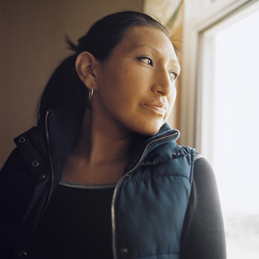For years the children bounced around from one home to the next where they were often physically, sexually and emotionally abused. Seldom in contact with each other and often in trouble, they quickly turned to alcohol and drugs as an escape. “I practically grew up in Juvenile Detention Centers,” Rachel says.
Released from state care when she was 18, Rachel had nowhere to go. As is so often the case, she was drawn to what she knew and soon found herself caught in an abusive relationship with the father of her two daughters. One night, in March 2005, he stabbed Rachel with a pair of scissors. He was arrested by the police—and ultimately sentenced to one year in prison—but at the same time Rachel’s daughters, Miah and Angelina, were removed from the home.
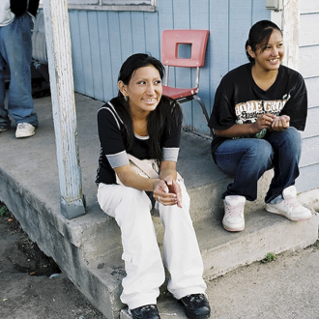Rachel began to turn her life around. She moved to the Rosebud Sioux Indian Reservation and found a job. She enrolled in school and began making progress toward an Associate’s Degree in Human Services. She successfully completed treatment for alcohol dependency and took two courses in parenting skills. She was awarded subsidized housing and maintains an apartment within walking distance of her school, Sinte Gleska University. In short, Rachel not only did everything the state asked her to do, she did everything that she possibly could do to create a safe and healthy environment for her children.
Despite all this—despite her innocence in the domestic dispute and her extraordinary efforts to transform her life—Rachel’s parental rights were terminated in January 2006.
The loss of her children has filled Rachel with grief. She has fought tirelessly to regain custody of her daughters, but believes that her caseworkers’ mind was made up from the beginning.
Rachel’s story should have had a happy ending. But in South Dakota, the chances that a Lakota family wins custody of a Lakota child are not very good. The state thumbs its nose at the Indian Child Welfare Act (ICWA) and other laws like they weren’t even there. It is stories like Rachel’s that motivate us to do this work.

