P R E S S I N F O R M A T I O N

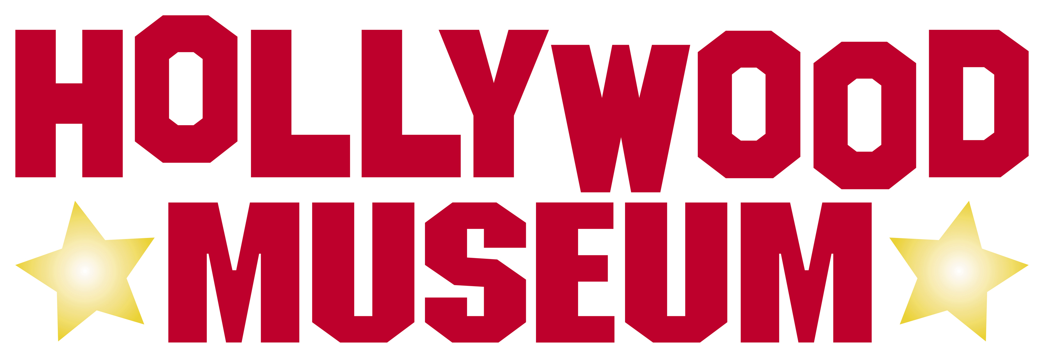

Hollywood’s Official Museum

in the Historic Max Factor Bldg.

Address: 1660 N. Highland Avenue (at Hollywood Blvd. )
Hollywood, CA 90028
323.464.7776

Hours: Open Wednesday – Sunday
10:00 am – 5:00 pm

Website: TheHollywoodMuseum.com
Twitter: Twitter.com/Hollywoodmuseum
Facebook: Facebook.com/TheHollywoodMuseum

PRESS CONTACT:
Cheri Warner/Carlos Gaona
Weissman/Markovitz Communication
O: (818) 760-8995
M: (818) 390-0999
cheri@publicity4all.com
HISTORY

The building that houses today’s Hollywood Museum at 1660 North Highland at Hollywood Boulevard in Hollywood was originally purchased by Max Factor, legendary make-up artist to the stars, in 1928, just moments before the Great Depression. It would not be until 1935 that it was finally opened. Famed architect S. Charles Lee designed it in the so-called Hollywood regency art deco style. Lee was celebrated for his design of many of the grand motion picture theaters in Los Angeles as well as hotels and other signature buildings in the city and elsewhere in California.
Through Max Factor this became much more than an elegant building. For the first time in history movie stars, women of high society and working women were all able to go to a public place for their make-up without the stigma of being called “hussies.”
Over the years the building went through various owners including the Norton Simon Foundation and Proctor & Gamble, who sold it to its present owner, Donelle Dadigan, founder and president of the Hollywood Museum. She purchased it in 1994, though P&G were initially unwilling to sell. They had many offers.

TODAY’S MUSEUM

Dadigan took another nine years to restore the museum to its original grandeur. It opened in 2003. Back in all its glory was the lobby, an art deco gem—a white and rose-colored oasis of lavish marble, recreated historical chandeliers, pastel hues, antique furniture, trompe l’oeil, faux finishes with 22kt. gold and silver leafing.
The ground floor houses many original displays from the old Max Factor Make-up Studio with one room for blondes (used by Marilyn Monroe) and another for redheads (Lucille Ball). Lucille Ball was not an original redhead. It was Max Factor who designed her hair color and the make-up to go with it.
The Hollywood Museum features four floors of exhibits (two floors above the lobby and a basement below), offering more than 35,000 square feet of exhibit space—that’s seven times the size of the nearby Guinness World of Record Museum, almost four times the size of the neighboring Ripley’s Believe It Or Not Museum and five times larger than the Warner Bros. Museum.
On the Hollywood Museum’s ground floor can be found the historic lobby, plus Max Factor’s restored make-up rooms, a gallery featuring more than 1,000 black and white photos, Cary Grant’s Rolls Royce, Planet of the Apes, Jurassic Park, a tribute to Judy Garland and The Red Shoes.
The second and third floors are devoted exclusively to costumes worn by famous stars in famous films, corresponding props and posters as well as a wealth of Hollywood memorabilia ranging from the earliest Technicolor film ever shot to a Roman bed from Gladiator
to the dog from There’s Something About Mary and the gold Cadillac from Dreamgirls.
The museum contains the world’s largest collection of genuine Marilyn memorabilia. In fact, historians and other experts specializing in entertainment ephemera, costumes, photos, text, posters etc. are consulted on a regular basis to make sure the museum is exhibiting the real thing.
The lower level has had many lives during the building’s long history. It was once a bowling alley and, during Prohibition, a speakeasy. Today it houses “all things creepy and scary.” Visitors can walk down the same jail cell corridor Jodie Foster walked in Silence of the Lambs. The array of crops from the film include Dr. Hannibal Lecter’s iconic mask.
When the museum opened its doors in 2003 it was open just two days a week. It has since become one of the most popular tourist destinations in Hollywood and is now open five days a week.
The museum has held many special events. A highlight of 2011 was a reunion of people who worked on the “I Love Lucy” show in celebration of Lucille Ball’s 100th birthday and the 60th anniversary of the show. Guests included Lucille and Desi’s daughter, Lucy Arnaz. Members of the public are able to view a special Lucille Ball exhibit. Later that year a recital entitled “From Russia With Love” was held with two internationally renowned concert pianists, both of them former winners of the José Iturbi contest.

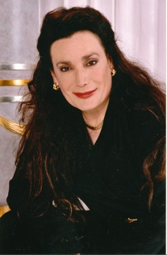

DONELLE DADIGAN
(Founder, President)

Donelle Dadigan is founder and president of two not-for-profit organizations. The José Iturbi Foundation, created together with Marion Seabury, Iturbi’s companion and secretary, in 1985, is dedicated to sharing the wonders of classical arts and music. The Hollywood Museum provides an in-depth opportunity to experience close up the evolving history of the entertainment industry.

Donelle is the god-daughter of Iturbi, the famed conductor, concert pianist and harpsichordist, and Marion Seabury, and began her piano studies with José’s sister Amparo when she was not yet five years old. She had the distinction of being Amparo’s youngest student ever and is the only pianist to have been taught by both Iturbis. Donelle has won many music awards and has performed internationally. She has a music degree from UCLA.

After her father passed away José Iturbi became an even more important part of Donelle’s life. She credits him with teaching her the important lessons in life, including the need to help shape the lives of others and giving back to the community.
The Hollywood Museum was a labor of love for Dadigan. She has dedicated it to the history and heritage of Hollywood and the entertainment industry by documenting, preserving and exhibiting the largest collection every assembled of costumes and personal effects of hundreds of stars including Marilyn Monroe, Russell Crowe, Elvis Presley, Lucille Ball and Johnny Depp. Even José Iturbi starred in many great motion pictures of the 1940s and he has a star on Hollywood Boulevard’s Walk of Fame.
Today Dadigan is the chairperson of the Hollywood Historic Trust, which controls the sidewalks where the Walk of Fame stars are located. She took over this duty from the late Johnny Grant, honorary mayor of Hollywood, who left her and the museum his vast collection of memorabilia.
Dadigan is also on the Board of Directors of the Hollywood Chamber of Commerce and chairperson of the Chamber’s Tourism Committee. She participates and serves on the boards of many service organizations, including Hollywood Entertainment District, the award-winning LACER (Literacy, Arts, Culture, Education, Recreation) after school programs, Hollywood Toys for Tots, Hollywood High School, PATH, the Hollywood Police Activities League, and the Hollywood Historic Trust.
She has received innumerable awards including the California Art Deco Society Preservation Award, the State of California Preservation Award, the Hollywood Chamber of Commerce’s Woman of Distinction Award, the Woman Entrepreneur Distinction Award from the Los Angeles Business Journal and the Charlie Chaplin Award. She has been recognized by the Travel and Tourism Marketing Association of Southern California, the State of California Travel Industry with the Best New Tourist Attraction, and by the American Federation of Television and Radio Artists (AFTRA) for Preservation of Entertainment Industry History.
She was named Beverly Hills Woman of the Year in 2005 and in 2010 received the Hollywood Police Activities League Community Leadership Award.
Donelle has received commendations and certificates from many of California’s civic leaders, including Governor Arnold Schwarzenegger, Lt. Governor Cruz Bustamante, Governor Gray Davis, Assembleywoman Jackie Goldberg, Congresswoman Diane Watson, Assemblyman Paul Koretz, the last three Los Angeles Mayors—Richard Riordan, James Hahn and Antonio Villariagosa; City Council President John Ferraro, City Council President Eric Garcetti, Councilmember Tom LaBonge, Hollywood’s Honorary Mayor Johnny Grant, State Senator Kevin DeLeon and Los Angeles County Supervisor Zev Yaroslavski.

