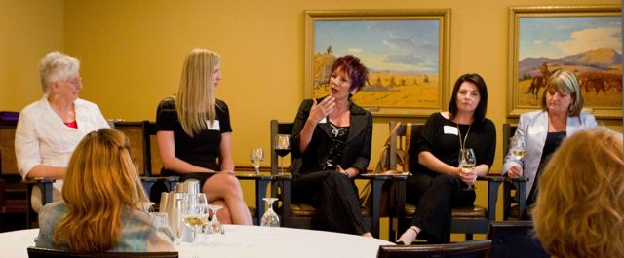 

### Web

www.EvesTribe.com

## Peg Ainsley

## Director, Communications

## Craig Attiwill

## Board Member, Technology

## Jade Humble

## Board Member, Marketing

## Debra Johnstone

## Board Member, Business

What’s Going On?

We have created an online social networking sanctuary for women, which offers the women of the world a place – their place – to find and express their true voice in the safety of anonymity. We have created EvesTribecom. We are a private site that connects like-minded women in a supportive community. We are a Tribe.

What do you mean, Anonymity?

Each member of EvesTribe is known within the site by her Eve ID only. This is comprised of Eve and six numbers, for example Eve123456. Everyone is an Eve. You do not know if you are communicating with your neighbor or the head of a large corporation on the other side of the world. Even the likes of Hilary Clinton could vent here or seek opinions without anyone ever knowing who she is. This is what we provide – the freedom to express one’s self without fear of judgment or repercussion; the freedom to speak from your true voice.

Help Others Be Heard

As part of the sign-up procedure, members may choose whether or not they wish to be a ‘Responder’. As a responder, women will be asked to answer the call from other Tribe members who wish input, opinions or comments on their topic. Responders are asked to choose topics they feel comfortable talking about from a comprehensive list. Any tribe member who wants responses assigns their question or comment one or more appropriate topics, and the EvesTribe system matches their entry to a number of responders. As an Eve you are guaranteed five responses from other members. Our promise? Each Eve will always have a voice and she will always be heard.

Write in here

**Backgrounder**

The original five Eves address a keen audience in Calgary, Alberta. The excitement was palpable. The movement has begun…

## Shelley Humble

## President & CEO

TRIBUS NOSTRA COMMUNICATIONS

Suite 176, 110-174 Wilson Street

Victoria, BC, Canada. V9A 7N7

### Phone

1-800-661-1875

The Home Page

After a member logs in, she lands on her own homepage, where the three components of EvesTribe.com are presented.

* Tribe Talk – Various topics of conversation are presented throughout the week for members to discuss. To weigh in on the subject, or not, is up to each Eve. Members will be asked for their input on Tribe Talk topics.
* The Vault – This is where the magic happens. Members create their entries here, which can be saved (just like a journal), or can be shared with other likeminded Eves. The home page shows them the most recent entries, so it’s easy for them to go back in where they left off.
* Daily Rumble – This is the saying or thought for the day and varies from silly to profound.

EveMail

When a member shares her Vault entry she is guaranteed five responses from other Eves. These responses are directed to her EveMail. She can choose to keep, delete or reply to her responses. As a responder, incoming shared entries will be directed to your EveMail. Once you respond to a shared entry it automatically deletes out of your EveMail as we believe the entry belongs to the author and her alone.

The Technology

The Victoria-based information technology firm Peloton Technologies, in partnership with PARC Systems, has developed EvesTribe.com utilizing leading-edge technology. Peloton provides all three services that our new website requires:

1. The development expertise;
2. The server provision; and
3. The online payment contracting.

Having these three areas covered in the same shop is highly unusual yet it has helped us streamline things for our site. EvesTribe.com was developed using an agile approach with Microsoft Visual Studio, the Microsoft .NET Framework, and SQL Server. These are integrated development tools that helped Peloton quickly build rich, intuitive, and connected applications. Knowledgeable engineering and rigorous security standards (usually reserved for government applications) were utilized in the development of EvesTribe.com.

Contact Information

For any further information on EvesTribe.com please contact our President, Shelley Humble at 1-800-661-1875 or via email at [shelley@evestribe.com](mailto:shelley@evestribe.com).

Write in here

TRIBUS NOSTRA COMMUNICATIONS

Suite 176, 110-174 Wilson Street

Victoria, BC, Canada. V9A 7N7

### Phone

1-800-661-1875

### Web

www.EvesTribe.com

**Backgrounder Page 2**