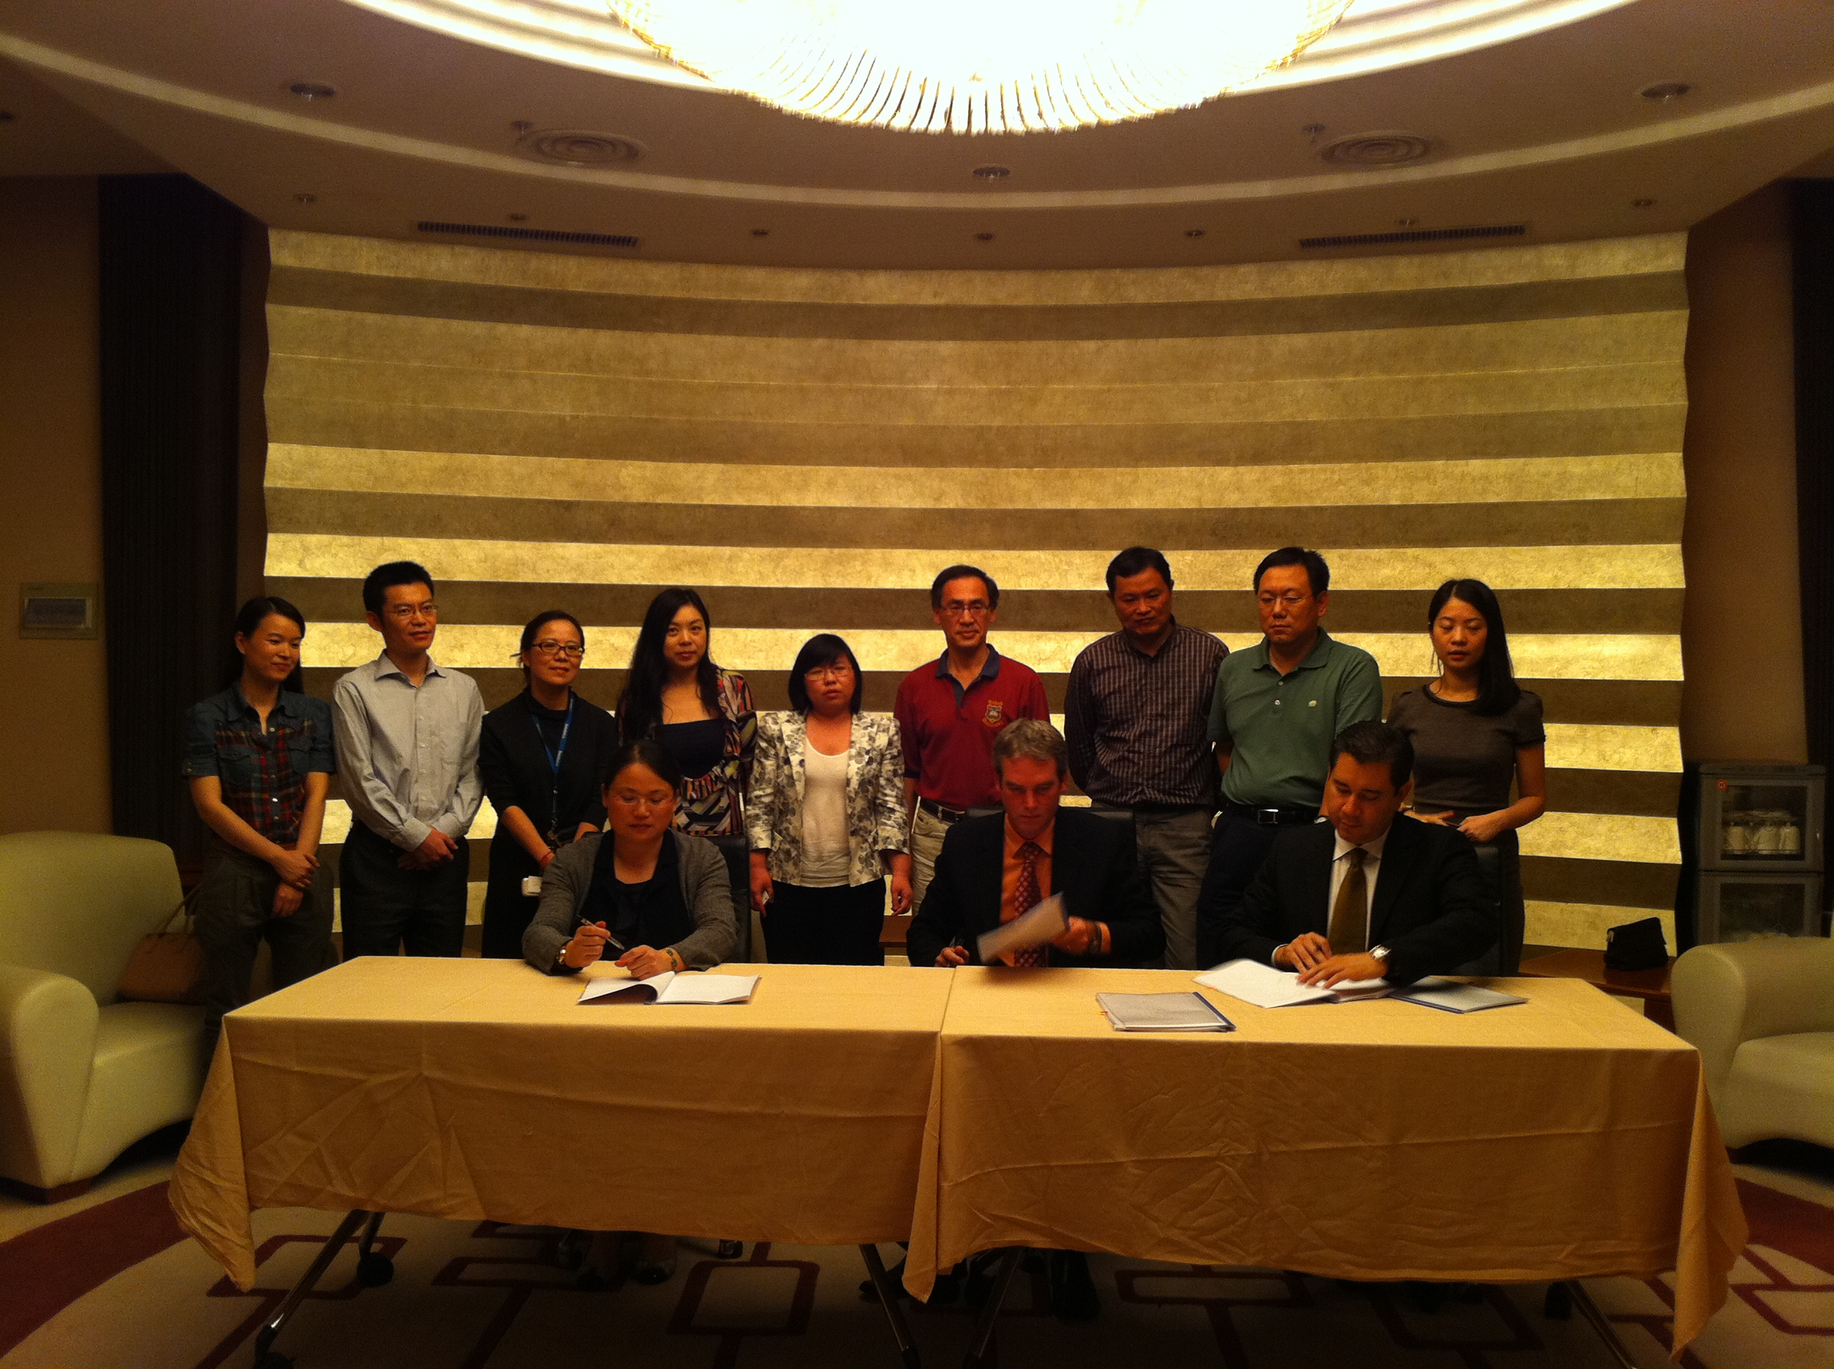
Principals from three firms sign a joint venture agreement for establishment of up to 13 facilities throughout China for production of reusable crumb rubber, clean steel and fiber from used vehicle tires. Sitting at the table, from left to right: Pan Lichun, Chairman of the Board, InSigma R&D Co. Ltd.; Andy Butler, CEO and Chairman of the Board, Blue Diamond Technologies LTD and Chairman, ECO BDT; and Sergio Castillo, CEO, ECO BDT. Standing second in from far right is Qin Yongsheng, President, Insigma Technology Co. Ltd.

