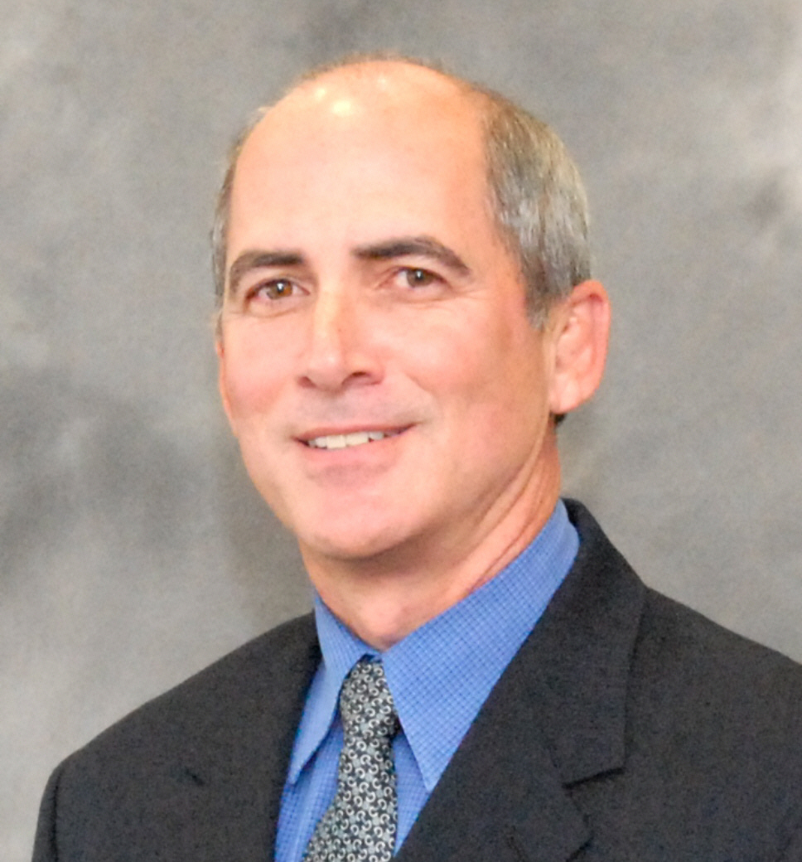

Jeff Elder
President

Jeff Elder serves as president at Trojan Battery Company. The first president in the company’s 85-year history that has not been a Godber family member, Elder is responsible for all aspects of Trojan’s business. Elder joined Trojan Battery Company in 2005 as chief financial officer and became chief operating officer and chief financial officer in 2008. He became president in 2010. During his tenure at Trojan, Elder has helped to substantially grow and improve the company’s core businesses. Under his leadership, Trojan also has expanded its business into new market segments resulting in significant market share gains in both the renewable energy and trucking industries.

Prior to joining Trojan, Elder served as chief operating officer and chief financial officer at Dynamic Cooking Systems where he led the team that turned the business around and ultimately negotiated and completed the sale of the business to Fisher & Paykel. Elder also held the position of chief operating officer and chief financial officer at Rand Technology, served as vice president of finance at Avery Dennison Office Products and held management positions at Toshiba America, Emerson Electric and Arthur Anderson. Elder is a CPA and his expertise in finance, operations and strategic planning spans more than 30 years.

Elder received his Bachelor of Arts degree in economics and accounting from Claremont McKenna College. He is a board member and the treasurer of Make-A-Wish Foundation for the Orange County and the Inland Empire chapters. Elder is active with AIDS Services Foundation in Laguna Beach.

