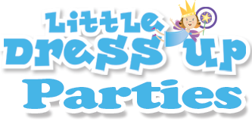
3417 Kennekuk Circle, Eagle Mountain, UT 84005 -- www.LittleDressUpParties.com -- 800-928-9412

PRESS RELEASE

FOR IMMEDIATE RELEASE
Contact: Julie Lafferre
Office: 800-928-9412

PRINCESS EVENT PROVIDES DRESS UPS FOR ALL CHILDREN ATTENDING
Little Dress Up Parties serves families, businesses and communities throughout Utah and Salt Lake Counties. They have selected Millennial Falls in Draper to host “Brunch with Rapunzel” on March 24th. All of the children attending will choose a dress up costume to be provided for them for the duration of the event.

“Our events are all about giving children the experience rather than just observing an appearance,” said company co-owner Lindsay Bills, “We want them to not just watch a princess, but BE a princess.” For “Brunch with Rapunzel”, Little Dress Up Parties has allowed for each child to reserve a princess gown, prince costume, or dragon costume of their choice upon purchasing tickets. These will be ready at the event for the children to don in the royal dressing room.

Along with Rapunzel, several of her princess friends will be in attendance to engage the families and play with the children. A number of local professionals and companies including Paul Mitchell Schools will also be participating in the event to provide hair up-dos, photography, and crafts which are all included in the purchase price.

Families attending “Brunch with Rapunzel” will welcome an event where each child is provided everything necessary to make a memory that will last forever after. To reserve tickets and costumes, parents should visit www.BrunchWithRapunzel.com or call 1-800-928-9412.
# # #

