FACT SHEET
Overview
Once regarded as the pinnacle of luxury accommodation in the west of Scotland, The Ugadale Hotel has been restored to its former glory and now serves as the centerpiece of The Village at Machrihanish Dunes. In its heyday, The Ugadale regularly welcomed captains of industry and their families from Scotland, Europe and the United States, who descended upon Machrihanish for summer holidays with their steamer trunks for relaxing times on the beach and golf links. The Ugadale Hotel has been lovingly restored to a new standard of luxury, comfort and sophistication in the region. Twenty-two stunning guest rooms and suites pamper guests in an atmosphere of casual elegance and offer modern amenities graced with historic charm. When it’s time to kick back, the Hotel will please even the most discriminating visitor with its Kintyre Club, a warm and inviting restaurant and bar in a private club setting offering inspired dining and spirited good times. In addition to its dining and spa facilities for guests, the Hotel will also serve as an ideal venue for corporate events, private parties, wedding receptions and other business and celebratory get-togethers.
History
In the late 1800’s, a small guest house opened on the stunning shores of Machrihanish overlooking the famed first tee of Machrihanish Golf Club. Known then as The Pans Hotel, much was written about the superb hospitality and comforts afforded there. Frequented by golfers and the Scottish ‘elite,’ the bustling area flourished and the hotel quickly expanded to accommodate the increased demand. In 1898, shortly after a program of renovations was made, an unfortunate fire ravaged the wooden expansion of the hotel and it was gutted. After extensive rebuilding, the hotel reopened as The Ugadale Arms Hotel and it was soon regarded as the pinnacle of luxury accommodation in the west of Scotland. The Ugadale Arms was a grand and splendid traditional hotel. The Ugadale regularly welcomed well-heeled visitors and their families, who came to Machrihanish for summer holidays to enjoy the picturesque beaches, links golf and lush hillsides. The hotel continued to provide extraordinary service and lodging through the years under different monikers, but eventually closed its doors to the public in the late 1990’s.
Economic Impact
The development of The Village at Machrihanish Dunes is estimated to generate more than 150 full-time hospitality-related jobs. Ongoing operations of the project are estimated to bring more than £3million to the economy annually. In addition to various job and career opportunities, there will also be new business opportunities inside and outside of the resort.
Investment
In addition to brining valuable jobs to the area, Southworth Europe has invested over $30 Million in the overall project, the creation of which was also aided by grants from Highlands and Islands Enterprise (HIE) totaling £2.2million, including £886,000 from the European Regional Development Fund (ERDF). In addition, HIE provided a grant totaling £ 509,606 for the development of the Machrihanish Dunes Golf Course, which opened in 2008. A special grant was also awarded to the Royal Hotel by the Scottish Ministers through Historic Scotland, under the Historic Environment Regeneration Fund, and by the Campbeltown Town Centre Regeneration Project (Argyll & Bute Council)

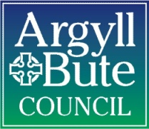

Getting Here
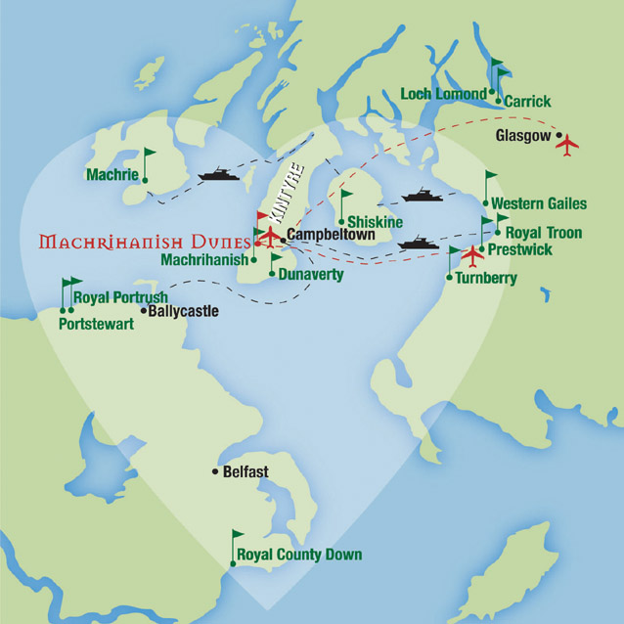
The award-winning Village at Machrihanish Dunes, Scotland’s most exciting new seaside golf resort, is a must-visit destination for golfers who appreciate something unique and demand the very best. Today, Machrihanish is more accessible than ever. From downtown Glasgow, it’s a little more than a three and a half hour journey down one of Great Britain’s most scenic routes to Machrihanish Dunes. Along the way, see Loch Lomond, drive along beautiful Loch Fyne and pass within steps of stately Inveraray Castle. If you’d prefer to fly, there are direct flights from Glasgow to nearby Campbeltown Airport. And with the Kintyre Express now connecting Campbeltown with both Troon in Ayrshire and Ballycastle in Northern Ireland, you can travel by sea, as well.

Upon arrival in the quaint seaside town of Machrihanish, you’ll have many options for both golf and other forms of holiday merrymaking on the Mull of Kintyre and beyond.

Hotel Highlights
Imagine waking up in the morning to views of the sparkling Atlantic and the Hebridean islands of Islay and Jura out your window, enjoying a hearty Scottish breakfast, and then making your way to the first tee or enjoying a soothing spa treatment - or setting off on some other worthy adventure. From your home base at The Ugadale, all the beauty and rejuvenating activities that define the Kintyre peninsula will be but moments from your door.
Superior Rooms
The Superior Rooms at the Ugadale Hotel are spacious and comfortable. These nicely-appointed spaces feature rich walnut wood and antique brass highlights, along with traditional Scottish elements. Each includes a cozy seating area, writing desk, flat screen HD television and is available in super king, regular king and twin bed configurations. All rooms feature shower baths and most include bath tubs. Some rooms include mini-bars. Enjoy breathtaking views of the Atlantic Ocean and/or the famed first tee of Machrihanish Golf Club.

Suites
Modern amenities meet classic Scottish elegance in the Suites at the Ugadale Hotel. These large, open-concept rooms have an ample sleeping area with king bed and the added luxury of a comfortable living room and sitting area. Other amenities include shower and bathtub, writing desk, generous wardrobe space, flat screen HD televisions and mini-bar. The Suite offers commanding views of the Atlantic Ocean.

Classic Rooms
The Classic Rooms at the Ugadale Hotel greet you in warm tones of deep red and brown infused with rich walnut wood and traditional Scottish elements. Each includes a writing desk, flat screen HD television and king or double bed. Rooms feature excellent views of the verdant hillsides that are a hallmark of the picturesque Mull of Kintyre.

Amenities:

- Complimentary Wi-Fi internet access
- Flat-screen HD Televisions
- Out of Eden toiletries
- Iron, hairdryer, valuables safe
- Discounted green fees at Machrihanish Dunes
- Guest dining privileges in The Kintyre Club
- Complimentary shuttle service to the Royal Hotel in Campbeltown and the Campbeltown Airport

The Kintyre Club
This warm and inviting restaurant and bar in a private club setting offering inspired dining and spirited good time will be the gathering place for hotel guests and members of The Kintyre Club. Named after the charitable organization founded in 1825 by a group of Scottish businessmen, The Kintyre Club will provide the best in hospitality with great food served in a relaxed atmosphere offering local seafood and fillets. Capable of seating up to 60 people the Kintyre Club will be the ideal venue for corporate events, private parties and get-togethers.
The Serenity Spa
Immerse yourself in your escape to Machrihanish with a visit to the full-service Serenity Spa at The Ugadale Hotel. Owner and operator Laura Kennedy has over a decade of experience helping her clients find their own calming oasis. She now leads Serenity’s warm and talented staff as they take visitors and residents alike through a few hours of complete tranquility and luxurious pampering. Top-of-the-line Decleor Paris products and procedures administered by caring professionals means you get the best facials, body treatments, and sports/full body massages. Whether you’re rejuvenating your mind to prepare for all Machrihanish has to offer, reinvigorating your body after a long day on the course, or simply treating yourself to a bit of “you time,” the Serenity Spa has everything you need to refresh your body, mind and spirit.

The Fitness Centre
Located on the lower level of the hotel is the Fitness Centre featuring state-of-the-art cardiovascular fitness machines, a selection of free weights and universal workout equipment with a stunning view overlooking the Atlantic Ocean.

The Development Team
Southworth Development, LLC
Machrihanish Dunes Golf Club and the luxury accommodations in both Machrihanish and Campbeltown, Scotland are managed by Southworth Europe Limited. Southworth Europe Limited is a subsidiary of Southworth Development LLC, a privately held company based in Newton, Massachusetts, specializing in the development of residential resort & hospitality branded real estate communities. Through its subsidiaries, Southworth Europe Limited and Southworth Golf, Southworth Development is also extremely active in the international golf industry.
Graham Construction
GRAHAM is a privately owned company operating in the construction, asset management and project investment markets whose primary focus is constructing and maintaining the infrastructure we all rely on in everyday life. The company has a proud heritage of traditional skills and values fused with professional management. It is ranked among the larger construction and services businesses in the UK and Ireland but still retains the core values upon which the Company was built.
GD Lodge Architects
GD Lodge Architects, established in 1972, has developed a reputation for providing imaginative solutions which combine design flair with commercial awareness. GD Lodge does not impose a "house style". A starting point is to fully understand the intentions of the client and other stakeholders. A unique design solution is then evolved which maximizes the opportunities presented by the brief, site context and other constraints. This practice has developed expertise over a broad range of project types. GD Lodge is currently actively involved in all market sectors.

Media Contact: Nancy Powers, npowers@southworthdevelopment.com
www.machrihanishdunes.com

