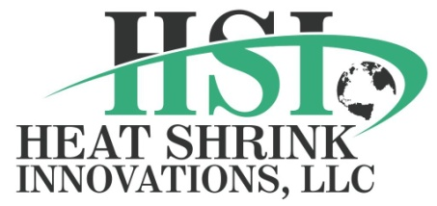1628 W. CROSBY RD, SUITE 100, CARROLLTON, TX 75006-6632
ISO 9001:2008 CERTIFIED

HEAT SHRINK INNOVATIONS, LLC (“HSI”) is a new ISO 9001:2008 registered company and is excited about opening our new facility in Carrollton, Texas. HSI welcomes new projects that are interesting and challenging. HSI has an experienced team that will work with customers closely to deliver a high quality FEP heat shrink tubing that will add value to your business. Our team’s experience consists of 15 years in the extrusion industry and with that in mind, HSI can produce clear and colored high yield products to increase your manufacturing bottom line profit. HSI realizes there are many choices in today’s market and this is where HSI is making a difference.

Using the latest innovation and with our competitive edge in manufacturing techniques, our FEP heat shrink and medical tubing products are among the most consistent in the industry. HSI provides the FEP heat shrink necessary for the reflow for thermal bonding required for the fabrication of catheter assemblies, aerospace and industrial applications. You will see your finished yields increase due to a more predictable process. HSI’s manufacturing focus is placed on product engineering and manufacturing processes, i.e. laser gauges and ultrasonics for measuring, a high level of product features, and the most efficient lean manufacturing process possible.

Characteristics for HSI heat shrink are:

- QUALITY
- PREDICTABILITY
- CONSISTENCY
- UNIFORMITY
- CLARITY

HSI insures this by using state of the art in-line gauging to insure the highest quality manufacturing process. HSI offers a variety of sizes, dimensions and lengths according to the customer’s specifications.

HSI would love the opportunity to provide many products and services to you in this industry. Please call or email with any questions or would like to request a quote.

Website: www.hsitubing.com
T: (469)568-0657 Email: sales@hsitubing.com F: (469)568-0659

