
WESTHILL PRESS RELEASE FOR IMMEDIATE RELEASE

GL Noble Denton puts
its people in the picture

GL Noble Denton, the independent technical advisor to the oil and gas industry, has launched a new advertising campaign that highlights the skills, experience and technical know-how of its people based in far-flung locations around the globe.
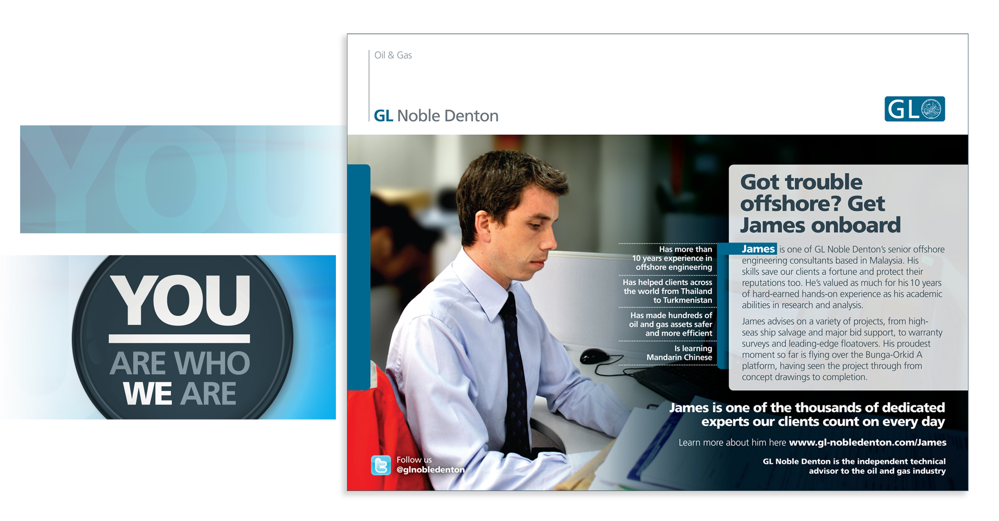
The new campaign will see a series of adverts and other marketing materials created over a period of time, each featuring a nominated GL Noble Denton consultant and significant engineering milestones in their career with the company.

London-based agency Westhill Communications worked alongside GL Noble Denton’s marketing team to devise a two-pronged approach for the campaign; initially an internal mechanic for its employees to nominate each other for their achievements and successes, followed by advertising and other marketing materials which focus on a selection of the successful nominees.

In order to encourage employees to put themselves or their colleagues forward for the campaign, Westhill and GL Noble Denton came up with
‘YOU are who WE are’, an internal communications initiative that reinforces the company’s approach to putting its people at the heart of its culture, while promoting the concept of employees submitting their achievements for use in a new advertising campaign.

The collateral for this phase revolved around playful “look what I did!” imagery, reflecting the overall themes of people, pride and achievement. This was delivered to GL Noble Denton’s offices worldwide via a poster and email campaign providing links to a dedicated nominations website, making it easy for people to put themselves forward or nominate colleagues.

As well as the chance of becoming “the face” of the company’s next advert, every successful nominee receives a donation to a charity of their choice.

The public face of the campaign launched with a series of ads in Upstream, the oil and gas industry newspaper, profiling the first four nominated employees. The adverts strike a balance between personal and professional – highlighting skills and achievements while reflecting the personalities of the real people involved.

Delegates at this year’s Offshore Technology Conference in Houston, Texas – one of the oil and gas industry’s largest trade events – will be greeted by a huge billboard on arrival at the airport and get the chance to see an animated presentation that brings details from the first four press ads to life.

GL Noble Denton’s director of marketing, Peter Richards said: “As a service-based company, the GL Noble Denton team was keen to develop a new campaign that allowed us to profile both our people’s technical expertise and the personalities behind that competence. It was crucial for us to get buy-in from our 3,000 consultants worldwide to achieve this, and the nomination mechanic of the ‘YOU are who WE are’ campaign has allowed us to do just that. The engaging and very human feel of the materials created with Westhill has captured everyone’s imagination.”

Westhill director Terry Hermon added: “As the buy-in of the staff was so important for the integrity of the campaign, we worked closely with the GL Noble Denton marketing team to enable people based all over the world to get involved. Following the campaign launch, we extended the internal promotion with poster-size press ads placed in offices, further nominated staff shown on the website, and by making the animation available on the company’s YouTube channel. All of which has helped maintain the momentum of the campaign and enthusiasm for it.”

Ends

MEDIA CONTACT INFORMATION

GL Noble Denton
Rob Coveney, GL Noble Denton: +44 (0)20 7812 8828 rcoveney@nobledenton.com

Westhill Communications
Paul Mitchell, Westhill Communications: +44 (0)20 7631 0274 paul@westhill.co.uk
Additional images are available

About GL Noble Denton
GL Noble Denton, part of the GL Group, is a global independent technical advisor to the oil and gas industry. With a presence in over 80 countries, we apply global best practice in safety, integrity and performance across the lifecycle of our clients' on- and offshore operations.

For more information, please visit: www.gl-nobledenton.com

About Westhill Communications
Westhill is a multi-disciplined marketing communications agency with dedicated web, print and editorial teams. Established in 1986, clients include BT, CPA Global, CTPA, I CAN, Department of Health, EdComs, Markel International and Openreach.

For more information, please visit: www.westhill.co.uk

