The CBRN Resource Network

The CBRN Resource Network is a comprehensive marketplace and knowledge base where decision makers and influencers learn about emerging technologies, source CBRN equipment, compare products, evaluate training opportunities, and monitor CBRN threats. We can’t control how government funds are allocated, but we can help minimize inequalities of information.
A unique digital media company, the CBRN Resource Network combines domain expertise on the Web with hands-on experience in the real world. Whether you’re a military or a civilian responder, you’ll find that the CBRN Resource Network is the place for peer-to-peer mutual aid and collaboration. The CBRN Resource Network is expert-focused and tailor-made for responders; it’s the place to learn about and discuss training, response tactics, and is also the place to compare and procure equipment.
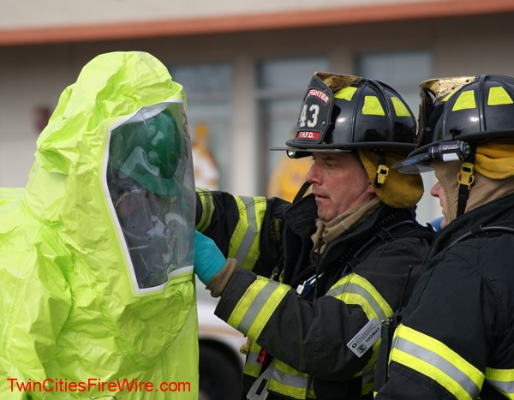
With its expert audience and highly focused content, the CBRN Resource Network:
- Delivers daily value to manufacturers, distributors, and advertisers.
- Provides branding, visibility, and lead generation are just part of your return on investment (ROI).
- Visitors enriched by participating in our community and engaging in social media
- You get to participate in discussions and talk to CBRN experts you might not encounter otherwise.
- Part of our low-cost, high-value appeal is that the CBRN Resource Network will list your products for free, and invite you to help shape the community.
So whether you’re a first responder or a CBRNE trainer, an equipment manufacturer or a product distributor, the CBRN Resource Network is the place for you.

The Responder Rundown Newsletter
In 2011, the CBRN Resource Network conducted five email campaigns. Three were client-specific mailings, and two were proof-of-concept editions of our Responder Rundown Newsletter. In total, our digital media company delivered targeted content to 460,000 readers. Over 10% of these CBRN experts (46,000) opened and read this content, with 5000 readers visiting advertiser websites.
In March 2012, the CBRN Resource Network will deliver the first of 10 more editions of the Responder Rundown. Each edition will include five advertisements and reach 50,000 recipients. With an open-rate of 15%, the Responder Rundown will deliver 90,000 unique opens and reads. The continuous development of our mailing list could deliver even greater results, providing visibility to 100,000 CBRN related experts.
By partnering with a technology leader in list development, the CBRN Resource Network has built a highly-targeted database of U.S. military, National Guard, state, local, civil, commercial and hospital responders. Unlike other mailing lists, however, our database is highly focused on CBRN experts rather than at the level of emergency management personnel. As the CBRN Resource Network continues to grow, we will identify even more interested experts via data mining and social media.
The Virtual CBRN Tradeshow
In October 2011, the CBRN Resource Network sponsored its first virtual event, an on-line conference and tradeshow with over 625 confirmed registrants, 500 unique presentations, and 450 interactive sessions. With the power of our virtual platform, keynote presentations and exhibitor content remained available for a full 60 days after the event. Unlike a traditional tradeshow then, Virtual CBRN continued to provide exhibitors with a return on their investment long after the event ended.
Starting from scratch, the CBRN Resource Network entered a crowded marketplace where virtual expos are not the norm. Although some CBRN experts attend all of the big traditional shows, many responders are unable to reach events such as NDIA CBRNE in Baltimore, Maryland or CBRNE World Convergence in Norfolk, Virginia. Other traditional tradeshows, such as the Homeland Security Professional Conference in Florida, aren’t as CBRN-specific.
When planning our first virtual event, the CBRN Resource Network invited 255,000 responders to attend. Over 17,000 CBRN experts opened our email, and some 1700 clicked-through. Although many more responders will attend future events, our 625 confirmed registrants and 250 unique attendees provided some basic benchmarks of success. Even after the show officially ended on October 5, another 25 registrants joined.
The October 2011 event provided other statistical successes, too. With over 600 presentations and briefs viewed collectively, the average time spent on the virtual platform was 3 hours per attendee. Participants watched an average of three presentations and examined content from over 475 unique events from exhibitors and sponsors. In addition to documents and downloadable .pdfs, October’s attendees watched informative videos and presentations.
Whether responders visited an exhibitor’s booth or the virtual tradeshow’s resource room, they absorbed a significant amount of information. Half the attendees examined at least one document. By the show’s end, 100 takeaway documents had been downloaded into virtual briefcases. This provided both the CBRN Resource Network and tradeshow exhibitors with actionable intelligence about a 99% U.S. audience that spans the entire CBRN Enterprise.
Exhibitors
The first Virtual CBRN Tradeshow featured engaging exhibitors from across the entire CBRN community, including the U.S. Army’s Dugway Providing Grounds, ANSI, IAB, and NIST.
- 20/20 Bioresponse
- ANSI
- Bruker
- CSI Learning
- Dugway Proving Grounds / United States Army
- HyGie-Tech USA
- Interagency Board (IAB)
- Morphix Technologies
- National Institute of Standards and Technology (NIST)
- Proengin
- Responder Knowledge Base (RKB)
- State of Wisconsin, Homeland Security REACT Center

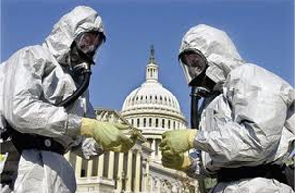
Presentations
The CBRN Resource Network featured virtual presenters who addressed a cross-section of topics covering technology, information, and other solutions that affect the entire CBRNE Enterprise.
White House Issues New Preparedness Strategy for CBRNE Threats
The Office of Science and Technology Policy (OSTP), in collaboration with the Departments of Homeland Security and Commerce, released a National Strategy for CBRNE Standards, which describes the federal vision and goals for establishing CBRNE equipment standards by 2020.
Improving U.S. Defenses against Weapons of Mass Destruction (WMD) – National Guard Bureau (NGB) Civil Support Teams (CST) and Custom Software Solutions
Retired LTC Keith Bauder, former head of the WMD NGB CST in Arlington, Virginia, described how the National Guard developed a custom information management system that enabled CSTs to direct and monitor the execution of team objectives while presenting a clear and thorough situation assessment to the on-scene incident commander.
ANSI Homeland Security Standards Panel – 2012 Initiatives and Priorities
Michelle Deane, the director of American National Standards Institute's Homeland Security Standards Panel (ANSI-HSSP), covered critical accomplishments that are helping to meet the homeland security standardization needs of our nation. Deanne also discussed the ANSI Homeland Security Standards Database (HSSD), a comprehensive source for standards related to homeland security.
Ground Truth, Credibility, Collaboration, Diversity, and Proactive Orientation – The IAB and the Voice of the Responder
Captain Doug Wolf is the Co-Chair of the Equipment Subgroup (ESB) for Department of Homeland Security (DHS) Interagency Board (IAB), Adjust Faculty at the National Fire Academy, and the Sarasota, Florida CBRNE Programs Manager. In this “boots on the ground” session, Wolf shared the current IAB perspective on personal protective equipment (PPE) certification and standards for All Hazards preparedness
The U.S.A. and the Challenges of a Chemical, Biological, and Nuclear Free World
Loyola University scholar Vassilios Damiras, head of Talon Strategic Consulting East Coast Operations, has an extensive background in European affairs, U.S. national security, and geopolitical analysis, as well chemical, biological, radiological and nuclear warfare. In this in-depth presentation, Damiras described three key challenges that the Obama Administration faces in reducing and eliminating CBRN threats.
Lessons learned from Ground Zero
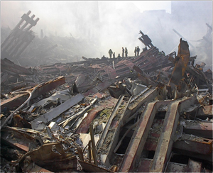
For the first time ever, LTC Robert Domenici (USA Ret.), now president of the CBRN Resource Network, publicly described his experiences commanding the NGB’s 2nd CST/WMD during its deployment to New York City in the aftermath of the 9/11 terrorist attacks. A graduate of the Army War College and holder of two Master’s degrees, Domenici also described the vigilant months that followed, including the 2001 World Series and visits by Present Bush and other high-profile dignitaries.

Lessons Learned from 800,000 acres in the U.S. West
Lance McEntire, chief of special programs at the U.S. Army’s Dugway Proving Grounds, presented an overview of the latest chemical defense protocols for military and civilian responders.
Best Practices from The Source
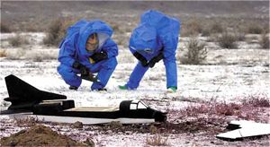
Demetria Hamilton-Caldwell, content analyst for the FEMA Responder Knowledge Database (RKB), shared key practices and important updates about the RKB website. Hamilton-Caldwell also provided an overview of national grants for responders whose departments and communities can apply for and benefit from these programs.
All Hazards Resilience in the Heartland
The Regional Emergency All Climate Training Center (REACT) from the State of Wisconsin’s Department of Military Affairs shared how the staff at Camp Douglas used trainers and a 15-acre campus for rope training, search and extraction, trench rescue, and other structural collapse response scenarios.
Protecting Our Own
Dr. Thomas Zink, MD, of the Institute for Biosecurity at Saint Louis University School of Public Health described Project Equal Immunization Policies and Practices (EQUIPP), a grass-roots initiative to counter the threat of antibiotic resistant-anthrax by pre-exposure vaccination of emergency responders.

No Battle Plan Ever Survives Contact with the Enemy
Anthony Davila (MA, CMAS-MSM) is a graduate of the U.S. Air Force Special Operations School’s Dynamics of International Terrorism and a former anti-terrorism specialist for the State of Connecticut. A retired detective, Davila offered case studies and real-life scenarios for how Murphy’s Law does not discriminate based on community size and resources.
Participant Feedback
Here’s what participants said about the first Virtual CBRN tradeshow from the CBRN Resource Network.
“This has been an excellent inaugural conference.” – Mark Newson of London, England
“This was a great forum and some really good talks . . . I am looking forward to the next conference and will invite more people.” – Dusty Kitzmiller
“Mr. Lance McEntire . . . Stand up so we can pin an impact Army Achievement Medal on your chest . . . Nice work in the briefing on DPG.” – Terrence K. Cloonan
Virtual CBRN Tradeshows in 2012
Internet marketing is a journey, and one with multiple points-of-interest along the way. By embedding the Virtual CBRN Tradeshow in our next-generation website, the CBRN Resource Network will continue to increase exhibitor ROI during our next virtual event, scheduled for June 2012. To nurture leads and develop dialog, virtual tradeshow exhibitors can benefit from blogging, social media, and other points-of=contact that the CBRN Resource Network will provide.
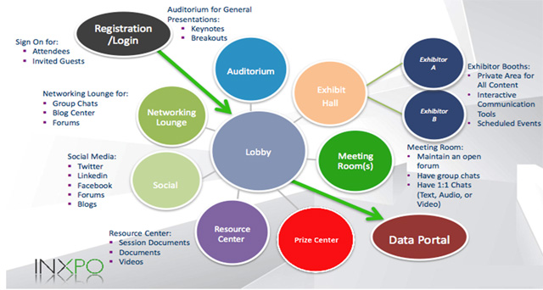

The CBRN Resource Network Website

In December 2011, the CBRN Resource Network welcomed its 10,000th unique visitor. With a return rate of 40%, the website provided 40,000 page views and average of 3 page views per visit. Some 70% of site traffic arrived via search engines such as Google – and with limited search engine optimization (SEO) activity. Approximately 15% of traffic came from referring sites such as the Virtual CBRN Tradeshow and Strategic Response Initiatives (SRI).
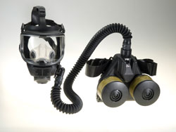
On average, the year 2011 also provided suppliers of CBRN products, services, and equipment with a lead a day. For each of the 365 sales leads that were left, the CBRN Resource Network advised potential buyers how to contact the supplier directly. Our next-generation website, scheduled for re-launch by May 2012, will enable buyers to compare products and create requests for quotes (RFQs). Suppliers who invest in our branded micro-sites, join our Virtual Tradeshows, and advertise in the Responder Rundown Newsletter will gather quality leads and gain additional visibility.
Responders who source products through the CBRN Resource Network will find everything from decontamination kits, personal flotation devices, hearing protection, and textiles to aerosol monitors, fingerprint ink rollers, CBRN undergarments, and stand-off passive object detectors. Companies of all sizes will showcase their products here, with emergency technologies securing the spotlight as CBRN experts confront both emerging threats and budgetary constraints.
With nearly 3000 products already added to the new website, the CBRN Resource Network will be more than a powerful product-comparison tool. In 2012, social media and on-line community will provide vendors with additional opportunities to connect with potential customers. All suppliers will receive free vendor profiles and product listings. Premium vendors can also submit news, white papers, videos, and presentations. Our robust SEO initiative and keyword analysis will benefit suppliers, users, and the website as a whole.
As part of this dynamic growth strategy, the CBRN Resource Network will continue to develop content that informs and educates visitors. The 700 responders and CBRN experts who have already registered with us will be joined by many more “boots on the ground”. In addition to high-quality product content, the Virtual CBRN Tradeshow, and the Responder Rundown Newsletter, the CBRN Resource Network promises to provide opportunities for peer-to-peer mentoring – all in one place.
Like nowhere else on the Web, the CBRN Resource Network will provide responders who register with access to product information, a community of their peers, and news they can use. So whether you’re a full-time CBRN expert or a part-time responder, the CBRN Resource Network is the place for you.
