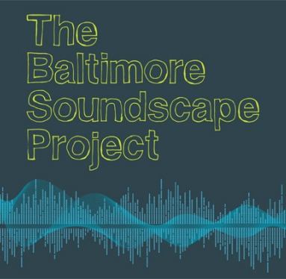
CONTEST
ANNOUNCEMENT

Even if you don’t sing or play an instrument, you too can “be heard” on MOBTOWNmoon’s one-of-a-kind tribute album. At the same time, you’ll be helping The Hearing and Speech Agency’s Baltimore Soundscape Project, a creative initiative to map our city’s unique sound print.
Remember how Pink Floyd used sound effects in its recordings? Alarm clocks, helicopter blades, footsteps, cash registers….
MOBTOWNmoon wants your help putting a fresh new Baltimore stamp on our versions of classic Floyd songs. Between May 15 and June 30, 2012, use your cell phone, portable computer, or mp3 recorder to take 30-second samples of compelling, interesting sounds you find on your Baltimore–the crowded streets or beautiful parks, the busy hospitals and marketplaces, the peaceful docksides or rowdy nightclubs. (Keep it family-friendly, folks!)
If you have an iPad, iPhone, or iPod Touch, you can download our free app and make the process incredibly easy.
The sounds you choose can be reminiscent of things you’ve heard on Dark Side of the Moon, or they can be completely unrelated to the original record. They just have to be clearly heard and interesting!
Upload your sounds by June 30 at The Hearing and Speech Agency’s Baltimore Soundscape Project. Full instructions are available there, and there’s also a contact form in case you have any questions or need additional help.
The five most interesting sound files will be chosen to appear on MOBTOWNmoon (tentative release date March 2013). All clips will become a permanent part of the interactive sound map for The Baltimore Soundscape Project.

