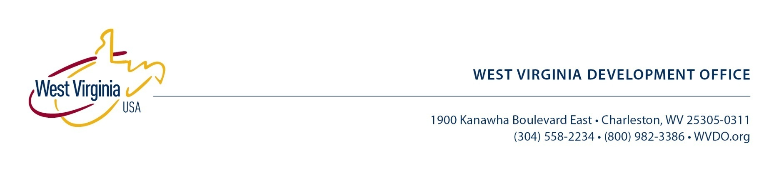

**FOR RELEASE:** June 13, 2012

**Contact:** Catherine Zacchi, 304-957-9340

**Celebrate West Virginia Day with made-in-West-Virginia wares**

**CHARLESTON, W.Va. –** This year, add a note of home state pride to your West Virginia Day festivities with wares made in West Virginia. You may be surprised by how easily available and varied the state’s goods can be.

**Get fired up**

The world's leading manufacturer of Kingsford barbecue briquettes is based in Parsons, Tucker County. Charcoal briquettes are made wood scraps — more than 1 million tons a year. Grilling or barbequing with charcoal infuses food with a delicious smoky flavor and aroma. Kingsford produces briquettes in original, hickory and mesquite. The company offers grilling tips and recipes on its website [www.kingsford.com](http://www.kingsford.com).

**In the chips**

Mister Bee is the only potato chip manufacturer in West Virginia. The tasty snack comes in original, barbecue, sour cream and onion, no-salt and dip style.

Mister Bee began operations in 1951 in Parkersburg, Wood County. Production stopped in October 2011, but new investment got the company up and running again April 30, 2012. The re-start put more than 30 employees back to work in plant, sales and delivery positions.

West Virginia’s native chips are once again stocked on store shelves.

**Cool it**

Ziegenfelder Company has been in business since the 1860s. The Wheeling-based company produces a number of frozen novelty sweets and it best known for its colorful Budget $aver flavored ices.

“Ziegenfelder Company produces more than one million frozen treats, including twin pops, every 24-hours, year round,” said CEO Lisa Allen.

In 2009, the firm celebrated the grand opening of its new, 40,000 square foot addition in downtown Wheeling. In 2012, the company expanded again with an 8,000-square-foot building addition to accommodate additional manufacturing and refrigeration equipment

The Budget $aver flavored frozen twin pops come in a variety of packages including the Assorted cherry, grape, orange, banana, blue raspberry and lime flavors. The new Budget $aver Monster Pops come in three different packages; cherry/pineapple, cherry/mango and lemon/lime. Ziegenfelder Company’s Budget $aver Rainbow Array twin pops, Monster Pops and other treats are available in grocery stores nationwide.

**Dish it up**

Set the table for your West Virginia Day feast with Fiesta® flair. The multi-hued line of Fiesta® dinnerware is ideal for mixing and matching. The complementary colors create a bright, bold mood for dining.

Fiesta® dinnerware was designed by Frederick Hurten Rhead in 1936 for Homer Laughlin China Company. Today, Fiesta® dinnerware is the most collected china in the United States and among the most collected china in the world. Homer Laughlin, the largest producer of china dinnerware in the United States, is headquartered in Newell, Hancock County.

**Loose your marbles!**

Get your family rolling in fun — without batteries or computers. Once a must-have item in every child’s toy chest, marbles still appeal today. Marble King in Paden City is a sponsor of the National Marbles Tournament in Wildwood, N.J. The 89th annual event takes place June 17-21, 2012.

A million marbles a day are produced at the Marble King factory in Paden City, says company president Beri Fox. “We make about 3,000 different types, sizes, shapes, coatings and finishes. Our marbles are used in games, recreational toys, landscaping, decoration, and architectural and industrial applications.”

Yes, industrial. When you shake a can of paint, that rattle you hear is a marble. Unlike steel ball bearings, marbles won’t rust.

This June 20, celebrate West Virginia Day from start to finish with home-state-made pride!

# # #