GET YOUR FITNESS BACK ON TRACK WITH OLYMPIC LEGEND MICHAEL JOHNSON’S MOTIV8

Four-time Olympic gold medal winning sprinter Michael Johnson is back in training following the release of his motivational running app for the iPhone.
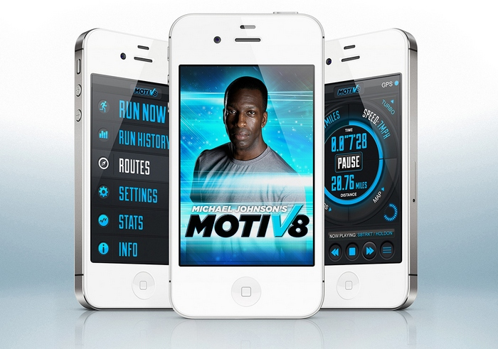
Johnson made history at the 1996 Summer Olympics when he became the first man to win both the 200m and the 400m gold at the same games. The legendary runner is the fastest man ever over 400m, and also held the world record for the 200m until recently overtaken by Usain bolt. Widely regarded as one of the most recognised athletes of all time, Johnson has since hung up his famous gold running shoes and will be one of the BBC’s lead pundits for the forthcoming London 2012 Olympic Games.

Now the former US track and field star is to put his running prowess and motivational skills into practice by helping walkers, joggers and runners, of all abilities, achieve their goals.

The Michael Johnson Motiv8 app features intuitive Timesplicing running technology, allowing you to have a world class athlete as your wing-man. Simply record your first run and from that point on Michael Johnson will be with you every step of the way, giving you words of encouragement and praise throughout your run, jog or even if you are taking a walk.

Michael Johnson Motiv8 also includes a step-by-step warm-up guide put together by ‘The Man With The Golden Shoes’, so that you will be in peak condition even before you take your first steps.

Need a boost mid-run? Michael Johnson Motiv8 knows when you need a kick and will provide you with an energy surge by playing your carefully selected Turbo Song. You can also add your favourite music tracks to accompany your run by selecting a playlist from iTunes. He’ll even comment on your choice of music!
Michael Johnson Motiv8 features full social media integration which allows runners to post personal achievements on Facebook and Twitter. Runners will also receive unique Michael Johnson Certificates of Achievement when they reach certain targets.
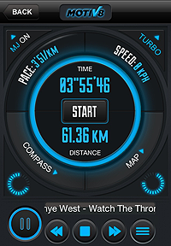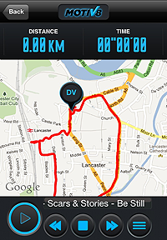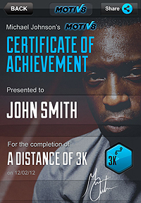

Speaking about the release of the Motiv8 running app, Michael Johnson said: “I am delighted with the way the Motiv8 app has turned out. I truly believe that it will help many people achieve more out of their running and will make it more fun too. The process of creating this has been really enjoyable and I look forward to sharing my enthusiasm with all those runners out there.”

Michael Johnson’s Motiv8 will be launched at an exclusive event at the Regents Street Apple store on Wednesday 11th July at 2pm. Michael will be answering questions from fans and the media at a specially arranged Q&A session.

Michael Johnson’s Motiv8 is priced at $2.99 in the United States and £1.99 in the United Kingdom and will be available on iTunes and Google Play app stores.

