Press Release
For Immediate Release

Website: laketrust.org

Lori Cieslak
734.462.8500 x5232
lcieslak@laketrust.org

Lake Trust Grants Local Student Michigan Scholarship
Lake to Lake Funding Awards Student $500 for Michigan College

Lansing, Michigan – Lake Trust Credit Union has awarded Michigan high school student and Credit Union member, Eric Olsen, a $500 College Scholarship, through the organization’s Lake To Lake Michigan Scholarship Program.

The Program provides financial assistance to three high school students seeking a higher level of education.

Olsen exemplifies many of the principles that Lake Trust looks for in its scholarship recipients: Trust, Teamwork, Adaptability, Learning, and Making a Difference; which are the organization’s core values.

Throughout high school, Olsen has been involved in many extra-curricular activities such as President of the National Honor Society and Student Council as well as community work for the American Cancer Society and Relay for Life.

Olsen will attend Michigan State University for Mechanical Engineering in the fall.

“I believe that I fully deserve to receive the Lake Trust Scholarship,” said Olsen. “Throughout my high school career, I have pursued every chance that I could to better myself, and more importantly those around me.”

Nicole Piche, Student Program Specialist at Lake Trust, appreciates the opportunity to assist these students.

“Eric is very deserving of this award and I’m thankful we’re able to help provide this opportunity to him and others,” says Piche. “We’re committed to supporting our members’ desire to attain a higher education.”

Visit the The CU Scoop to learn more about Lake Trust’s student resources.

Lake Trust Credit Union, Michigan’s fourth largest credit union and headquartered in Lansing, stretches from Lake Michigan to Lake Huron and Lake Erie. With over $1.5 billion in assets and 21 branches, Lake Trust provides its almost 156,000 members best-in-class products and offers individualized, trust-based member service. Membership is open to anyone within its 35-county service area. Learn more about Lake Trust Credit Union at laketrust.org.

Follow Lake Trust Credit Union on Twitter at http://twitter.com/lake_trustcu
###
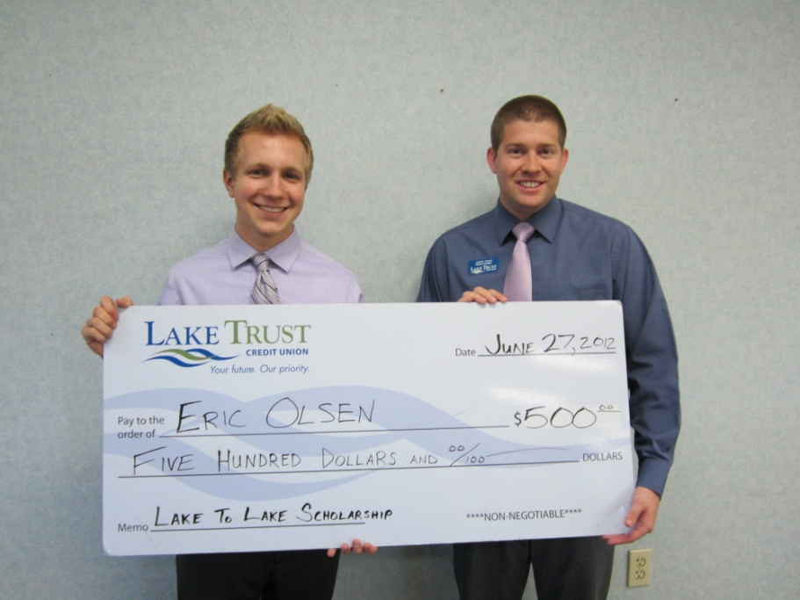
Eric Olsen pictured with Lake Trust Dewitt Branch Manager, Justin Haun

