For more information about Microsoft Cloud Power, go to:
www.microsoft.com/cloud
Partner: GreenQube
Website: www.greenqube.com
Customer Size: 15 employees
Country or Region: United States
Industry: Professional services—IT services
Partner: Citrix
Partner website: www.citrix.com

Partner Profile:
Based in Monroe, Louisiana, GreenQube is a cloud services provider that specializes in application and desktop virtualization and disaster recovery solutions.

Software and Services
- Microsoft Server Product Portfolio
- Windows Server 2008 R2 SP1
- Third-Party Services
- Citrix XenApp 6.5

 |  | 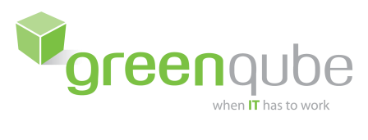 |  | Provider Uses Strategic Alliance to Add 20 New Partners in Three Weeks | Cloud Solution Provider Uses Strategic Alliance to Add 20 New Partners in Three Weeks
"By working directly with Citrix and Microsoft, we were able to accelerate our entry into the market for hosted desktop services by at least six months.”
Hunter McFadden, Chief Executive Officer, GreenQube
GreenQube sought to expand its hosting business by capitalizing on the growing demand for desktop-as-a-service capabilities. It chose to base its hosted desktop solution on Citrix XenApp and Windows Server 2008 R2. Through its strategic alliance with Citrix and Microsoft, the company has gained access to technical trainings and sales support, helping GreenQube release its solution six months faster and add 20 new nationwide partners in three weeks.

Business Needs
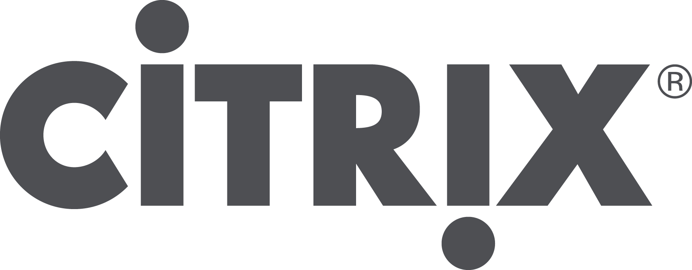

GreenQube believes in the power of the cloud to change the way people work. In fact, the company’s name derives from its commitment to helping customers shift their perception of work as a place you go to—like a cubicle—to something you do, from wherever you are.

Since 2005, GreenQube has specialized in providing cloud-based solutions, including application hosting and desktop virtualization, for customers in a range of industries. “We’re passionate about helping customers use best-of-breed virtualization technologies to increase efficiency, save money, and provide a better work-life balance experience for employees,” says Hunter McFadden, Chief Executive Officer at GreenQube. The company originally focused on hosting electronic medical records and business management applications for healthcare providers. To deliver these solutions, it relied on a number of Citrix technologies, including Citrix XenApp. Executives saw a number of trends developing that prompted them to consider incorporating a hosted desktop offering into the company’s solution portfolio. “Continuous improvements in virtualization technology, the rise of the bring-your-own-device-to-work model, and more companies looking to maximize their IT investments has led to increased interest in replacing physical PCs with hosted desktops,” says McFadden.

In concert with expanding its business model to include support for hosted desktops, GreenQube saw an opportunity to broaden its market and service offerings. It transitioned from engaging directly with customers to establishing a nationwide network of resellers. To rapidly recruit new partners—while empowering resellers to succeed in their local markets—GreenQube needed to provide them with expert training and marketing campaign support.

Solution
GreenQube chose to base its hosted desktop solution on Citrix and Microsoft technologies. “With the tight integration between Citrix technologies and the Windows Server operating system, GreenQube partners can deliver high-quality desktop virtualization solutions to customers,” says McFadden.

In designing its hosted desktop solution, GreenQube accessed expert training resources and documentation through its Citrix Service Provider (CSP) and Microsoft Service Provider License Agreement (SPLA). The company used reference architecture documentation from Microsoft and Citrix to optimize its data center environment. And, it worked with the Citrix Cloud Platform Team to gain specific guidance on incorporating the latest version of Citrix XenApp into its solution. The GreenQube hosted desktop service is delivered through Citrix CloudPortal Services Manager and based on Citrix XenApp 6.5 running on Windows Server 2008 R2 SP1. Over the past three years, GreenQube has helped businesses in numerous industries—from healthcare and professional services to manufacturing and distribution—realize the benefits of desktop virtualization.
One of its customers—a healthcare services agency—was able to defer US$50,000 in hardware and software upgrade costs. “The company has been able to expand into new geographies because it has a much more predictable cost structure,” says McFadden.

To increase the number of customers GreenQube reaches through its partner channel, the company continues to take advantage of marketing and sales support resources from Microsoft and Citrix. It has adapted collateral from joint Microsoft-Citrix campaigns focused on topics such as work shifting and consumerization of IT to equip partners with field-tested sales materials. And GreenQube even provides a White Label option for resellers to develop customized offerings for their customers.

Benefits
By choosing to build its hosted desktop solution on Citrix and Microsoft technologies, and by taking full advantage of service provider agreements with each technology vendor, GreenQube has experienced the following benefits:

- Gained competitive edge. GreenQube capitalized on access to product experts, online trainings, and extensive technical documentation from Citrix and Microsoft to rapidly advance its entry into the hosted desktop market. Company leaders affirm that the availability of these resources, which it gained through its participation in partner programs managed by each vendor, played a pivotal role in delivering its solution to market ahead of potential competitors. “Demand for desktop-as-a-service functionality is reaching a critical mass,” says McFadden. “By working directly with Citrix and Microsoft, we were able to accelerate our entry into the market for hosted desktop services by at least six months.”

- Added 20 new partners in three weeks. As more companies see the benefits of a cloud-hosted desktop model, competition is intensifying among service providers. McFadden sees a major advantage in allying with Citrix and Microsoft in recruiting partners nationwide. In one three-week period, GreenQube enrolled 20 new partners. “We’re able to offer service providers the chance to market a solution based on the gold standard in desktop virtualization technology,” says McFadden. “The success of our business depends on the health of our reseller network, and with help from Citrix and Microsoft, especially in supporting the growth of our White Label Program, our partner channel is thriving.”

- Improved customer acquisition rates for partners by 77 percent. Because GreenQube is equipped to efficiently meet the marketing and sales needs of its partners, it can help its partners gain customers faster. It used to take GreenQube partners up to nine months to close their first deal. Now, it takes new partners an average of two months to achieve this milestone, or 77 percent faster. Based in large part on the recent growth of its partner ecosystem, GreenQube projects that it will add up to 5,000 new users over the next six months. “With help from Citrix and Microsoft, we’re able to support the growth goals of our partners nationwide,” says McFadden. “And when we empower them to succeed, our business booms.”

