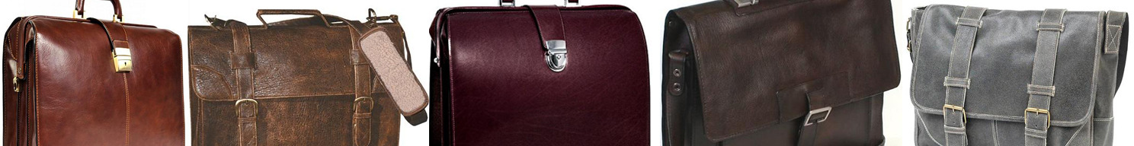

# Will a New Briefcase Land me a Job?

Well, perhaps! But let's face it in these hard times, you will need more than a great leather laptop briefcase to land that job for which, perhaps thousands of workers are competing. However, can it hurt? Absolutely not! A fine leather laptop briefcase can help to seal the deal, if you have the skills, experience and interview well.   
  
The most important thing to keep in mind when purchasing a leather laptop briefcase, is to match its style with your profession or intent. For example, don't spend several hundred dollars on a lawyer briefcase, when you are searching for a job as a Customer Service Representative. However, you may want to show your intent to eventually manage the Customer Service Department by selecting a leather briefcase that offers superior quality and style.  
  
Some detailed features that exhibit superior manufacturing and style are listed below. The quality level of these components should support your investment in a [**professional briefcase**](http://www.leathergiftitems.com/).

* Laptop - You must measure your laptop and assess the laptop compartment measurements. If the laptop will not be stored in a center compartment, there should be additional padding to protect the laptop from damage.
* Style - There are many styles of briefcases, i.e. flap over, vertical, east west, messenger, backpack briefcase, etc. The main thing about style, is try to choose a current sophisticated style that matches your profession, and perhaps it would be better to be a bit conservative, rather than too trendy.
* Hardware - Brown leather briefcases look best with brass or gold-tone hardware, while black leather briefcases tend to show better with Nickel hardware. It's always a bonus, when you find a briefcase with feet, which extends the life of your bag.
* Closure - There are top-zip briefcases, flap over briefcases and open access bags. When choosing a laptop bag, you may want to select a bag that closes around the laptop for security of the laptop. Most of the flap over briefcases offer magnetic or slip lock closures, while others offer an additional key lock or combination lock.
* Frame - There are wood frames, full metal or half metal frames. If you want a wood frame briefcase, have a strong arm! The lighter weight briefcases, usually have lightweight metal frames.
* Lining - Leather lining may be preferable for the durability and quality statement, however, there are many durable briefcases with washable ballistic lining or even cloth lining.
* Handle - It is best to have a durable handle that is stitched tightly, and has one piece of leather covering the entire handle. Some handles are made of wood, while others are made from metal. The handle takes a lot of treatment, so this is not a feature to overlook, and the hardware should be durable.
* Size - Always choose a briefcase that is complimentary to your body frame and weight. If you choose a briefcase that is larger than you are, you have not served your purpose. If you don't have an overly large laptop, most briefcases that carry a 15.4 inch laptop will be in proportion with an average sized man of 5 ft. 10 in. height. If you need to carry legal files, you must make sure the file compartment is slightly larger than 11 in. by 14 in. wide or tall, depending on whether it is a vertical briefcase.
* Color - Whether it’s a men’s black or brown leather briefcase, Burgundy, Cognac, Tan, Cherry, or Red women’s leather briefcase, it needs to match your profession. All of these colors are acceptable in most professions, so it's your preference.
* Strap – A comfort, padded strap is the best choice. Thin straps do not serve your shoulders, and may not support the laptop briefcase well enough. Leather, leather trim, and nylon are all good choices, and they must absolutely be adjustable. Many stores sell straps separately. When assessing your purchase of a leather briefcase, go for the model that fits your budget, while exhibiting some of the finer features discussed above. Your bag must have tight stitching of the leather, a strong handle, consistent tanning process of the leather, it must be sized to fit your purpose, and exhibit a style that matches your intent and profession. A great leather laptop briefcase can pump up your ego, and therefore help you to interview better!

Original copyrighted article published at: <http://www.leathergiftitems.com/articles/will-new-briefcase-land-new-job.html>

