
N E W S R E L E A S E

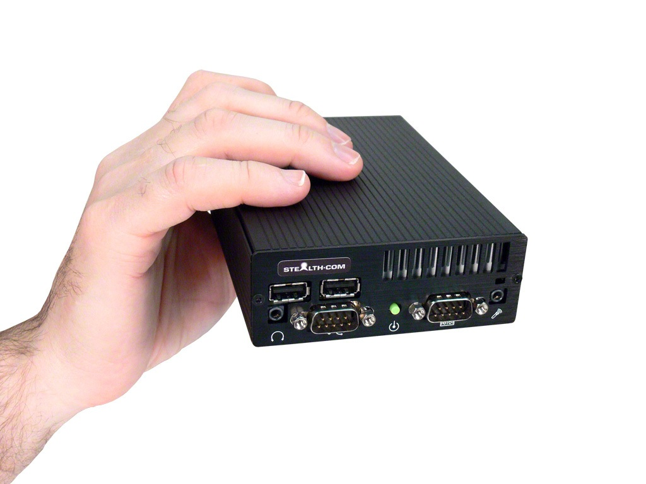
FOR IMMEDIATE RELEASE
Contact: Andrew Pakula
905-264-9000 ext #243
marketing@stealth.com

Stealth.com Launches a New Version of the LittlePC.com Website
Specializing in Small Form Factor Computer Technology

Toronto/San Jose ~ November 2012 – Stealth.com Inc. (Stealth Computer) a leading ISO 9001 manufacturer of industrial rugged computers and peripherals has launched a new version of its LittlePC.com website created to accommodate the growing market demand for SFF (Small Form Factor) computers.

The new LittlePC.com web portal features a wide selection of small sized computer products that are built to address the demanding applications of industry. Product designs such as; high performance processors, fanless/dust-free, low power consumption, multi i/o ports, expansion slot and mobile/vehicle machines are available as standard products that can be configured to fit the exact needs of the application.

“Over 10 years ago we launched our first LittlePC.com website and product line which has been very successful resulting in tens of thousands of systems being deployed all over the world. The new version of the website was released today as we continue to support the growing small form and embedded PC market.” stated Ed Boutilier CEO of Stealth.com Inc.

Page #2
Stealth.com Launches a New Version of the LittlePC.com Website
Specializing in Small Form Factor Computer Technology

About LittlePC.com
LittlePC.com is an exclusive brand developed by Stealth Computer to address the ongoing market demand in small form factor computing. An ISO 9001 registered manufacturer with over 22 years of industry proven success in delivering high performance and specialized computer products.

About Stealth
Founded in 1990 Stealth.Com, is a leading manufacturer of specialized Computers and Peripherals. The company is ISO 9001 registered and continually develops innovative products designed to meet the exact needs of their clients. For two decades Stealth has provided thousands of proven reliable product solutions that have assisted clients with a myriad of applications. Our impressive customer base includes a wide range of customers from single man operations to Fortune 500 companies, Military installations and Governments worldwide. www.stealth.com

#########

For more information, press only:
Andrew Pakula, Stealth Computer, PH: 905-264-9000 ext #243
E-mail: marketing@stealth.com
The Brand New LittlePC website: www.littlepc.com
Stealth’s main website and corporate information is available at: www.stealth.com
For high quality digital images of Stealth’s products (300 DPI): www.stealth.com/photos
Stealth’s newly launched ecommerce website is available at: www.stealthdirect.com

