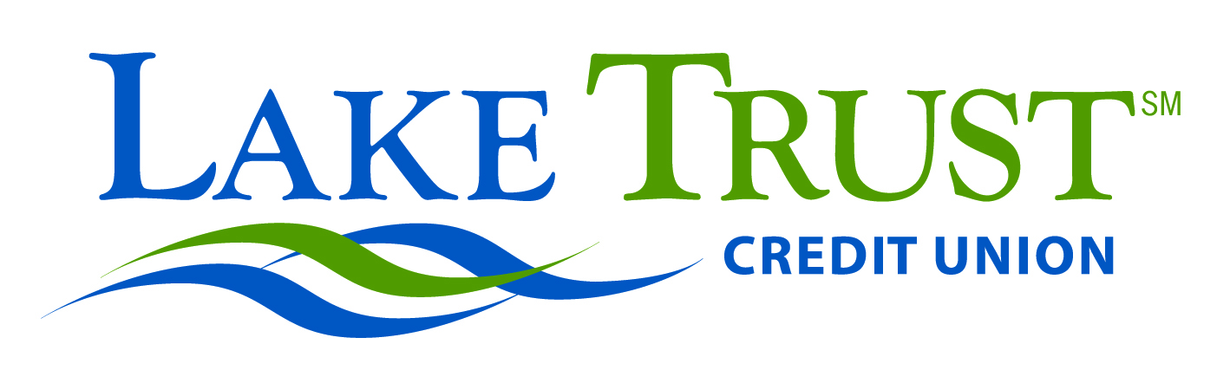

News Advisory  For Immediate Release  October 30, 2012  Website: laketrust.org | Lori Anderson or Danielle Brehmer  landerson@laketrust.org  or dbrehmer@laketrust.org  517.267.7439
Lake Trust Credit Union Sponsors Lake-to-Lake Food Drive on Friday, November 16, 2012
Local food banks join Lake Trust effort at 21 Michigan branches

Mt. Pleasant, Michigan – Lake Trust Credit Union will sponsor a Lake-to-Lake Food Drive on Friday, November 16, 2012 to collect non-perishable food items at its 21 branch offices located throughout Michigan. The Lake-to-Lake Food Drive is an effort to help fill pantry shelves at local food banks and feed deserving families in Michigan this season.

“Lake Trust Credit Union wants to make a difference in the many communities, from Lake-to-Lake, that we serve,” said Lake Trust President and CEO David Snodgrass. “Lake Trust will be open to the public and our members on November 16th, and we want to invite everyone to join our enthusiastic team and donate cans and non-perishable food items to help feed the hungry.”

Lake Trust has set a goal of collecting 1,000 pounds of food per branch location during the daylong food drive, equaling a total of 21,000 pounds. Food will be collected and distributed to a number of local charitable food distribution agencies around Michigan that are partnering with Lake Trust, including the Greater Lansing Food Bank, West Michigan Food Bank, Food Gatherers, Gleaners Community Food Bank of Southeastern Michigan, and Feeding America.

“Good people who might forget a can of food when they visit us on November 16 are welcome to donate even just a dollar or any amount, and Lake Trust will purchase food from local stores to include in our donations,” Snodgrass said. “Our goal is to help bring awareness to what we can all do to make a difference, and to help feed as many people as we possibly can, by collecting food during this daylong, all-out effort.”

Lake Trust Credit Union is Michigan’s fourth largest credit union and is headquartered in Lansing, with branches stretching from Lake Michigan to Lake Huron and Lake Erie. With more than $1.6 billion in assets, Lake Trust provides over 153,000 members with best-in-class products and offers individualized, trust-based member service. As a community-based credit union, Lake Trust strongly believes in supporting its communities and participates annually in Komen for the Cure® in Ann Arbor and Lansing, as well as nearly 100 events and causes annually throughout Michigan. Membership is open to anyone within its 35-county service area. Learn more about Lake Trust Credit Union online at laketrust.org or follow Lake Trust Credit Union on Twitter @lake_trustcu.

#####

