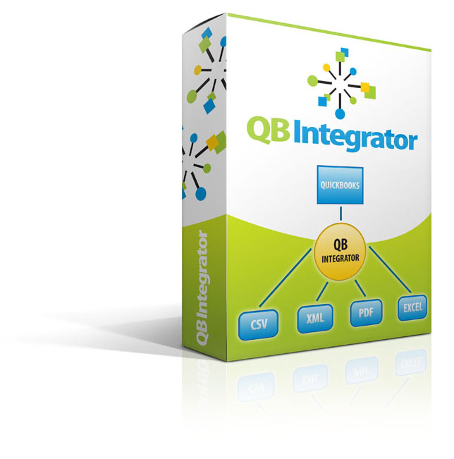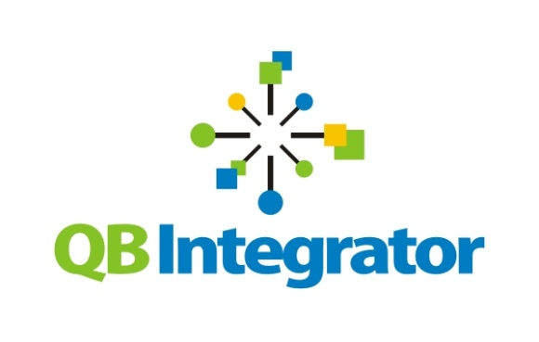

Start saving time and money today. Phone us at [858-866-8786](tel:858-866-8786)

**QuickBooks Integrator** is an application we will install for you on the same computer you use for QuickBooks. In just a few quick steps, we help you customize the Integrator to receive the data you need, from any source or sources - ACI, a la Mode, Clearbox, eTrac, Mercury Network, etc. Even if you use multiple systems, a proprietary system – and even when you process nonstandard invoices - the QuickBooks Integrator can be customized to accept and process that data - without manual entry.

There is no better way to speed and simplify appraiser invoicing. By eliminating the wasted effort of double entries, the **QuickBooks Integrator** buys you greater operational efficiency and instantly drives lower cost per transaction.

# Our QuickBooks Integrator converts data from your management systems into importable files, and then moves the files straight into QuickBooks for processing.

# No manual entry required.

REDUCE THE COST AND COMPLEXITY   
OF APPRAISER MANAGEMENT WITH OUR NEW

QUICKBOOKS INTEGRATOR

**Request   
ROI Analysis TODAY**

You are in the appraisal business, not the accounting business. But you still have to invoice your customers and pay your appraisers, so why not manage your invoices and payments as quickly and efficiently as possible?

Sell Seven© has developed **QuickBooks Integrator** to automate your invoicing and payments for you. Suddenly, your bookkeeper will be able to complete far more accounting, faster – and no one knows better than an AMC that time is money.

In our experience, even the most tech-savvy AMCs do not have a way to automatically move data from their appraisal process management systems into QuickBooks. This means that your bookkeeper has to pull some kind of hard-copy report off the appraisal process management system – sometimes several different systems - and manually enter the information into QuickBooks for invoicing.