Press Release 05 December 2012

BabyPing strikes gold at this year’s PPP Awards
BabyPing picks up Two Awards at Practical Parenting & Pregnancy Awards

BabyPing is delighted to announce it has won this year’s Practical Parenting and Pregnancy Gold Award for “New Product to Market (over £40)” and the Silver Award for “Innovative Product (over £30)”.

The awards were judged by an expert panel, including contributors and editors of Practical Parenting and Pregnancy, as well as parenting industry specialists.
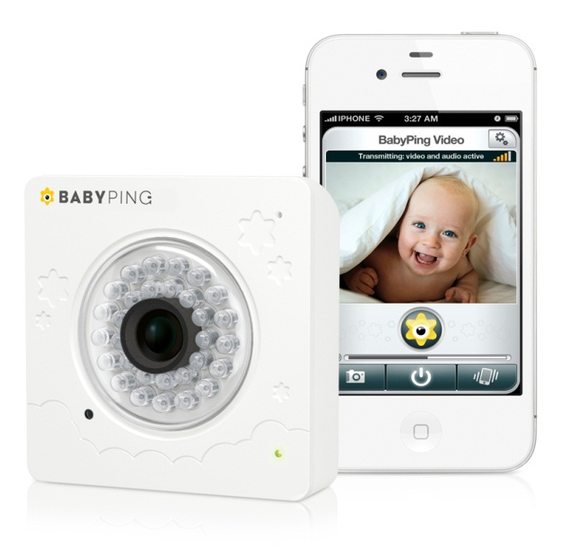
BabyPing is leading the pack of a new breed of smart baby monitor and has taken the core functionality of a traditional baby monitor and added the latest features to create a truly next generation smart baby monitor - not just a “baby viewer”. Unique features such as Constant-Connect (which keeps parents reliably informed of baby’s cries, as well as range and wireless network status), an app capable of working in the background (so you can keep using your Apple device to surf the web, play games or watch movies while your baby is still being monitored) and Smart-Filter (which blocks out background noise and static).

This double award success for BabyPing comes hot on the heels of their recent win of the 2012 Kind Und Jugend Innovation Award for “Baby Safety at Home”.

Spokesperson for BabyPing, James Hunt, commented “It’s a great honour to have won these awards – the whole team is incredibly proud. We know first-hand about the importance of security and peace of mind for parents, so we set out to develop a product that has all the features they could need to keep a watchful eye over their children. With technology advancing at such a fast pace, the competition in categories such as Innovative Product and New Product is really stiff, so it’s a fantastic achievement to have been recognised by Practical Parenting & Pregnancy.”

For more information about BabyPing, please visit: www.babyping.com.

-ENDS-
Editors’ Notes:

Website: www.babyping.com
Twitter: @BabyPingUK

BabyPing key features:

- Replaces a traditional baby monitor PLUS lets you view when you’re away from home.
- Easy to setup direct from your Apple device - no computer or technical wizardry required.
- Know when baby needs attention - through popup, vibrate or audio alerts.
- Unrivalled video and audio quality so you can see and hear everything in your baby’s room.
- App works in the background so you can use other apps or make calls & still be monitoring.
- View your baby from anywhere over 3G, 4G, W-Fi - free to use, no ongoing charges.
- Exclusive - Truly invisible, crystal clear night vision lets you see in the dark without disturbing.
- Easily invite family & friends to view your monitor from anywhere. Retain full control over access.
- Award winning Constant-Connect feature keeps parents reliably informed through the app.
- Add more Apple devices at any time to view baby from multiple rooms or locations.

BabyPing is a young, British based company who believe in combining the latest innovation with safety and security. The BabyPing monitor has been developed using feedback from parents to ensure it meets their needs. The result is a product in which parents can place their trust. BabyPing is proof that baby monitors have finally grown up, putting parents firmly in control and creating the safest way to monitor their children using the latest technology available.

BabyPing is £149.99/$199/€174.99 and is available from www.babyping.com and other leading retailers such as Amazon and Best Buy.

For further information and images please contact:

James Hunt
james@babyping.com
+44 (0)20 8334 7364
http://www.babyping.com/media

