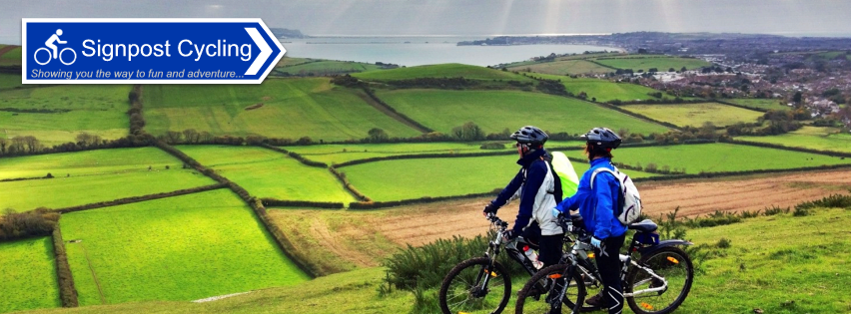
New Cycling Tours Business Inspired by London 2012 Olympics
Team GB’s success at the London 2012 Olympic and Paralympics along with Bradley Wiggins becoming the first Brit to win the Tour de France has inspired cycling enthusiast Roy Griffiths to start up a new cycling business.
Signpost Cycling www.signpostcycling.co.uk is a brand new cycling package tour business based in the South West of England and features guided and self-guided cycling tours initially in Dorset, Hampshire and the New Forest. Roy says “Having loved my cycling across this region for many years coupled with the fact that cycling is providing a high growth route to a healthier lifestyle for more and more people led me to believe that there is a real need to provide a quality activity break experience business based around cycling.”
Tour packages can be tailored to each client’s requirements and can include cycle hire (including electric option), accommodation, tour route maps & information or the services of a professional cycle tour guide. There are two styles of packages ‘Hub & Spoke’ with one venue as the base or ‘Linear’ where riders stay in a different location each night with luggage carried forward if needed.
Tours are often on traffic-free ‘off the beaten track’ routes and have been planned with meticulous care taking in some of the best scenery the region has to offer with rides through beautiful countryside, stunning coastlines, including the Jurassic Coast a World Heritage Site, and a whole host of picturesque chocolate box villages. Many of the rides have break off points to allow for visits to specific places of interest linking in to the history, culture and heritage of each area that is being cycled through including Hardy’s Wessex and the ancient New Forest National Park.
Accommodation has been specifically chosen for its high quality of offer and cycle friendliness. Riders will find themselves staying in boutique bed & breakfasts, family run small hotels, manor houses or even a castle. Many of the regions accommodation providers are realising that activity breaks are rising in popularity, as recognised by Visit England, and are committed to the provision of facilities that match the exacting requirements of this new marketplace providing great facilities for cyclists including secure bike storage, cleaning areas and laundry facilities.
The total value of cycle tourism across Europe is estimated to grow to around £14 billion a year (source Sustrans); moreover this green sustainable tourism does not heavily rely on cars. It makes minimal impact on the local environment and opens up opportunities ‘off the beaten track’ as well as in traditional locations. Signpost Cycling will be well placed to provide solutions to both domestic and overseas cycling tourists across the south west of England and northern Europe.
In development are routes linking in with the Cycle West INTERREG IVA European Programme initiative which includes - the Tour de Manche which creates a loop taking in Poole, Weymouth, Exeter, Okehampton, Plymouth, Roscoff, Saint-Malo, Mont Saint-Michel and Cherbourg and the Petit Tour de Manche providing a shorter loop taking in Weymouth, Dorchester, Poole then crossing over to Cherbourg and on to Saint Malo and back to England via Jersey. Both routes can be done in bite-sized pieces, long sections or the entire route with many opportunities to branch off along the way.
Ends

Notes to Editors
Contact Details:
Roy Griffiths - Principal
Signpost Cycling
Booking Office
4 Birch Way
Weymouth
Dorset, DT3 6HZ
t: +44 (0)1305 832512
m: +44 (0)7976 425719
skype: roy.griffiths21
roy@signpostcycling.co.uk
www.signpostcycling.co.uk
Twitter: @signpostcycling
Facebook: www.facebook.com/SignpostCycling
Photographs are available in high resolution if required email roy@signpostcycling.co.uk
Cycle West is a cross channel cycling network of more than 1000km connecting South West England with Brittany and Normandy www.cycle-west.com
Signpost Cycling is operated by Creative Solutions (Marketing, PR & Events) Ltd www.creativesolutions-uk.com

