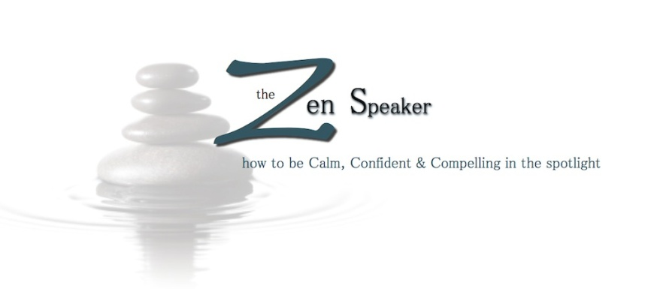
FOR IMMEDIATE RELEASE
Media Contact:
Amy Ayoub, Owner/President
(702) 786-7687 office
(702) 204-4911 cell
Amy@TheZenSpeaker.com
Hotline Launches to Help Public Speakers Decrease Anxiety and Polish Presentations
The Zen Speaker Announces the New Speakers’ Anxiety Hotline, Designed to Provide Creative Insight Resources and Help Overcoming the Fear Associated with Public Speaking
Las Vegas, N.V. – Whether it’s personal or professional, every turn behind the podium provides an opportunity for business building and networking. Everyone will eventually be called upon to make a speech or presentation—often with little preparation, to an unknown audience, or in an intimidating environment. Extreme panic can overcome those who find themselves unprepared. Surrendering to this fear or failing to practice can weaken the speaker’s credibility and lead to difficulty securing future business—not to mention the personal embarrassment that comes along with giving a bad speech.
Until now, speakers had no one to turn to for quick, affordable assistance with their specific speaking challenge. Enter The Speakers’ Anxiety Hotline, founded by Amy Ayoub, President of The Zen Speaker.
“We all find ourselves the position of being asked to speak at a wedding, a funeral, a City Council meeting, or a board meeting, and most people become overwhelmed with fear at the thought of speaking in front of a group of any size,” said Ayoub.
A public speaking and presentation skills coach, Ayoub developed this unique method of aiding speakers who are unable to attend her in-person groups or workshops, take a series of private coaching sessions, or join a teleclass series.
“I have seen time and again that even a short period of focused coaching and training can arm you with simple techniques that will make your presentation compelling while you remain calm,” she continued. “When you call The Speakers’ Anxiety Hotline, you will hang-up the phone with clarity on what you’ll say and the skills to:
- Immediately decrease your anxiety with a sure-fire secret weapon;
- Communicate your message in YOUR voice;
- Deliver your presentation in a calm, confident and compelling manner;
- Avoid rambling and boring presentations by using humor, storytelling and other dynamic speaking tools.
Ayoub also encourages those who may want help revising an existing presentation or need a little extra polish to utilize the hotline. Personalized sessions are scheduled in 15, 40 and 90-minute increments and will arrange additional sessions based on the needs of each individual. As a special introduction to the hotline, she is offering a 40-minute coaching session for $79.00.
To learn more or register for a coaching session, visit http://www.speakersanxietyhotline.com.
Amy Ayoub, a certified World Class Speaking Coach, is hailed for her ability to help clients easily conquer their fear of speaking in public and the ease with which she shows them how to make small changes in speeches that allow them to be calm, confident and compelling.
For more information on coaching or workshop opportunities with The Zen Speaker, visit http://www.thezenspeaker.com.
###

