For immediate release

Secure your home in high definition with the
small and sleek Y-cam Cube
Y-cam unveils the Cube, their latest professional grade wireless network camera range, providing VGA, 720p & 1080p HD resolution models, with IR night vision, Wi-Fi N and up to 64gb of on-camera storage, giving home or business customers the utmost in security, integration, design and reliability.
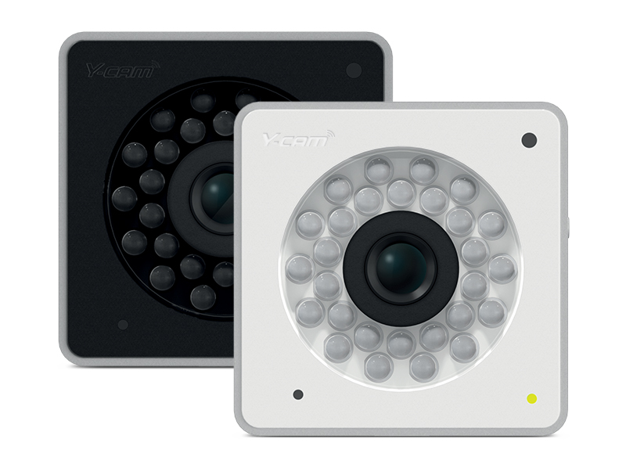
LONDON, UK – Thursday 31st January 2013 – Award-winning British wireless camera specialist, Y-cam Solutions Ltd, the leading provider of affordable and easy-to-use security cameras, have announced their new professional IP camera range, featuring the Cube, the Cube HD 720 and the Cube HD 1080.
Offering professional quality and sleek design, the Y-cam Cube range is unique to the home and SMB market. It is available in three grades of video resolution – VGA, 720p HD and full 1080p HD, and provides uncompromised image quality, and the widest range of inter-device compatibility. Measuring a discrete 6.5cm in width and height, the Cube blends harmoniously into any surroundings and is full to the brim with specialised features that provide the next level of security for high-tech homes and safety conscious businesses, allowing users to stay in control wherever they are.
“Our customers are particular about quality, design and aesthetics and the Cube is a result of two years of customer feedback and development” commented Simon Carr, Commercial Director at Y-cam, “We have created a device that is smaller, smarter and sleeker than your average security camera, and will easily disappear into a user’s home or business – it’s perfectly unobtrusive and discreet.”
Simon continues, “There’s no question that the market is calling for high quality HD cameras, and the advancements within technology allows customers to have the bandwidth and storage to take advantage of it. The Cube delivers on this, and in keeping with our ethos on high quality yet affordable products, we have used a balanced package of lens, sensor and chipset to offer VGA, 720p and 1080p options, perfect for those seeking the utmost quality, integration, design and reliability.”
All three Cube cameras provide 24 hour protection and peace of mind. Advanced round-the-clock features include powerful market-leading night vision, powered by 28 instantly activating infrared LED lights and an automatic IR cut-filter which provides accurate daytime colour representation, as well as crisp night time images, even in pitch black darkness. Teamed with the highest quality CMOS lenses and built-in microphone means the Cube gives ultimate security throughout the day and night.

This feature-packed professional camera range combines market leading features and the latest technology. Intuitive motion detection, instant email alerts, one-button Wi-Fi set-up with WPS, real-time video and audio streaming (including HD at 30fps), advanced Wi-Fi N, minimal bandwidth usage and storage from the latest H.264 compression technology, the Cube is an IP camera with clout. On top of these features, the Cube houses a built-in microSD slot for on-camera recording capable of storing up to 64GB of data, equating to over 90 hours of footage at the highest quality HD resolution.
Offering heightened compatibility, the Cube range is one of the few IP cameras that not only supports both PC and Mac computers but also offers a dedicated mobile stream for direct mobile viewing on both Apple and Android products. It also works with a huge variety of 3rd party products and services, eradicating any need to purchase separate or additional equipment. Additionally, with a simple PoE Dongle (sold separately), the cameras are capable of Power over Ethernet installations offering complete flexibility for users and installers.
The Cube is a robust and powerful security solution providing complete reassurance and protection, 24 hours a day, 7 days a week. The Y-cam Cube and Y-cam Cube HD 720 are available now - direct from Y-cam.com, Amazon and all good IP camera stockists. The Y-cam Cube HD 1080 will be available in Spring.
For more information please visit: http://www.y-cam.com/
For further press information on this or any of the Y-cam product range, including review models and image requests, please contact: Victoria Smith, Marketing Coordinator, Y-cam Solutions Ltd, Telephone: +44 (0)208 334 7373. Email: victoria@y-cam.com

ENDS

Product details

Model: Y-cam Cube  Product Code: YCB005 (Black)  YCW005 (White)  SRP: £149.99/ $199.99/ €174.99 | Model: Y-cam Cube HD 720  Product Code: YCBHD5 (Black)  YCWHD5 (White)  SRP: £199.99/ $274.99/ €249.99 | Model: Y-cam Cube HD 1080  Product Code: YCBHD6 (Black)  YCWHD6 (White)  SRP: £249.99/ $349.99/ €324.99

About Y-cam Solution Ltd
Y-cam Solutions Ltd is a British manufacturer of affordable and easy-to-use remote monitoring solutions designed for residential and small-medium business users. Founded in 2005, Y-cam is a young and dynamic company with rapid growth and award-winning products. For more information, visit www.y-cam.com and follow Y-cam on Facebook (www.facebook.com/ycamsolutions) and on Twitter @ycamsolutions.

