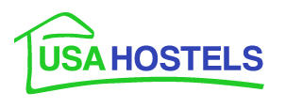

2013 FACT SHEET

History:

- 2013 – USA Hostels, Inc. wins Best Hostel Chain Worldwide
USA Hostels San Francisco wins #7 Large Hostel Worldwide
USA Hostels San Francisco wins Most Popular Hostel in San Francisco
USA Hostels Hollywood wins Most Popular Hostel in Los Angeles

- 2012 – USA Hostels San Diego awarded Top 3 Hostel in USA by Hostelbookers.com customers*
USA Hostels San Francisco awarded Best Staff by Hostelbookers.com
USA Hostels San Francisco awarded Certificate of Excellence by Trip Advisor reviewers

- 2011 - USA Hostels San Francisco awarded the #2 hostel in the USA and #3 in North America by Hostelworld.com customers*
USA Hostels Hollywood ranked the #3 hostel in the USA by Hostelworld.com
USA Hostels Hollywood wins Most Popular Hostel in Los Angeles by Hostelworld.com

- 2010 - USA Hostels San Francisco awarded the #1 hostel in the USA and #3 in North America by Hostelworld.com customers
USA Hostels Hollywood is ranked the #2 hostel in the USA by Hostelworld.com
USA Hostels Inc. is awarded the #1 hostel chain in the USA by Hostelworld.com

- 2009 - USA Hostels San Diego is ranked the #1 hostel in the USA and the #2 hostel in North America by Hostelworld.com customers
USA Hostels San Francisco is named the #2 hostel in the USA and #4 in North America by Hostelworld.com
USA Hostels Hollywood is ranked the #4 hostel in the USA and #7 in North America by Hostelworld.com

- 2007 - USA Hostels is once again ranked the #2 hostel chain in the world by Hostelworld customers.
- 2006 - USA Hostels San Francisco relocates to a much larger facility on Post Street.
- 2005 - USA Hostels is named the #2 hostel chain in the world by Hostelworld customers. Las Vegas and Kanab locations are sold.
- 2004 - USA Hostels adds a second location in San Francisco on Sutter Street
- 2003 - USA Hostels San Francisco is opened on Taylor Street.
- 2001 - locations are added in Las Vegas and Kanab, Utah, near the north rim of the Grand Canyon.
- 2000 - the Hollywood location is relocated to a larger facility and the company renamed USA Hostels.
- 1998 - USA Hostels Hollywood is initially opened as Hollywood Hills Hostel.
- 1994 - USA Hostels starts business in April as the Grand Pacific Hostel in San Diego’s then redeveloping Gaslamp Quarter.
*Hostelworld.com and Hostelbookers.com are the #1 and #2 ranked third party booking sites for hostel accommodation worldwide. Rankings are based on customer feedback in the areas of cleanliness, staff, security, fun, character, atmosphere and value.

Company Commitment:

Each of the USA Hostels is run by travelers for travelers. All management staff have a background in hostel travel and/or the hostel industry. Guests can expect to find friendly, helpful staff, who understand the ins and outs of traveling in the USA. The goal of the company is to provide fun, modern, secure and clean facilities that foster a social environment to help travelers feel comfortable and meet new people.

General:

- Website: www.usahostels.com. Information in English, Italian, Spanish, German, Portuguese, French, Japanese, Korean and Simplified (mainland) Chinese.
- Video tour: available on Hostelworld.com , www.usahostels.com, YouTube and Facebook
- Please contact Maria Argyropoulos-Minos at maria@usahostels.com or 001-323-359-7577 for photos, videos or interviews.

USA Hostels San Francisco

Just three blocks off Union Square, USA Hostels San Francisco is a short stroll from the historic cable cars, Chinatown and some of the city’s best shopping, bars and restaurants.

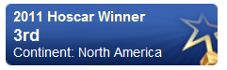
Recent Awards:
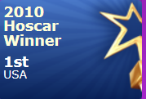
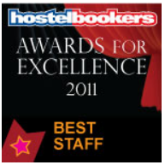
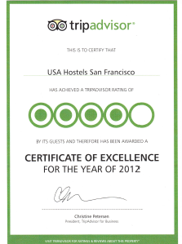
Unique Amenities in the Market:

- USA Hostels-designed ‘privacy pods’ on each dorm bed. Pods house a shelf, LED light and outlet, providing guests a place to store small belongings, read, use their laptop and/or charge their phone all within a screened area that provides the guest privacy from other roommates and shielding from ambient noise and light.
- 20 private rooms reflecting boutique-hotel style and quality. Rooms feature a funky, youthful décor, microwave, cable tv, fridge, mp3 player, duvet
- Free backpack-sized lockers with power points inside for secure electronics charging (guest provides lock)
- 50-seat theatre showing daily movies

Additional Amenities:
- Free Wii games available in theatre
- Large communal kitchen with 8 cooking kiosks
- Library/reading room
- Electronic key card entry to building and guest rooms
- Daily pancakes, toasts, oatmeal, fruit, juice and coffee/tea.
- Large lounge with free billiards and foosball
- Guest laundry with free washing powder, iron and ironing board
- Low-cost internet kiosks and Skype headsets
- Free wireless internet

Tours and Activities:
- Free neighborhood walking tours twice weekly
- Free Thursday night pub crawl
- Free Weekly parties
- Free Wii/Guitar Hero, Billiards and Karaoke tournaments
- Free Games Night
- Day tours of San Francisco
- Overnight trips to Yosemite
- Day trips to Muir Woods and Wine Country.
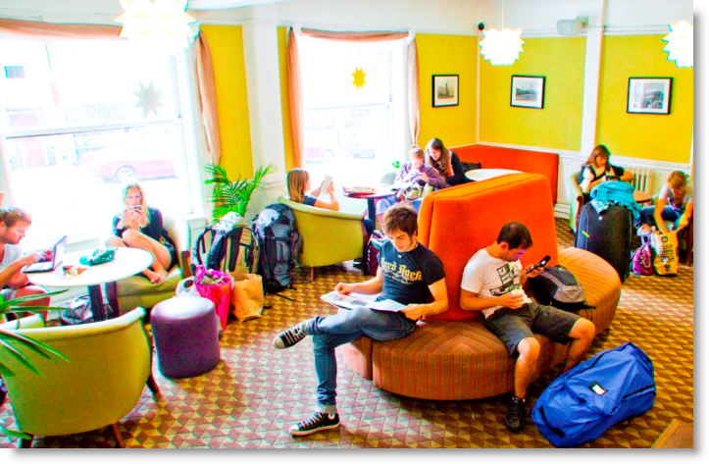

Accommodations:
- Rates include taxes (prices vary with room type, season and availability)
- 4-bed dorms, female and mixed
- Privates with queen and bunk beds
- Rooms are available with and without bath

Green Measures
- Low flow toilets and showers
- Waste recycling and recycling bins for guests
- Motion sensor lighting
- Green cleaning products

General information:
- Reception open 24 hours
- Check out: 10 a.m.
- Check in: 11 a.m. for dorm rooms, 2 p.m. for private rooms
- Beds: 210

Address: 711 Post Street, San Francisco, CA 94109
E-mail: sanfrancisco@usahostels.com
Website: www.usahostels.com
Toll free: 1-877-483-2950
Tel: 1-415-440-5600
Fax: 1-415-651-8802
Skype: (USA) 8774832950

USA Hostels Hollywood

Half a block from the Walk of Fame, 6 blocks to Graumann’s Chinese and Kodak Theatres in the heart of Hollywood’s Entertainment District. Located next door to Opera nightclub and near to Le Dux, Mood and Cress nightclubs all of which were featured on “Gossip Girl” and “The Hills’ TV shows. Only five blocks from the annual Oscar Awards.

Recent Awards:

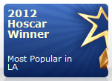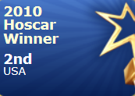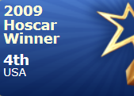

Unique Amenities in the Market:

- USA Hostels-designed ‘privacy pods’ on each dorm bed. Pods house a shelf, LED light and outlet, providing guests a place to store small belongings, read, use their laptop and/or charge their phone all within a screened area that provides the guest privacy from other roommates and shielding from ambient noise and light
- Free backpack-sized lockers with power points inside for secure electronics charging (guest provides lock)
- Large, private patio for relaxation and sunning
- Weekly Barbeques and parties

Additional Amenities:
- Daily pancakes, toasts, oatmeal, fruit, juice and coffee/tea.
- Newly renovated communal kitchen
- Large lounge with 3 high definition TVs
- Guest laundry with free washing powder, iron and ironing board
- Free wireless internet throughout hostel
- Low-cost internet kiosks and Skype headsets

Tours and Activities:
- Free Comedy Night Wednesday and Sundays
- Free Open Mic Night Tuesdays
- Free shuttle to Venice and Santa Monica beaches 3xs per week
- Beverly Hills Walking Tour, Runyon Canyon Hike, Hollywood Sign Tour 2xs per week
- Friday night pub crawl
- Weekly parties
- Discounted tickets to Universal Studios, Magic Mountain, Disney and Los Angeles area tours.

Accommodations:
- Rates include taxes (prices vary with room type, season and availability)
- 6- and 8-bed dorms, female and mixed
- Privates with full and bunk beds. Cable tv, fridge, air conditioning, mp3 player and duvet included
- All rooms have ensuite baths

Green Measures:
- Low flow toilets and showers
- Waste recycling
- Green cleaning products

General Information:
- Reception open 24 hours
- Check out 10 a.m.
- Check in 11 a.m. dorms, 2 p.m. private rooms.
- Beds: 154

Address: 1624 Schrader Blvd, Hollywood, CA 90028
E-mail: hollywood@usahostels.com
Website: www.usahostels.com
Toll free: 1-800-524-6783
Tel: 1-323-462-3777
Fax: 1-323-417-5152
Skype: (USA) 8005246783

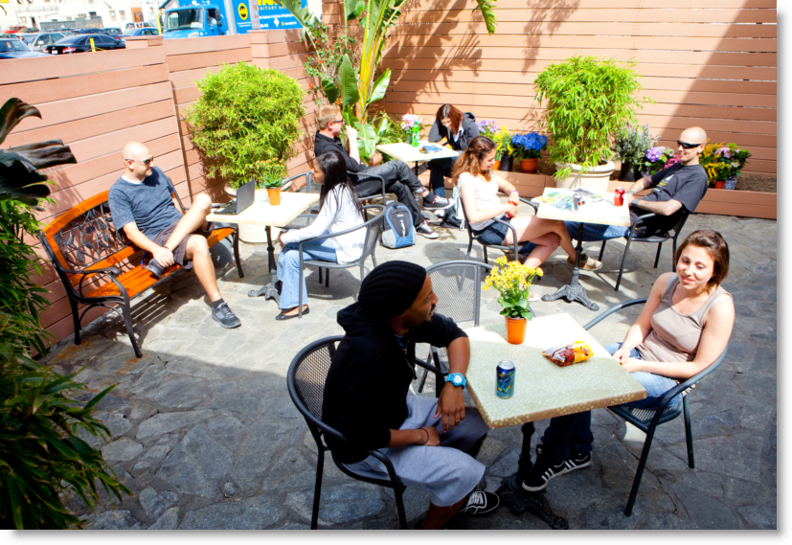

USA Hostels San Diego
In the heart of San Diego’s Gaslamp Quarter; home to the city’s best bars, clubs and restaurants. Located within walking distance of Seaport Village, Balboa Park, the San Diego Zoo and the city’s major bus and trolley lines. Short trolley ride to Tijuana.

Awards:

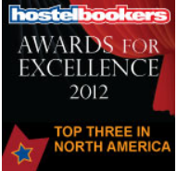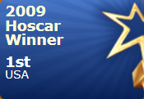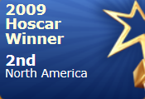

Unique Amenities in the Market:

- Historic 1880’s building features unique décor and is reportedly haunted
- USA Hostels-designed ‘privacy pods’ on each dorm bed. Pods house a shelf, LED light and outlet, providing guests a place to store small belongings, read, use their laptop and/or charge their phone all within a screened area that provides the guest privacy from other roommates and shielding from ambient noise and light
- Free backpack-sized lockers with power points inside for secure electronics charging (guest provides lock)

Additional Amenities:
- Daily pancakes, toasts, oatmeal, fruit, juice and coffee/tea.
- Free wireless internet throughout hostel
- Communal kitchen
- Electronic key card entry to guest rooms and front door
- Lounge with high definition TV
- Guest laundry with free washing powder, iron and ironing board

Tours and Activities:
- Free Wednesday Pub Crawl
- Free movie nights
- Tijuana Walking Tour every Saturday
- $2 Taco (and margarita) Tuesdays
- Discounted tickets to San Diego Zoo, Seaworld, Harbor and Whale Watching Cruises
- Weekly parties
- Low-cost internet kiosks and Skype headsets

Accommodations:
- Rates include taxes (prices vary with room type, season and availability)
- 4- and 6-bed dorms, female and mixed
Privates with queen and bunk beds. Lofted suite also available. Cable tv, fridge, mp3 player and duvet included
Green Measures:
- Low flow toilets and showers
- Motion sensor lighting
- Waste recycling and recycling canisters
Green cleaning products

General Information:
- Reception: 24 hours
- Check out: 10 a.m.
- Check in: 11 a.m. for dorm rooms, 2 p.m.
for private rooms.
- Beds: 98

Address: 726 5th Avenue, San Diego, CA 92101
E-mail: sandiego@usahostels.com
Web site: www.usahostels.com
Toll free: 1-800-438-8622
Tel: 1-619-232-3100
Fax: 1-619-393-0155
Skype: (USA) 8004388622



