Women Express Themselves 20% More Than Men as per 123Greetings Analysis
Summary: This Women’s Day, let us reciprocate and express ourselves to the women we care about in our lives. 123Greetings.com offers over 350 free ecards across 10 categories exclusively for International Women’s Day to help you select just the right expression for the occasion.
New York, NY, February 27, 2013: Women form an integral part of the 123Greetings.com community, and the company mined some numbers to understand how women differed from men as far as expressing themselves is concerned. The results were not startling but the magnitude of difference was.
As per our analysis 46% more women wished men on their birthdays in comparison to men. While away from each other, women missed their counterparts 32% more. However, a little surprisingly, women fell short of men on their wedding anniversary by 2%. However, overall on average, women were 20% ahead of men as far as expressing themselves to their counterpart is concerned on various important occasions.

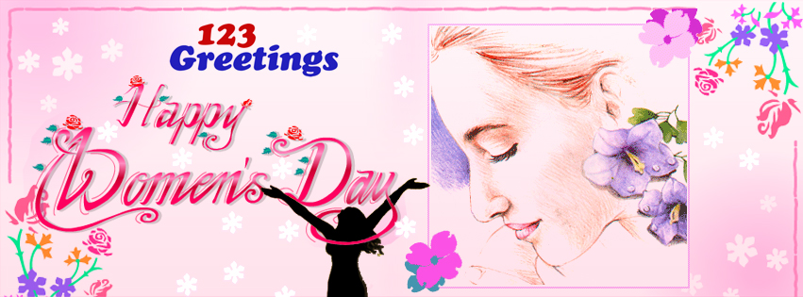
Happy Women’s Day from 123Greetings.com

Given that Women’s Day 2013 is just a few days ahead, the finding that women express themselves to men 20% more is worth nothing. Women spent more time and effort to wish their counterparts on various important occasions in their lives. Contrarians might argue it is not so important to express your feelings. However, this notion has been debunked well by Dr. James W. Pennebaker, Professor of Psychology at the University of Texas Austin, in his noted work, Opening Up – The Healing Power of Emotions.
This Women’s Day, it would be important for us as a mature community to understand, appreciate and learn from women. Thomas Hardy himself wondered – “Why is it that a woman can see from a distance what a man cannot see close?” The findings from 123Greetings.com goes to show the importance women give to emotional bonds and relationships and expressing their feelings, therefore spending more time and effort in ensuring that the relationship is nurtured and developed in the best way.
This International Women’s Day, 123Greetings.com urges all, especially men, to express their appreciation to the women in their lives, be it their mothers, friends, teachers, siblings, daughters or their partner. Appreciation, recognition and reciprocation to women perhaps goes that extra bit more in building your space within their hearts.
123Greetings.com has over 350 free Women’s Day ecards across 10 categories only for women’s day for you to choose the perfect expression for the women in your life.
About 123Greetings.com:
123Greetings.com is the world's leading online destination for human expressions reaching over 95 million visitors annually. Drawing from its tag line "Free Greetings for the Planet" the service exemplifies the notion that the best things are free in our planet and so should wishes, greetings and personal expressions be. Its offering of over 37,500 greeting cards covers a mix of 3,000 seasonal & everyday categories.
For details visit www.123greetings.com.

