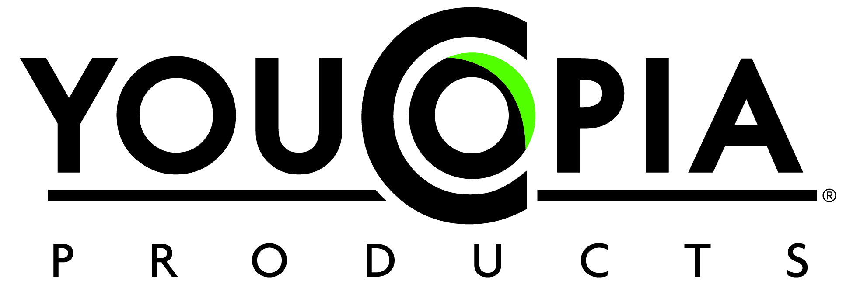

For More Information: For Immediate Release
Lauren Greenwood
773-252-0710
Lauren@YouCopia.com

Innovating to Control Kitchen Clutter

Chicago (March 2, 2013) -- YouCopia Products expands its line of innovative organizers for spices, coffee, tea, medicines, and baking tools and accessories to help consumers stay in control and happy at home. The company’s fourth appearance at the International Home + Housewares Show includes product introductions, new bold colors, and a patent-pending update to the best-selling SpiceStack® organizer.
YouCopia was founded in 2006 by product designer and longtime entrepreneur Mark Greenwood. The company’s first product, the SpiceStack, challenged the traditional meaning of a “spice rack” by smartly organizing store-bought spices in the cabinet with a stacked-drawer design. More than 500,000 SpiceStacks have been sold to date through national and specialty retailers, catalogs and e-commerce.
The Original SpiceStack®, Classic SpiceStack® and Chef’s Edition SpiceStack® hold 18, 24 and 30 spices bottles respectively. Introduced in late 2012, SpiceStack’s universal drawer (patent-pending) holds round and square spice bottles. Four new metallic colors—bronze, platinum, copper and wine—will be displayed at the show. The SpiceStack offers the perfect solution for cabinets overflowing with disorganized spices.
With 12 bottle compartments, the new MiniStack™ makes an ideal home for spices, sprinkles, medicine, vitamins and even craft supplies. Less than 6” wide, the organizer fits almost all kitchen and bathroom cabinets. Four snappy colors will be available in limited quantities for fall 2013.
“The MiniStack is the perfect solution for taking control of all those little containers that clutter up your home and life,” said Lauren Greenwood, VP of sales and marketing for YouCopia Products.
The stacked drawer concept found in all SpiceStacks has been borrowed and refashioned into an exciting line of coffee, espresso and tea organizers.
- more -
New Products//add one

The CoffeeStack®, is a hot accessory to Keurig® single-serve coffee machines. Unlike other revolving/basket pod holders, the CoffeeStack is designed to efficiently store more K-Cups® in less space in the kitchen cabinet. Consumers love that pods stay neatly tucked away, yet easily accessible.
The CaféStack® is a unique space-saver that organizes 60 Nespresso® capsules—more than any other organizer on the market—in less than five inches of cabinet width. Slim drawers lower to reveal capsules, with colors facing out, for easy selection of espresso of choice. The CaféStack is available in six high-gloss colors, three of which are new introductions for 2013, to match the most popular Nespresso machines.
New for 2013, PodStack™ is the only in-cabinet organizer for Starbucks® Verismo™, Keurig® Rivo™, and CBTL™ capsules. The organizer was recently named one of five finalists for the Home Organization + Storage category in the 2nd IHA Innovation Awards. The compact unit measures less than 6 inches wide and fits in all standard kitchen cabinets. Five drawers hold a total of 50 capsules, making PodStack the highest-capacity pod organizer of its kind on the market.
Another new product for 2013, BakeStack™ is the first in-cabinet organizer for baking tools and accessories. Three customizable drawers allow home bakers to save valuable pantry and drawer space by storing sprinkles, icing, candles, cake tips, cookie cutters and more in the standard kitchen cabinet. BakeStack includes 18 easy-fit drawer dividers—three vertical, six small horizontal, and three each of medium, large and extra-large horizontal—that provide hundreds of possible drawer configurations.
YouCopia Products is focused on designing organizers that help you feel calm, in control, and happy at home. YouCopia’s products are available at leading retailers including Bed Bath & Beyond, The Container Store and Amazon.com. Several new organizers will be on display at the 2013 International Home + Housewares Show. Please visit Booth #S746 for pricing and availability, or email info@YouCopia.com for more information. Be sure to check out the YouCopia Blog and follow us on Facebook, Twitter & YouTube.

# # #
For more information or images, please contact Lauren Greenwood at lauren@youcopia.com or call 773-252-0170.

